**THE MAHARAJA SAYAJIRAO UNIVERSITY OF BARODA**

**FACULTY OF SCIENCE**



# AN INTERNSHIP REPORT ON

# Web Development

# for

**Novus Ark Solutions**

*Submitted by:*

**Lakhmapurkar Tarang Jayendra**

# PRN No.: 2020033800114903

*In fulfillment of the award of the degree of*

# BACHELOR OF COMPUTER APPLICATIONS

## *In*

# Department of Computer Applications

## **APRIL 2023**

|  |  |
| --- | --- |
| **Internal Guide:**  **Ms. Krupali Panchal** | **External Guide:** |

CERTIFICATE

This is to certify that Mr./Ms.………………...…………………. a student of Bachelor of Computer Applications (PRN…………………………….) in the Department of Computer Applications, Faculty of Science, The Maharaja Sayajirao University of Baroda, Vadodara, has completed the Project/Internship prescribed for the sixth semester of the program during the period from ………………… to ……...…………. towards the partial fulfillment for the degree of Bachelor of Computer Applications.

Date:

|  |  |
| --- | --- |
| **Ms. Krupali Panchal**  **Internal Guide and**  **Teaching Faculty** | **Prof. Prashant K Mehta**  **Head**  **Department of Computer Applications** |

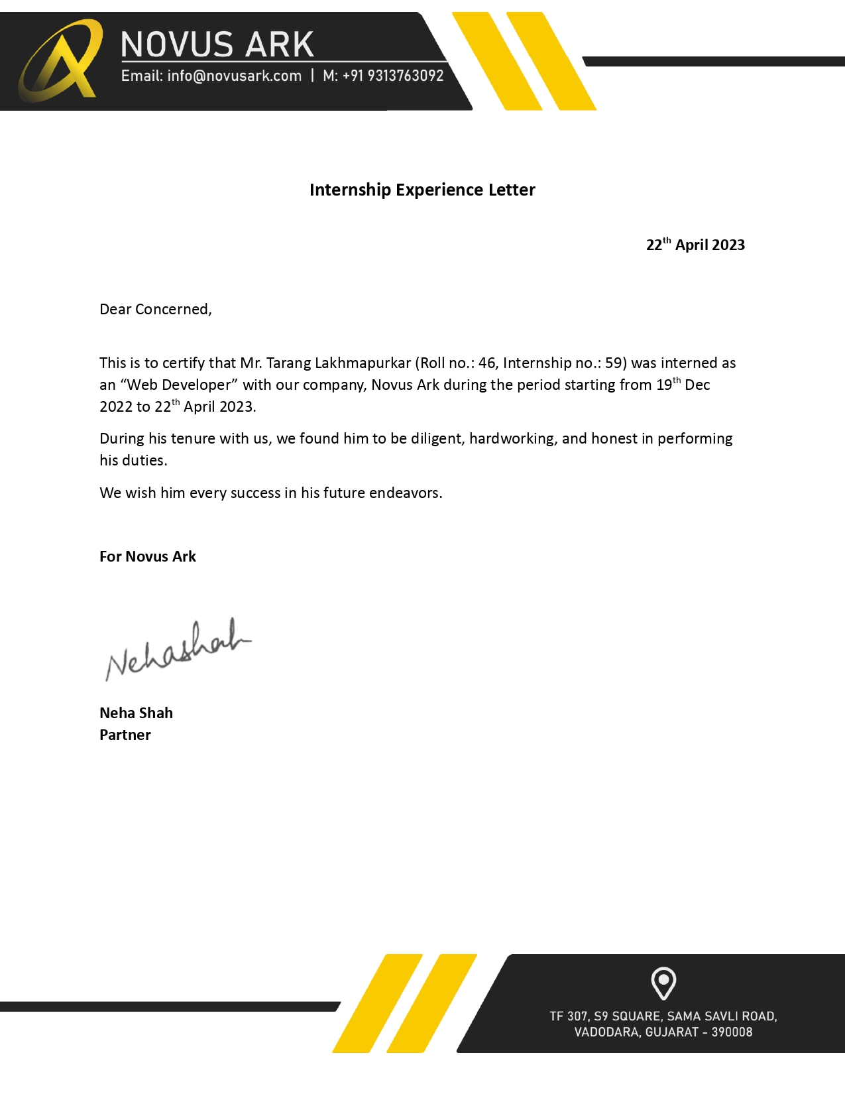

## **Acknowledgment**

The success and the final result of this internship program required a lot of guidance and endorsement from many people and I am fortunate to get all of these throughout my entire internship program. I was able to accomplish these tasks only with such assistance and supervision and therefore, I will never forget to thank them.

I respect and thank Mr. Devanshu Shah and Ms. Neha Shah who allowed me to work on various assignments including a company live project at Novus Ark and gave me all the support and guidance that motivated me to complete the given tasks. Despite being busy dealing with corporate matters, I am very grateful to him for such admonition.

My thanks to our internship project guide Ms. Krupali Panchal for supporting me in every possible way and helping me in getting this project towards partial fulfillment for the degree of Bachelor of Computer Applications. I’m thankful for her patience and support.

Apart from the people involved with the internship for this semester, I would also like to thank Mr. Tejash Soni and Mr. Kshipra Jadav for guiding me through the technical obstacles that I faced and helping me come out as a more valuable student and an intern. I am thankful for their willingness to help me when required and for being patient with my queries.

Above all, I would like to thank our BCA Department, for giving me this opportunity to gain practical experience and enabling me to understand the demand of the experience and professional environment. Throughout this internship, I have gained valuable experience which has given me confidence and has enhanced my professional skills for a competent career.

In addition, I would like to express our heartfelt gratitude to all the all-possible people for their timely support and help to achieve the goal.

#### **ABSTRACT**

I present this document as a report of the progress of my internship completed at Novus Ark Solutions, Vadodara. This report describes my internship experience at Novus Ark Solutions regarding the VI semester of the BCA Degree. The duration of the internship is of six months i.e., 24 weeks. I am required to attend the office 6 days a week from 10:00 am to 7:00 pm. This has made me self-disciplined and finish my work regularly and on time.

**Chapter 1:** Summarizes the introduction of the organization and the internship objectives.

**Chapter 2:** Includes the resources used to find the internship, departments in which I worked as an intern, the tools and technologies that were used, and provides the list of projects and/or assignments that were assigned to me during this course of the internship.

**Chapter 3:** Describes the software modules and their details which include the requirement analysis, design of the modules, database design, screenshots of the UI, and the test report of the tasks performed.

**Chapter 4:** Discusses the experiences of the corporate culture as well as the working atmosphere of the company.

The report focuses on and about the organization, assignments completed, working environment, corporate culture, communications, and career reflection that I encountered while handling various tasks assigned to me by the organization. The report contains the learning goals set by me and the purpose of choosing this internship. Along with the organization details from where I have carried out my internship.

**Chapter 5:** Focuses on the career reflection of all work that was done and if I would continue my work in the same domain of technologies.

**Chapter 6:** Conclusion of this documentation.

**Chapter 7:** References used.

**Table of Contents**

**Certificate** i

**Internship Certificate** ii

**Acknowledgment** iii

**ABSTRACT** iv

1. INTRODUCTION 3

1.1. Organization 3

1.1.1. Type of Organization 3

1.1.2. The Customer/Client of Organization 3

1.1.3. Major strength of organization 4

1.2. Objective 4

**1.3.** **Internship Objectives** 5

Some of the significant objectives of web development are as follows: 5

To verify the fulfillment of all specified requirements: 5

To build confidence in the quality level of the product: 5

Regular code reviews done by senior developers: 5

Implementing the changes suggested: 6

Focus on delivering an overall better product: 6

2. INTERNSHIP DETAILS 7

2.1. Methods/Resources Used to Find This Internship 7

**2.2.1.** **Frontend Department** 7

2.3.1. **Tools used** 7

2.4. Projects and tasks that were assigned 7

3. SOFTWARE MODULES AND SPECIFICATIONS 8

3.1. Software development Model followed: 8

3.2. Requirement Analysis of Modules Developed 12

3.3. System Design of Modules 13

3.4. Database Design of Work Done 14

3.5. Description of each assignment with screenshots 17

4. Corporate Culture 84

a. Working atmosphere in the organization 84

b. Remarks On the Culture Within the Organization 84

c. Insight gains about the corporate culture that I will take into consideration when searching for full-time employment 84

5. Career Reflection 85

a. Internship related to the field of study 85

b. List out the technologies learned during the internship 85

6. Conclusion 86

7. REFERENCES 87

# INTRODUCTION

### Organization

Novus Ark is a leading information technology and web solution company in Gujarat, India that provides information technology solutions, products, and services using the current industry standard tools and technologies.

We provide timely business information solutions. Our capability involves cloud hosting, software development, mobile application development, blockchain technologies, website development, etc.

We always try to create great value and productivity gains for clients by providing quality solutions to various business functions. We bring good experience in information technology, customer service, and global operations by continually combining our strategic thinking with the best in Technology, People, and Processes.

With a perfect blend of young and experienced IT professionals, the team has the dual-edged advantage of being both dynamic and stable. Both these advantages assure that the organization will be dynamic enough to adapt itself to the fast-changing world of Information Technology and is always in a position to provide cutting-edge solutions.

#### Type of Organization

Novus Ark is a partnership firm and professionally managed software solution company, and web solution company in Gujarat, India that provides information technology solutions, products, and services using the current industry standard tools and technologies.

We provide timely business information solutions. Our capability involves cloud hosting, software development, mobile application development, blockchain technologies, website development, etc.

#### The Customer/Client of Organization

Our software products are consumed by many government and private organizations. We have a wide range of products for educational institutes that help them to do their day-to-day work easily and do effective communications with students to keep them on top of the information chain. We also provide customizing software solutions for overseas clients widely spread in the United States and the globe.

#### Major strength of organization

* + - * Professionally managed
      * State-of-the-art technology
      * Cloud solutions
      * High Integrity.
      * Consistent Planning and Action.
      * Implementation and Support Methodology.
      * Quality Consciousness.
      * Excellent Customer Service.

### Objective

The primary objective of the internship is to generate a thorough understanding of the workplace relationship, perform the activities, and engaging oneself in the working environment. In a way, it was more to get the practical implications of all the studies, and theories that I had acquired so far. This would help me to pave the way toward growth in my academic as well as personal development. Apart from general objectives, the specific objectives are highlighted below:

* To acquire exposure in the working environment resulting in the development of practical knowledge, confidence, and diplomacy.
* To learn and apply theoretical knowledge practically in the workplace.
* To develop interpersonal, managerial, and communication skills.
* To come up with possible strategies to gain a competitive advantage.
* To be a valuable asset to the organization by contributing positive aspects
* To fulfill the partial requirements for The Bachelor of Computer Applications in The Department of Computer Applications at The Maharaja Sayajirao University of Baroda

As a learning objective of my internship, I have taken the position of a **Frontend Web Developer** intern.

#### **Internship Objectives**

#### Some of the significant objectives of web development are as follows:

*To understand the fundamentals of web development and its sub-parts:*

The work divided in the field of web development is what makes it modular and faster to develop all the full-scale applications. In addition, how web applications are actually developed in the real world with all the industry standards was a huge learning segment for me. Communication with the client, gathering all the requirements, listing down all the entities, and developing the database accordingly to create a visually stunning front end of the website serves as very integral part of delivering a refined software solution.

##### To verify the fulfillment of all specified requirements:

This objective reveals the fact that the essential elements of a web application should be to fulfill the customer’s needs. Developers understand the product and ensure the implementation of all the specified requirements. Developing all the modules, regardless of the tools and technologies used ensures verification of the functionality for every necessary module. The developer should also maintain version control of the project so that whenever there are some features, we need to roll back, it relatively becomes easier.

##### To build confidence in the quality level of the product:

One of the critical objectives of web development is to develop a well-integrated and sturdy software solution. High- Quality software means a lesser number of defects. In other words, the more efficient the developing process is, the fewer errors you will get in the end product. Which, in turn, will increase the overall quality of the deliverable product. Excellent quality contributes to a significant increase in customer satisfaction as well as lower maintenance costs.

##### Regular code reviews done by senior developers:

While developing a module, it is important to get code reviews done on a regular interval because there is always a better way to develop something. Another upside of this is that the same functionality can be achieved in a much more optimal way which in the end enhances the user experience while using the application. It also helps track bugs during the developing stage itself and fix those accordingly.

Implementing the changes suggested:

When a web application is developed, it is always expected changes to occur whether it be because of changes in the requirements or making the UI/UX of the website more appealing. Nevertheless, all the changes suggested are worked on right away while maintaining version control for any rollbacks necessary.

##### Focus on delivering an overall better product:

The ultimate objective was to learn how to build a quality product for the client and make sure it gets maintained all through its usage. Testing it at every stage, and check the integrity of the system with a great user experience makes a good software product.

# INTERNSHIP DETAILS

### Methods/Resources Used to Find This Internship

Applied online through *Indeed.com* and joined after clearing the interview.

* 1. **Departments of Organization In Which I Worked**

#### **Frontend Department**

* + - * In ReactJS
    1. **Backend Department**
       - In ASP .NET Framework using C# [Training]
  1. **Tools and technologies used during internship**

#### **Tools used**

* + - * VS Code
      * MS SQL Server
      * SQL Server Management Studio
      * Visual Studio
      * Thunder Client
    1. **Technologies worked on**
       - ReactJS
       - C#
       - ASP. NET Framework

### Projects and tasks that were assigned

* + 1. Assignment: 1 (Demo Admin Panel using ReactJS and Chakra-UI)
    2. Assignment: 2 (Demo Admin Panel using ReactJS and React-Bootstrap)
    3. Assignment: 3 **[Live Project]** (Kalash-Seeds Admin Panel)
    4. Assignment: 4 **[Backend Training]** (MS SQL Server and ASP .NET Framework)
    5. Assignment: 7 **[Current going work]** (Car Reselling website)

# SOFTWARE MODULES AND SPECIFICATIONS

### Software development Model followed:

**SPIRAL LIFECYCLE MODEL**

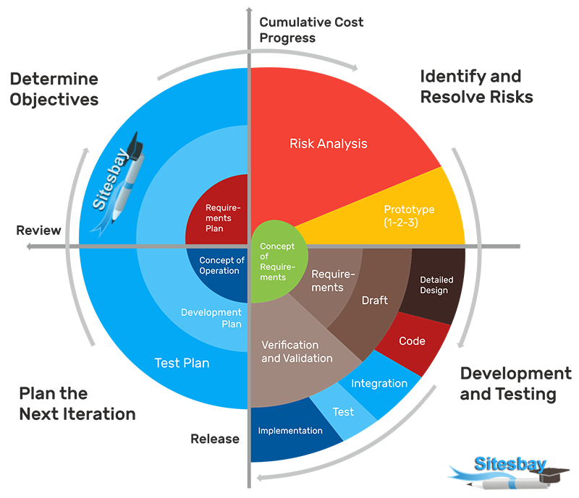

The spiral model combines the idea of iterative development with the systematic, controlled aspects of the waterfall model. This Spiral model is a combination of the iterative development process model and sequential linear development model i.e., the waterfall model with a very high emphasis on risk analysis. It allows incremental releases of the product or incremental refinement through each iteration around the spiral.

The spiral model has four phases. A software project repeatedly passes through these phases in iterations called Spirals.

* **IDENTIFICATION**

This phase starts with gathering the business requirements in the baseline spiral. In the subsequent spirals as the product matures, identification of system requirements, subsystem requirements, and unit requirements are all done in this phase.

This phase also includes understanding the system requirements through continuous communication between the customer and the system analyst. At the end of the spiral, the product is deployed in the identified market.

* **DESIGN**

The Design phase starts with the conceptual design in the baseline spiral and involves the architectural design, logical design of modules, physical product design, and the final design in the subsequent spirals.

* **CONSTRUCT OR BUILD**

The Construct phase refers to the production of the actual software product at every spiral. In the baseline spiral, when the product is just thought of and the design is being developed a POC (Proof of Concept) is developed in this phase to get customer feedback.

Then in the subsequent spirals with higher clarity on requirements and design details, a working model of the software called to build is produced with a version number. These builds are sent to the customer for feedback.

* **EVALUATION AND RISK ANALYSIS**

includes identifying, estimating, and monitoring the technical feasibility and management risks, such as schedule slippage and cost overrun. After testing the build, at the end of the first iteration, the customer evaluates the software and provides feedback.

* **SPIRAL MODEL APPLICATION**

The Spiral Model is widely used in the software industry, as it is coordinated with the natural development process of any product, i.e., learning with maturity, which involves minimum risk for the customer as well as the development firms.

The following pointers explain the typical uses of a Spiral Model

* When there is a budget constraint and risk evaluation is important.
* For medium to high-risk projects.
* Long-term project commitment because of potential changes to economic priorities as the

requirements change with time.

* Customer is not sure of their requirements which is usually the case.
* Requirements are complex and need evaluation to get clarity.
* New product line which should be released in phases to get enough customer feedback.
* Significant changes are expected in the product during the development cycle.
* **SPIRAL MODEL - PROS AND CONS**

The advantage of the spiral lifecycle model is that it allows elements of the product to be added in when they become available or known. This assures that there is no conflict with previous requirements and design.

This method is consistent with approaches that have multiple software builds and releases which allows making an orderly transition to maintenance activity. Another positive aspect of this method is that the spiral model forces early user involvement in the system development effort.

On the other side, it takes very strict management to complete such products and there is a risk of running the spiral in an indefinite loop. So, the discipline of change and the extent of taking change requests is very important to develop and deploying the product successfully.

* **The Advantages of the Spiral SDLC Model are as follows**
* Changing requirements can be accommodated.
* Allows extensive use of prototypes.
* Requirements can be captured more accurately.
* Users see the system early.
* Development can be divided into smaller parts and the risky parts can be developed earlier which helps in better risk management
* **The Disadvantages of the Spiral SDLC Model are as follows**
* Management is more complex.
* End of the project may not be known early.
* Not suitable for small or low-risk projects and could be expensive for small projects.
* process is complex.
* Spiral may go on indefinitely.
* a large number of intermediate stages requires excessive documentation.

### Requirement Analysis of Modules Developed

* + 1. Assignment: 1 (Demo Admin Panel using ReactJS and Chakra UI)

When I started this internship the first task given to me was to make an admin panel in ReactJS using whichever UI library I preferred hence I began with Chakra UI.

As majorly of the projects developed in the company are developed upon Angular and AngularJS, a basic ReactJS admin panel would be an appropriate project that could be given to an intern before assigning a live project.

* + 1. Assignment: 2 (Demo Admin Panel using ReactJS and React-Bootstrap)

The second task given to me was to make an admin panel in ReactJS using the Bootstrap library to make the website more responsive.

As majorly of the projects developed in the company are developed upon Angular and AngularJS, a basic ReactJS admin panel would be an appropriate project that could be given to an intern before assigning a live project.

* + 1. Assignment: 3 **[Live Project]** (Kalash-Seeds Admin Panel)

This is the live project that was assigned to me on January 6th.

The project requires creating an admin panel for an online business website that deals in selling plants, seeds, fruit and vegetable saplings, etc.

This website was created using ReactJS and Bootstrap.

Many other libraries were used such as react-router, Axios, react-table, tippy-js, etc.

* + 1. Assignment: 4 **[Backend Training]** (MS SQL Server and ASP .NET Framework)

For Backend development, I was given to install MS SQL Server and SQL Server Management Studio for database and tables creation.

Apart from that, to create APIs, Visual Studio 2022 with .NET framework v4.7 was required.

* + 1. Assignment: 5 **[Current going work]** (Car Reselling website)

For application development I am using ViteJS which is a flavor of ReactJS that comes with a custom JavaScript bundler that is faster than the usual eslint bundler.

For UI, I will be using Chakra UI with react-router for routing the pages.

And finally, three-js and react-three-fiber for rendering the 3D models.

### System Design of Modules

* + 1. Assignment: 1 (Demo Admin Panel using ReactJS and Chakra UI)

When I started this internship the first task given to me was to make an admin panel in ReactJS using whichever UI library I preferred hence I began with Chakra UI.

As majorly of the projects developed in the company are developed upon Angular and AngularJS, a basic ReactJS admin panel would be an appropriate project that could be given to an intern before assigning a live project.

* + 1. Assignment: 2 (Demo Admin Panel using ReactJS and React-Bootstrap)

When I started this internship the first task given to me was to make an admin panel in ReactJS using whichever the Bootstrap library to make the website more responsive.

As majorly of the projects developed in the company are developed upon Angular and AngularJS, a basic ReactJS admin panel would be an appropriate project that could be given to an intern before assigning a live project.

* + 1. Assignment: 3 **[Live Project]** (Kalash-Seeds Admin Panel)

After around a month and a half in this internship, I was assigned the first live project.

As the client’s requirement was for a technology that managed the relationship between the customer and the business, CRM software was to be developed.

I was assigned to develop the front end of the admin panel of that particular project which handles the customer data, order details, and even the homepage content from the website itself.

All the data that is to be managed is done via the website. Adding, Deleting, Updating records of different categories, and enabling and disabling are also done via the admin panel.

* + 1. Assignment: 4 **[Backend Training]** (MS SQL Server and ASP .NET Framework)

After the completion of the admin panel, my domain was changed to the backend department.

My tasks included creating a database, adding tables with all the necessary relationships between the tables, and creating APIs in the ASP .NET framework to perform CRUD operations.

Applying the 3-tier architecture to the backend of the system and making the system integrated is how the company follows the methods.

* + 1. Assignment: 5 **[Current going work]** (Car Reselling website)

As I had already designed an admin panel for a live project, I was assigned a new task of designing a client-side website using ReactJS for any domain that I would want.

Hence, I began developing a client-side website for car sales.

### Database Design of Work Done

* + 1. Assignment: 1 (Demo Admin Panel using ReactJS and Chakra UI)

No database was used as it was a static website.

* + 1. Assignment: 2 (Demo Admin Panel using ReactJS and React-Bootstrap)

No database was used as it was a static website.

* + 1. Assignment: 3 **[Live Project]** (Kalash-Seeds Admin Panel)

As I was only required to develop the front end of the given website, I was only provided with the API links for all the necessary CRUD operations

* + 1. Assignment: 4 **[Backend Training]** (MS SQL Server and ASP .NET

Framework)

Project 1:

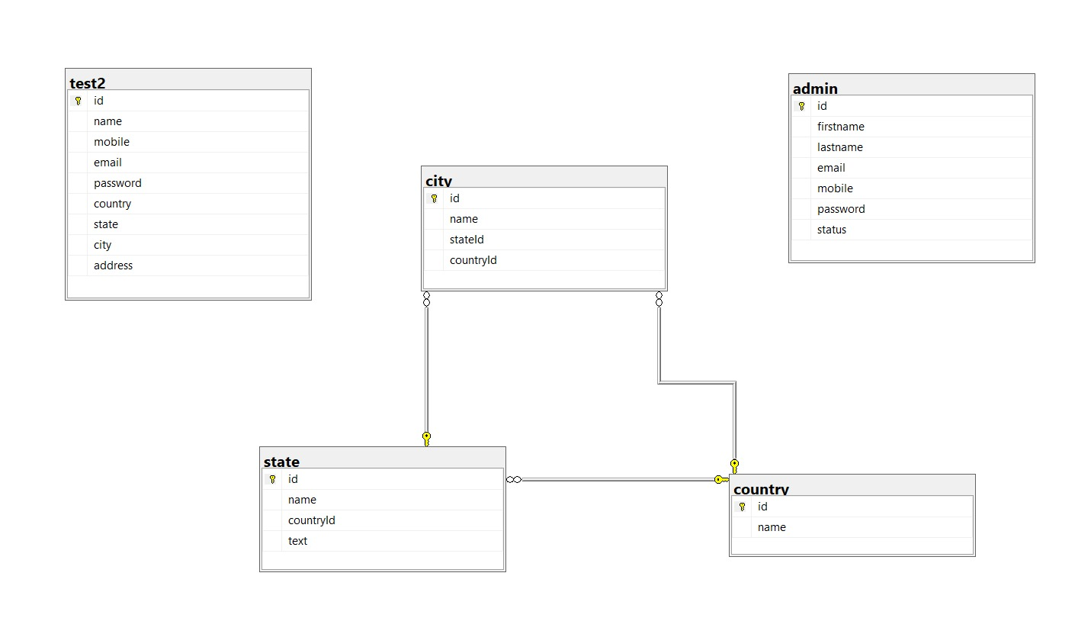

Project 2:

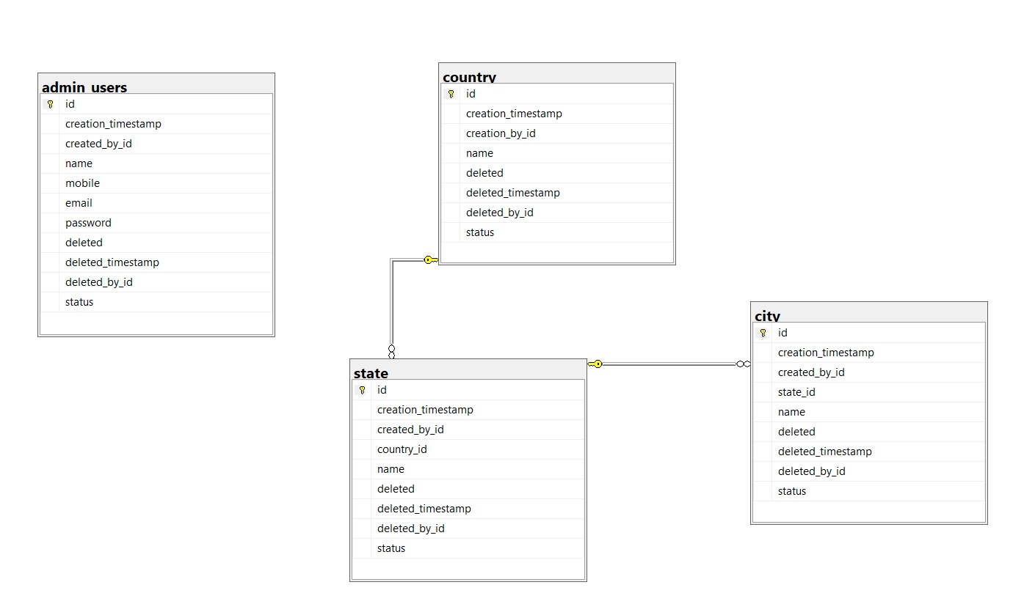

* + 1. Assignment: 5 **[Current going work]** (Car Reselling website)

No database was used as it was a static website.

### Description of each assignment with screenshots

* + 1. Assignment: 1 (Demo Admin Panel using ReactJS and Chakra UI)

When I started this internship the first task given to me was to make an admin panel in ReactJS using whichever UI library I preferred hence I began with Chakra UI.

As majorly of the projects developed in the company are developed upon Angular and AngularJS, a basic ReactJS admin panel would be an appropriate project that could be given to an intern before assigning a live project.

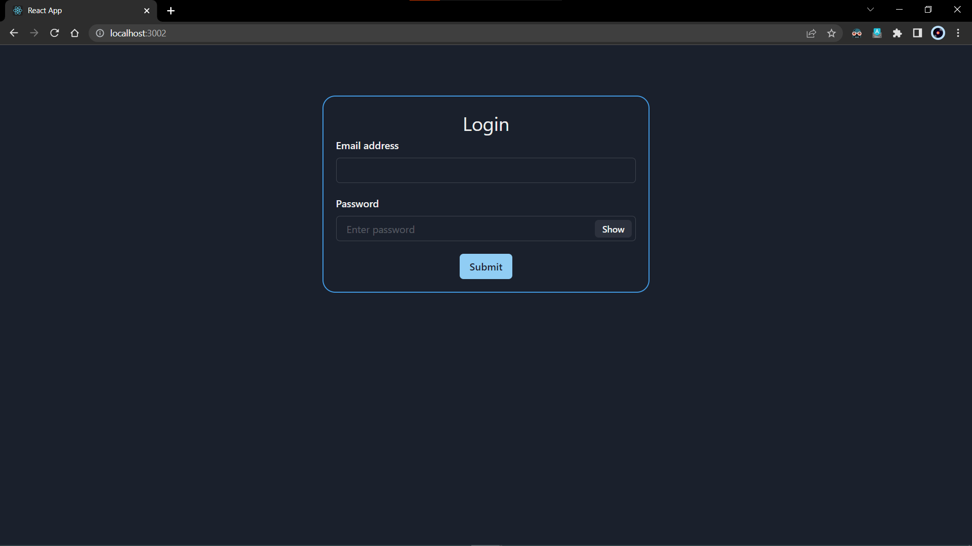

1. This screenshot demonstrates the first page of the website. It is a login page that has two labels and two text boxes for Email and Password respectively.

The password field has a hide and show button which is managed using state.

The final component of this page is a submit button which is routed to the dashboard using react-router-dom.

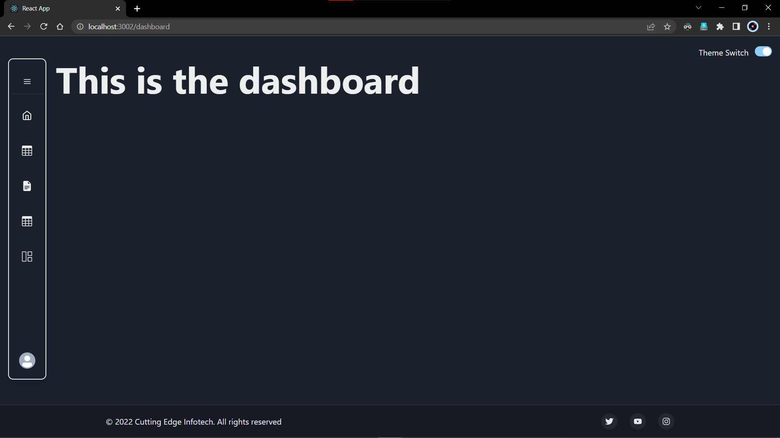

1. From the login page, the user is treated with the dashboard.

This page mainly exists to route all the other pages with ‘/dashboard’ preceding their own respective routes. It has a navbar component which when turned into a mobile view, turns into a hamburger menu for the responsiveness of the website.

The above is the dark-themed version of the website.

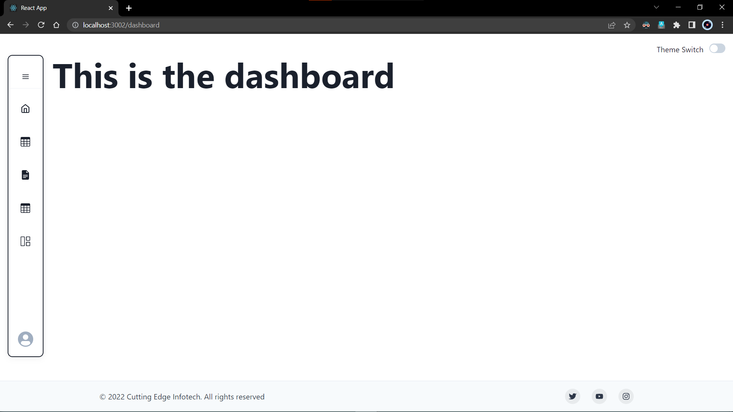

1. From the login page, the user is treated with the dashboard.

This page mainly exists to route all the other pages with ‘/dashboard’ preceding their own respective routes. It has a navbar component which when turned into a mobile view, turns to a hamburger menu for the responsiveness of the website.

The above is the light-themed version of the website**.**

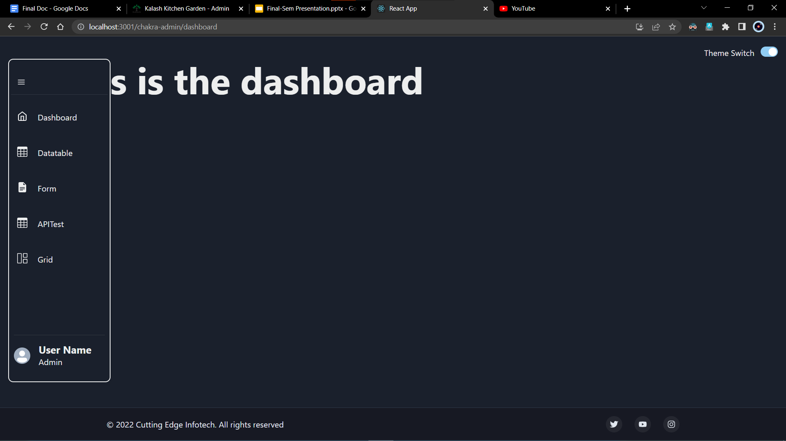

1. This is how the Side Navigation bar looks when expanded.

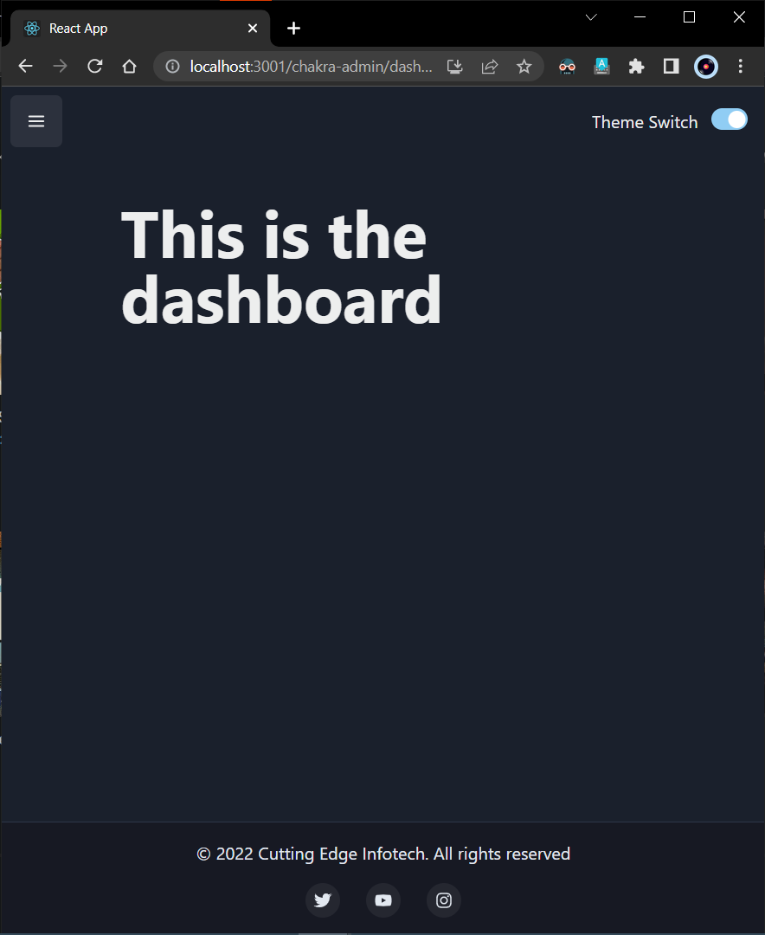

1. Responsiveness of the website. Sidebar turns to a hamburger menu.

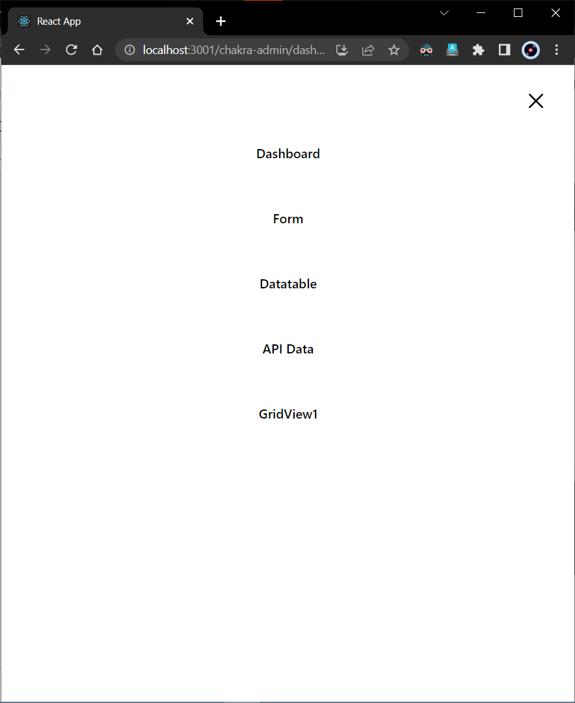

1. When the hamburger menu is clicked, a list of all pages is displayed.

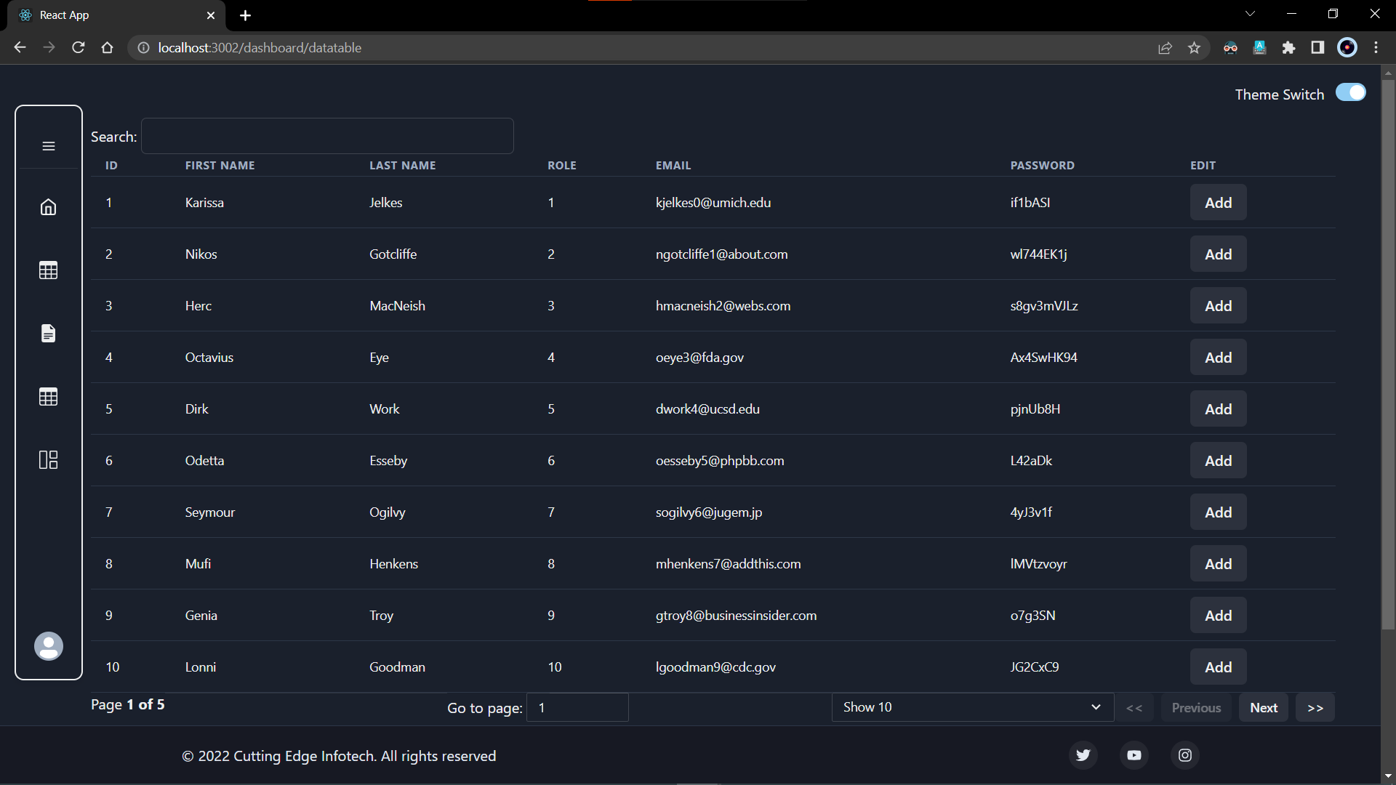

1. From the side navigation tab, the first route takes the user to a data table with all the functionalities that are required in a data table of any admin panel website.

Those include pagination, filtering, searching, sorting according to the column, the number of entries shown on a page, skipping to the page, etc.

All the visible data is mapped from a static mock JSON file.

The above is the dark-themed version of the website.

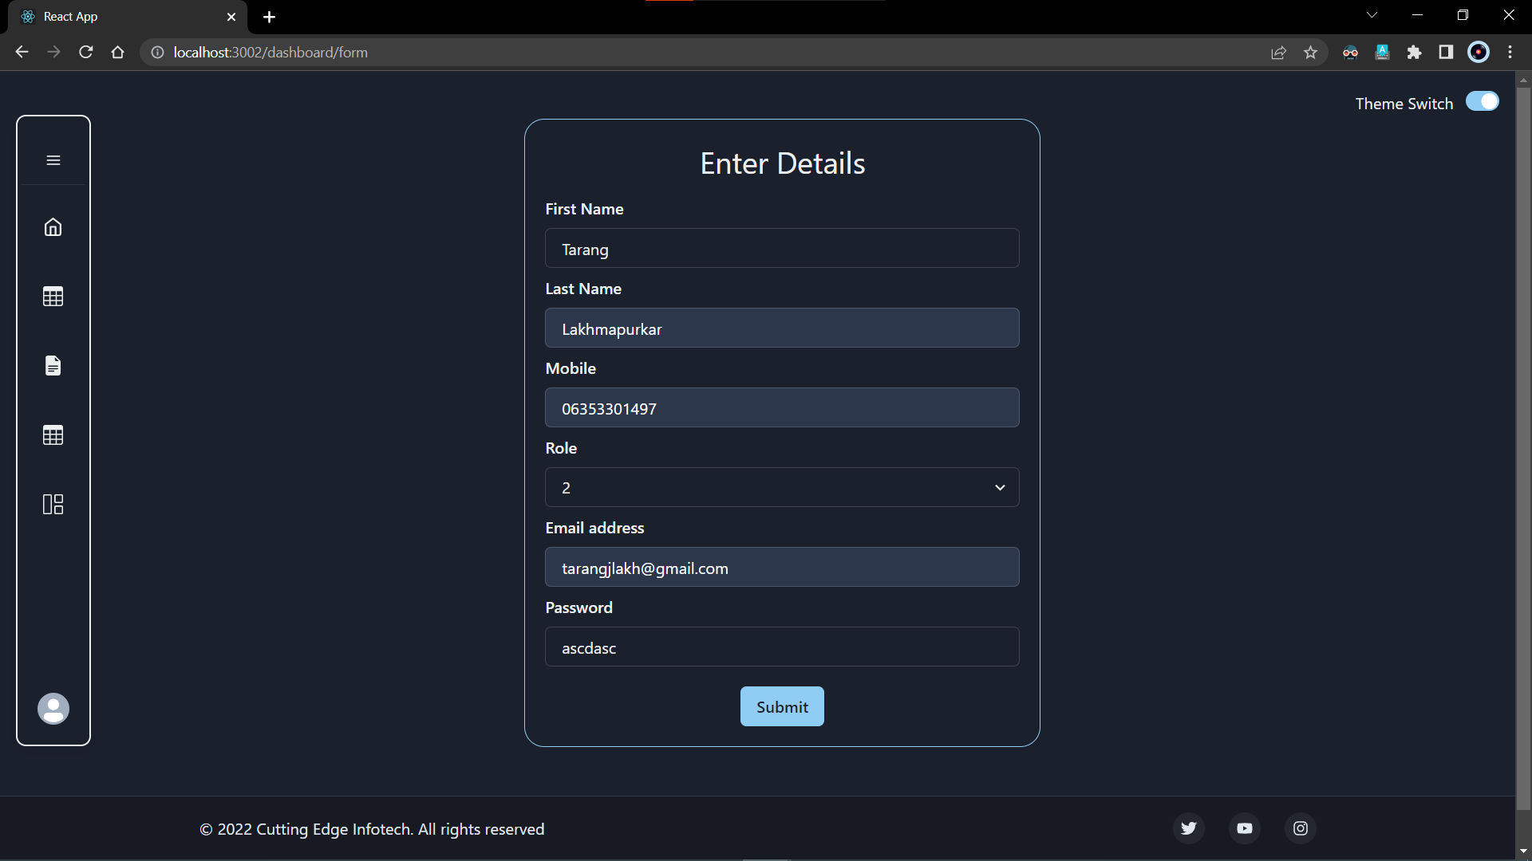

1. The next page consists of a form component with fields of first name, last name, mobile number, role, email address, and password.

It was a learning experience with react forms and implementing those accordingly.

Though the above-given form was just a static form, it gave an idea of how the layout on a website is done.

The above is the dark-themed version of the website.

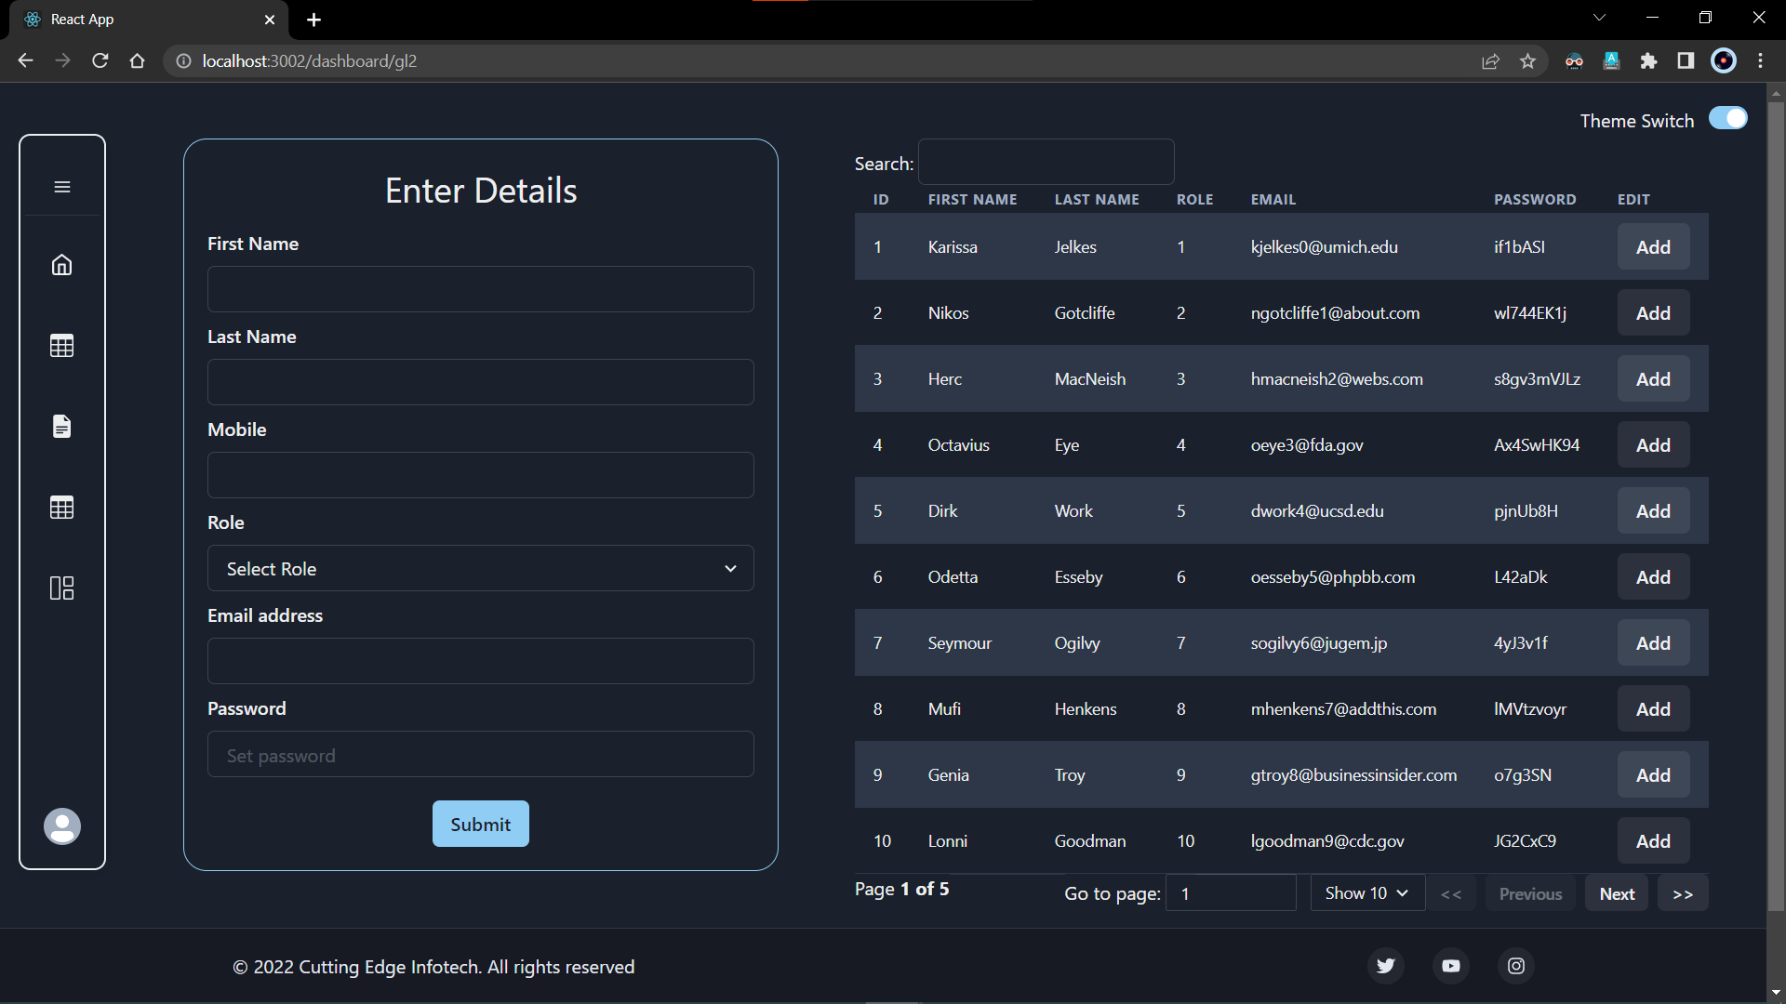

1. The final page consists of a page wherein both, a form and a data table has to be displayed. The main objective of this type of layout is to make it easier for the user to add or edit the records while being on the same page.

For responsiveness of the website, the form is placed on top followed by the data table in the mobile view.

The above is the dark-themed version of the website.

* + 1. Assignment: 2 (Demo Admin Panel using ReactJS and React-Bootstrap)

When I started this internship the first task given to me was to make an admin panel in ReactJS using whichever the Bootstrap library to make the website more responsive.

As majorly of the projects developed in the company are developed upon Angular and AngularJS, a basic ReactJS admin panel would be an appropriate project that could be given to an intern before assigning a live project.

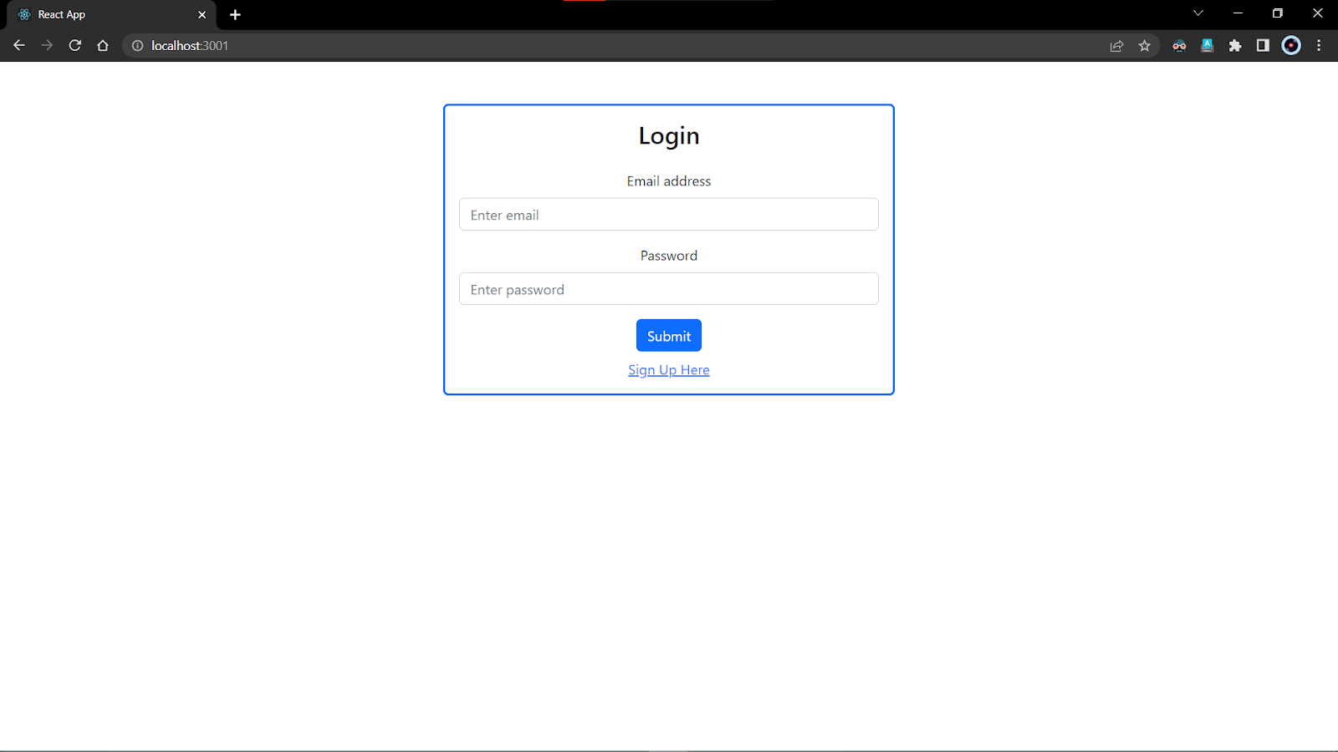

1. This screenshot demonstrates the first page of the website. It is a login page that has two labels and two text boxes for Email and Password respectively.

The final component of this page is a submit button which is routed to the dashboard using react-router-dom.

The Signup link below the submit button redirects the user to the Register page.

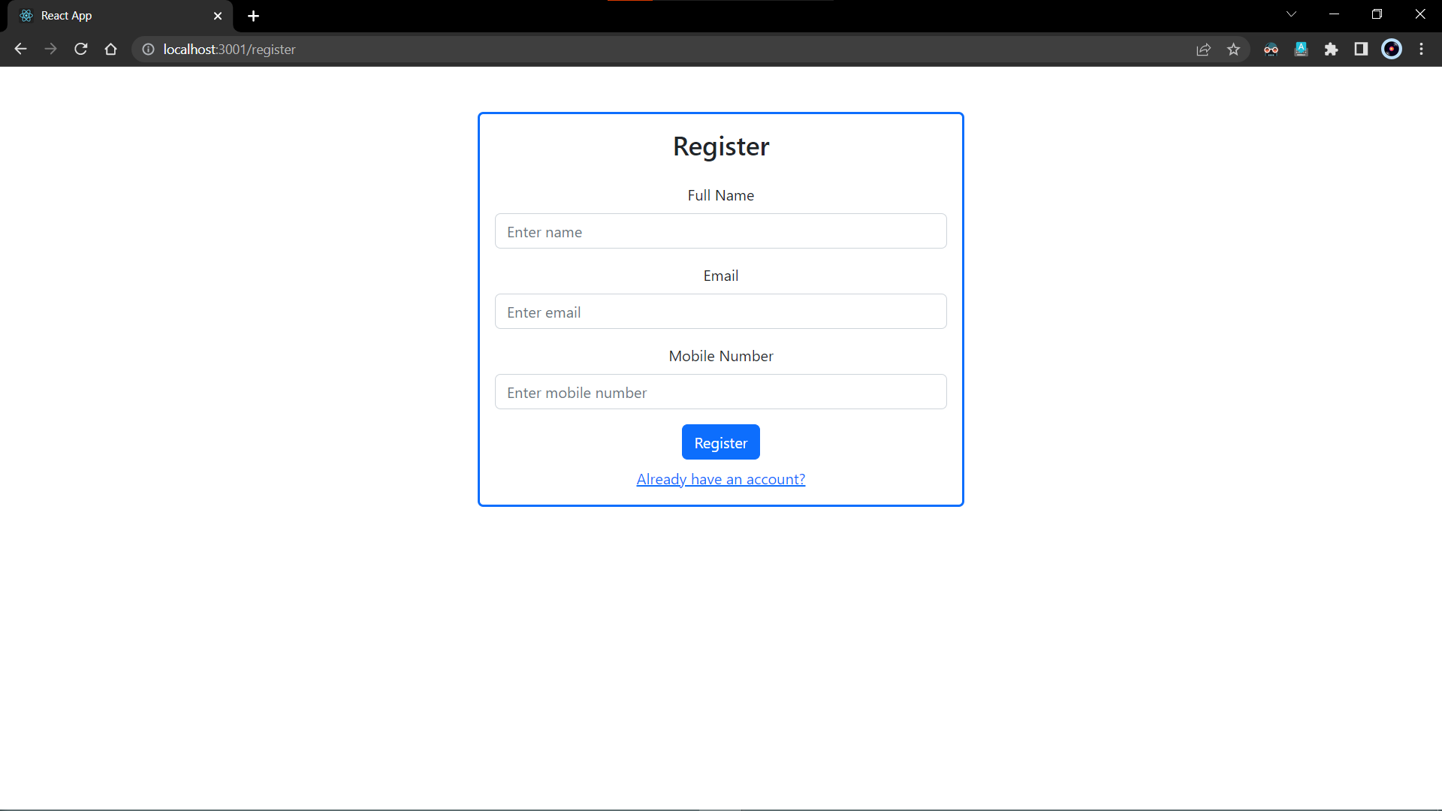

1. This screenshot demonstrates the Register Page.

It consists of labels and text boxes for full name, email, and mobile number.

The form component has a Register button in the end which redirects the user to the password page.

When clicking on the link given below the button, it redirects the user to the Login page again.

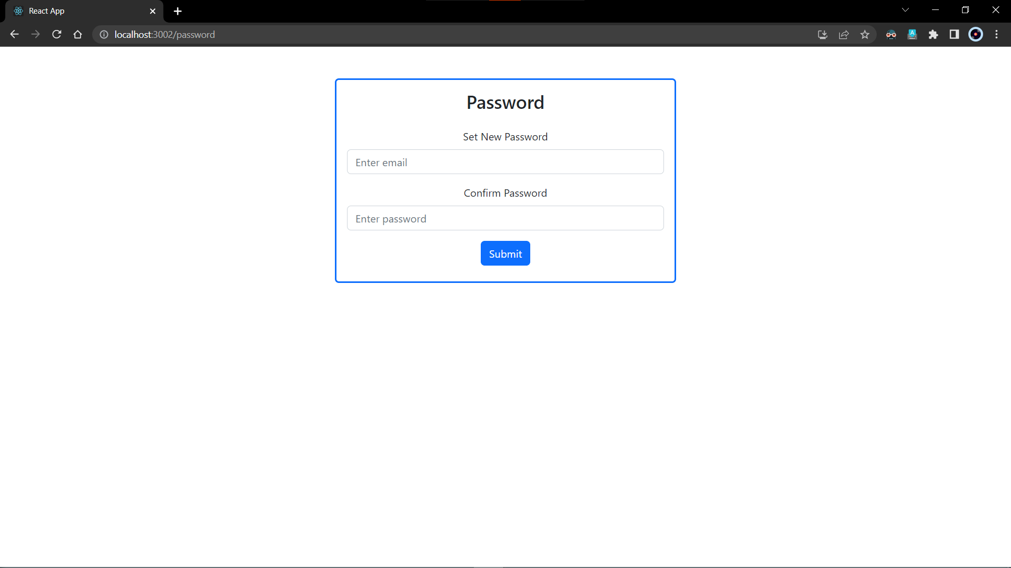

1. This screenshot demonstrates the set new password page.

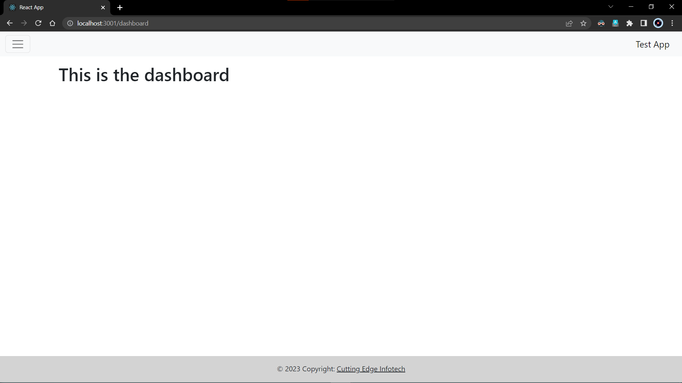

1. From the login page, the user is treated with the dashboard.

This page mainly exists to route all the other pages with ‘/dashboard’ preceding their own respective routes. It has a hidden side nav integrated in the header as a hamburger menu. By default it is hidden but when clicked upon, it appears on the page.

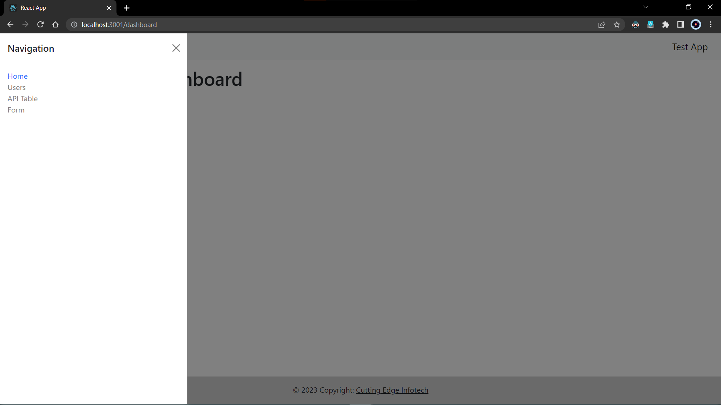

1. This is how the side navigation unhides and the user is presented with all the pages routed with their respective routes.

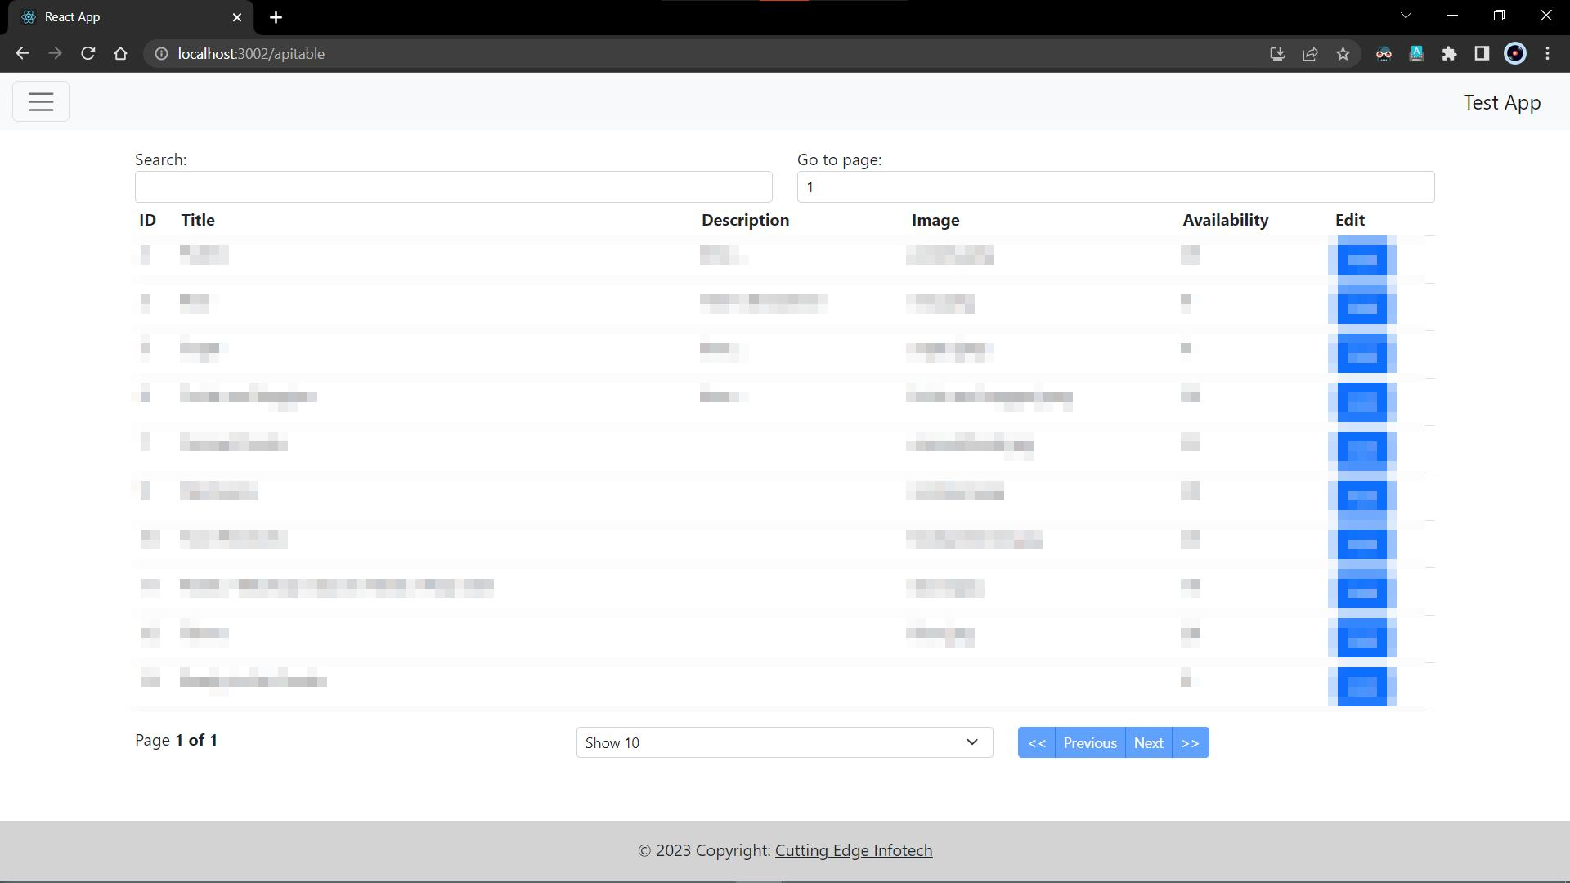

1. This screenshot demonstrates a data table which gets its data from an API.

The API provided comes from the server to which we just have to make a get request and map the JSON data that comes as a response.

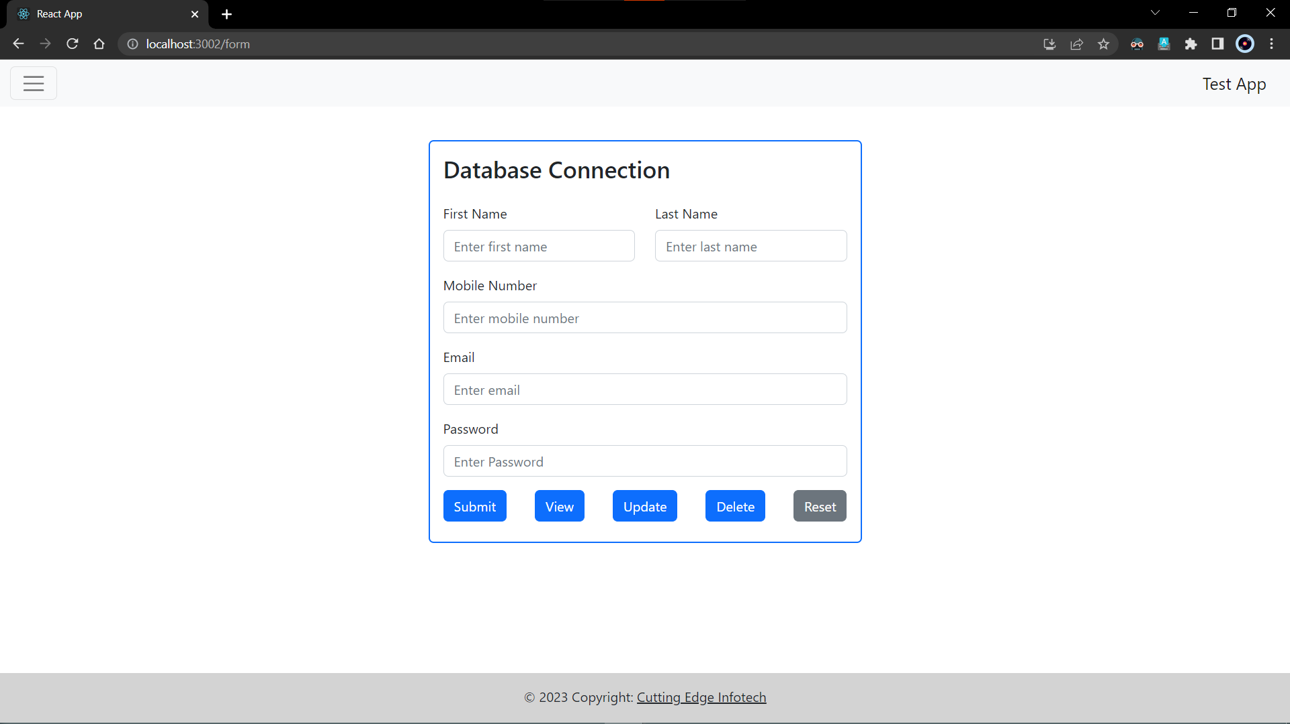

1. This screenshot demonstrates the Register Page.

It consists of labels and text boxes for full name, email, and mobile number.

The form component has a Register button in the end which redirects the user to the password page.

When clicking on the link given below the button, it redirects the user to the Login page again.

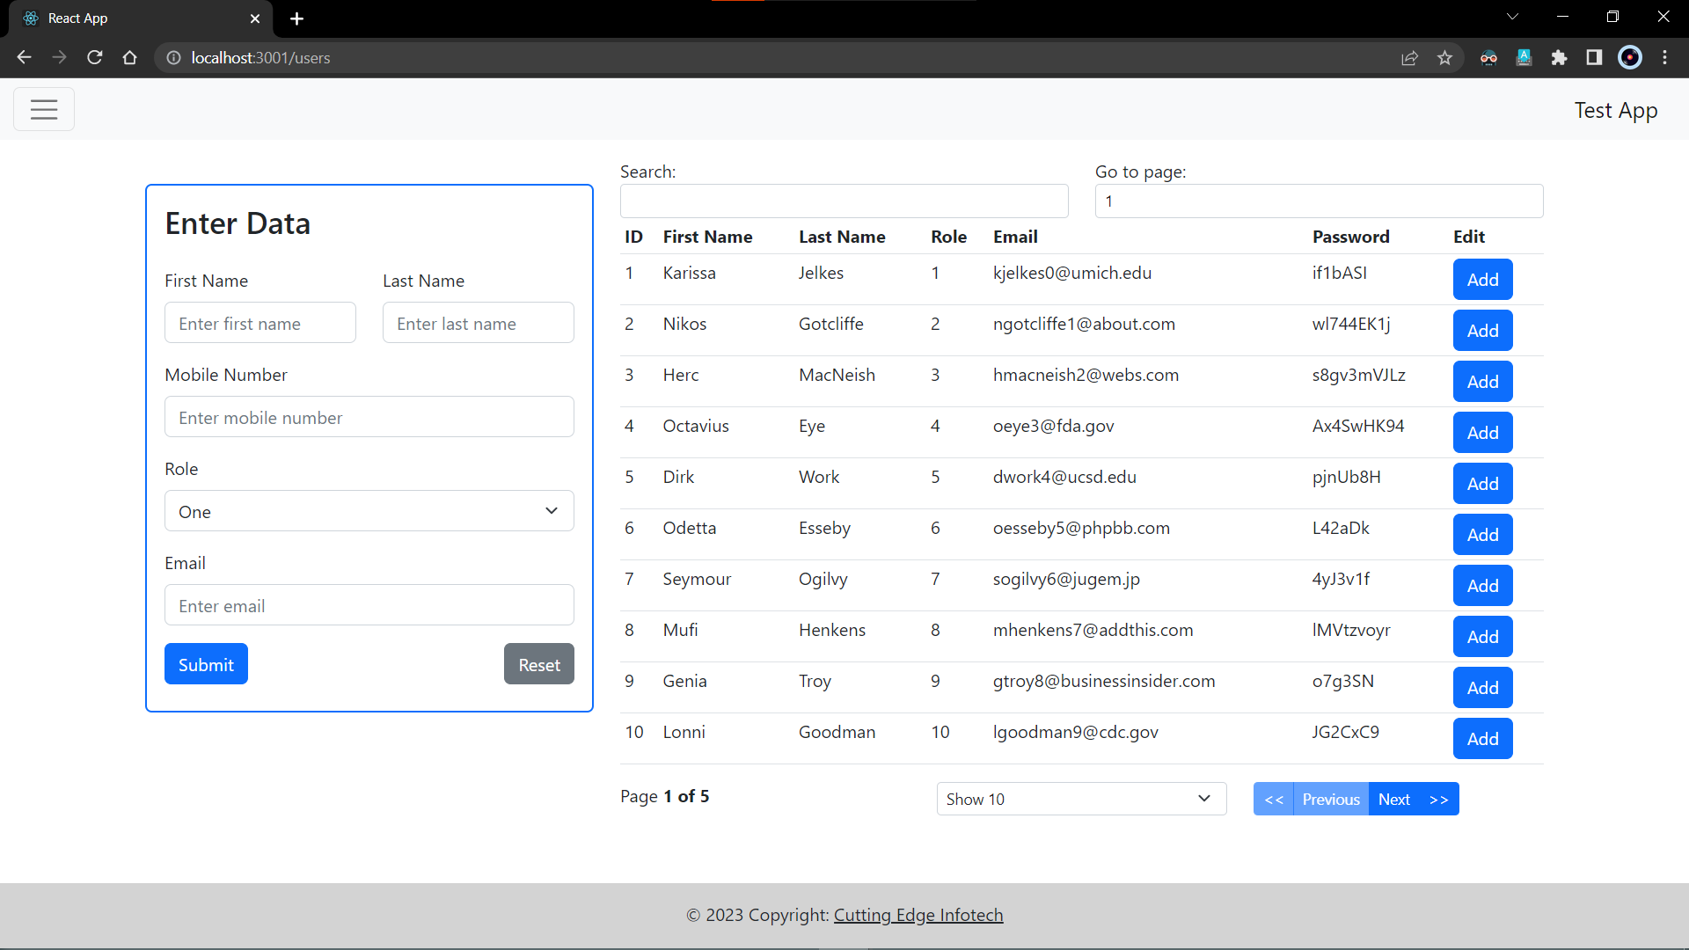

1. The final page consists of a page wherein both, a form and a data table have to be displayed. The main objective of this type of layout is to make it easier for the user to add or edit the records while being on the same page.

For responsiveness of the website, the form is placed on top followed by the data table in the mobile view.

The following image demonstrates the same.

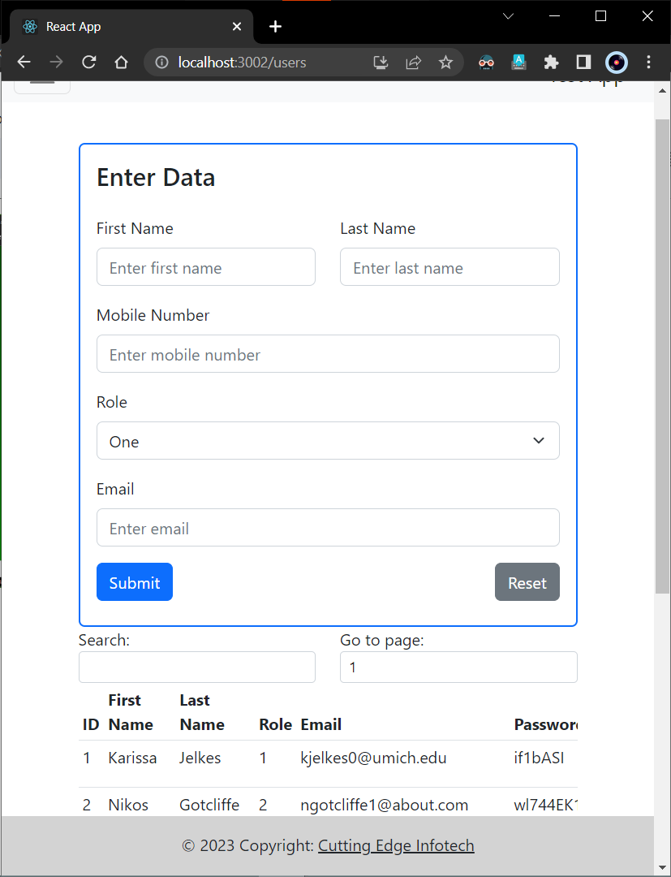

* + 1. Assignment: 3 **[Live Project]** (Kalash-Seeds Admin Panel)

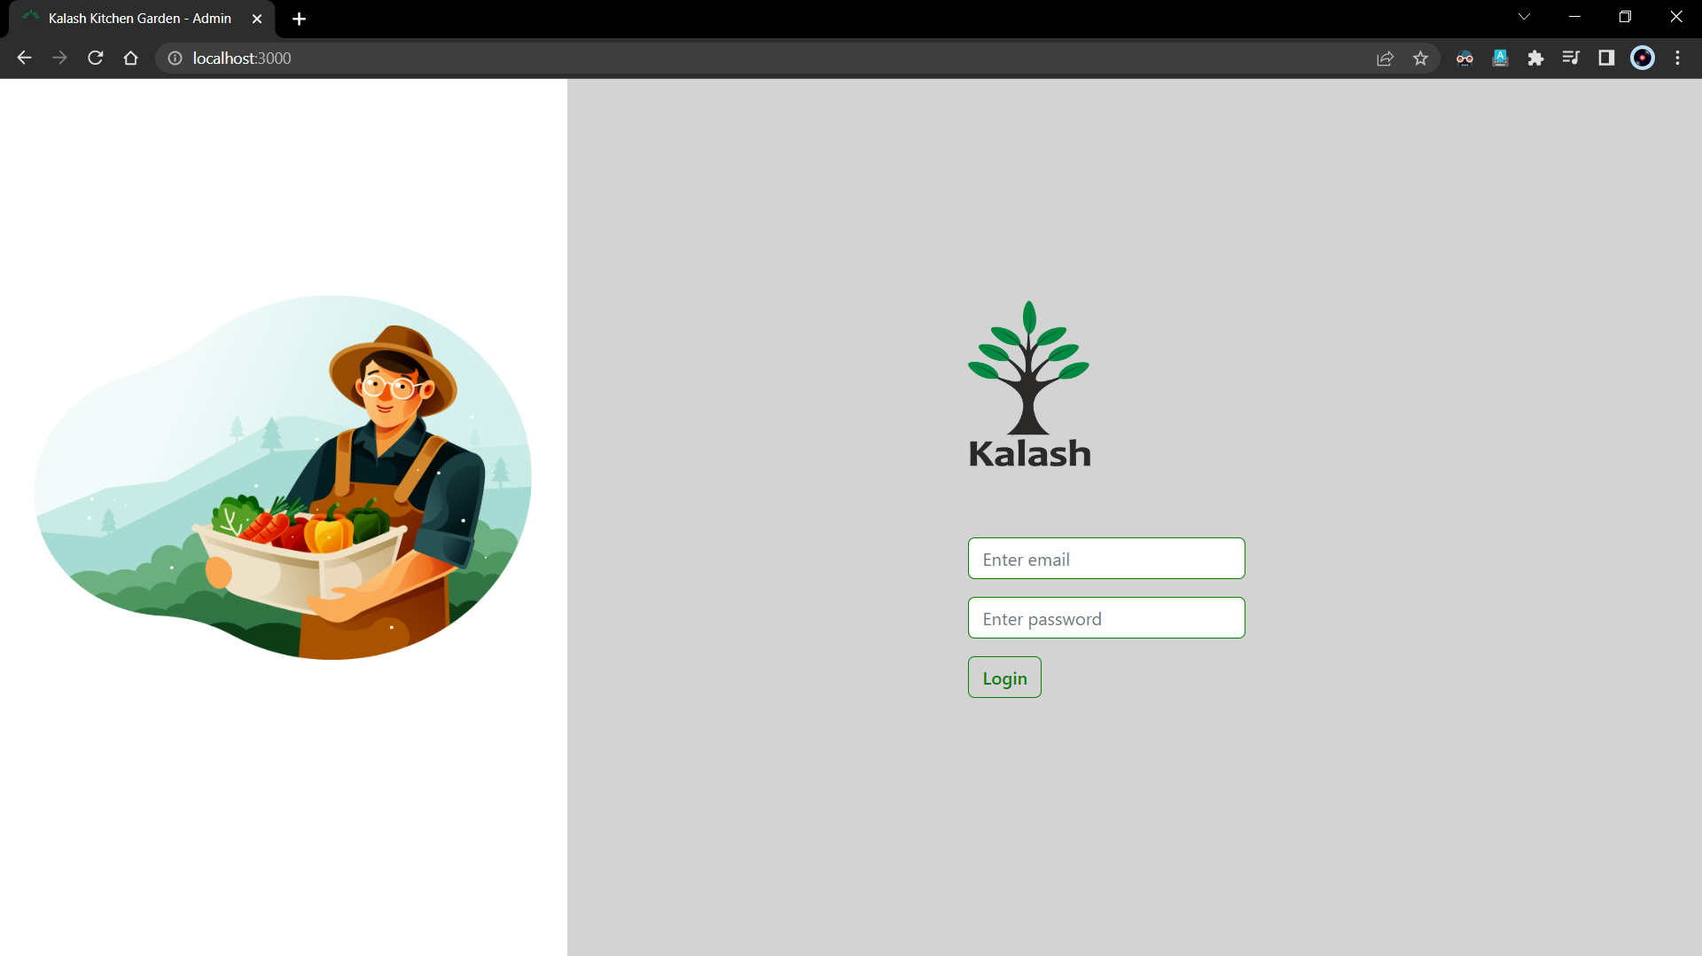

1. This is the live project that was assigned to me on January 6th.

The project requires creating an admin panel for an online business website which deals in selling plants, seeds, fruit and vegetable saplings, etc.

The admin panel treats the user with the login page given above which requires the user to log in with the given credentials.

The verification and validation is based on JWT authentication which is provided from the backend.

All the other APIs require the token in the header to access the data from the server.

When logged in, the user is treated with a toast message. as shown below.

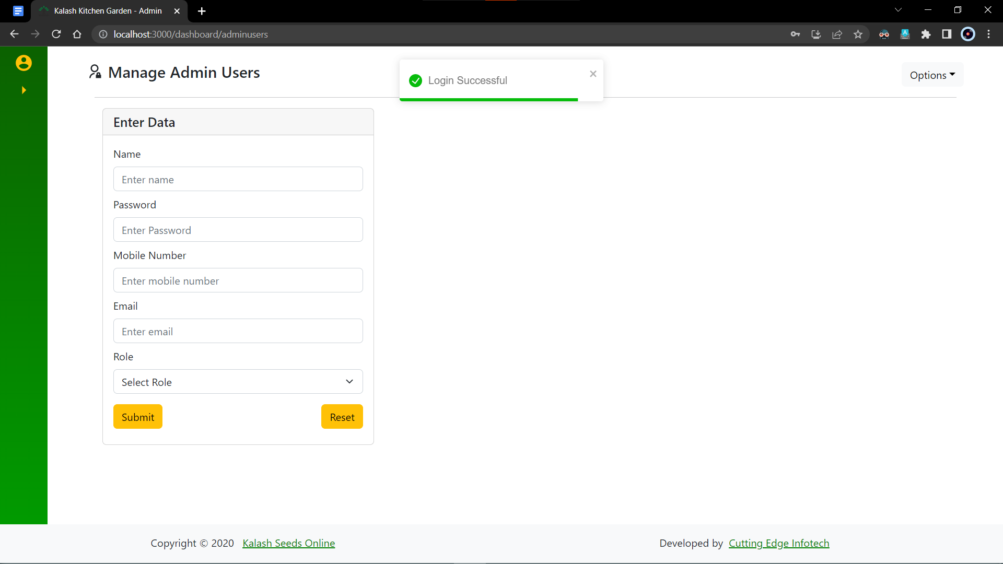

1. The above image demonstrates the working of the toast message.

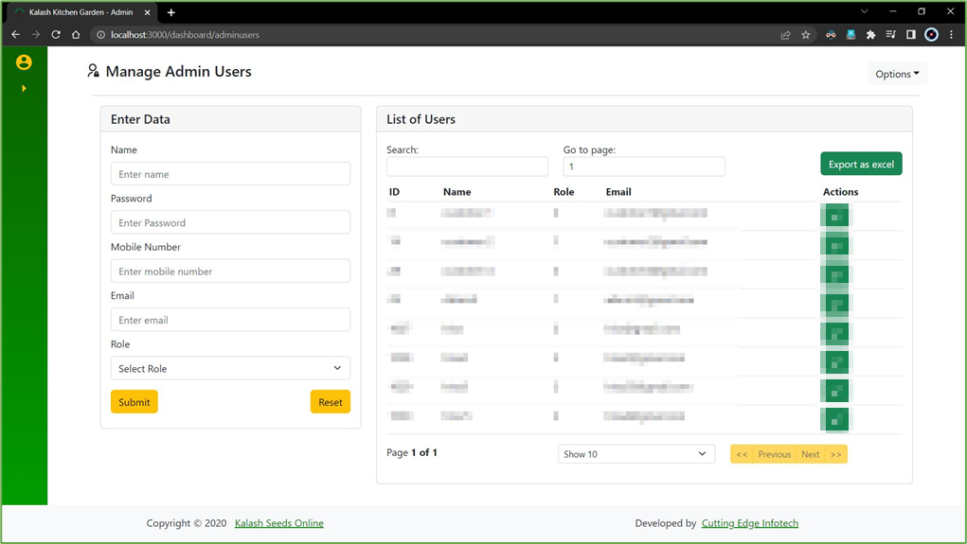

1. The following image consists of a form and a datatable which is created using the library react-table.

This page is intended to manage the admin user’s data from within the website.

The form has all the necessary fields required to add new admin users and all the current admin users are visible in the datatable next to it.

The action column includes the buttons for editing or deleting any users.

Edit button loads the row data according to the id in the form and it can be edited and updated from there itself.

Delete button will give the user a prompt asking if the user wants to delete it and if they click “Yes”, a toast message will be displayed for the same.

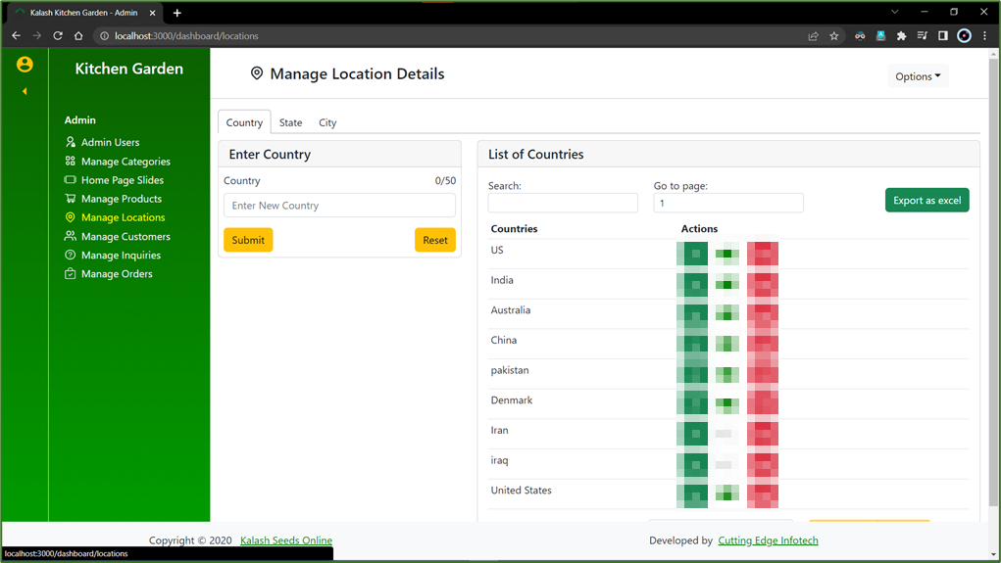

1. The following image consists of a form and a datatable which is created using the library react-table.

This page is intended to manage the location data from within the website.

The locations page is divided into 3 sections namely, Country, State and City.

The above image represents the Country.

The library react-tabs is used to manage the views.

The form has all the necessary fields required to add new countries and all the current countries are visible in the datatable next to it.

The action column includes the buttons for editing, deleting and enabling or disabling any countries.

Edit button loads the row data according to the id in the form and it can be edited and updated from there itself.

Delete button will give the user a prompt asking if the user wants to delete it and if they click “Yes”, a toast message will be displayed for the same.

The enable and disable button is represented by a switch icon which changes state based on the status of the country.

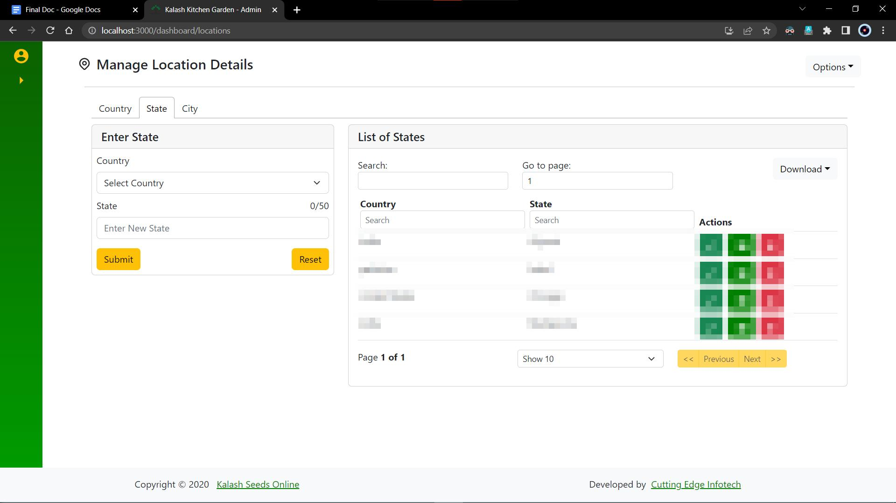

1. The following image consists of a form and a datatable which is created using the library react-table.

This page is intended to manage the location data from within the website.

The locations page is divided into 3 sections namely, Country, State and City.

The above image represents the State.

The library react-tabs is used to manage the views.

The form has all the necessary fields required to add new states and all the current states are visible in the datatable next to it.

The action column includes the buttons for editing, deleting and enabling or disabling any states.

Edit button loads the row data according to the id in the form and it can be edited and updated from there itself.

Delete button will give the user a prompt asking if the user wants to delete it and if they click “Yes”, a toast message will be displayed for the same.

The enable and disable button is represented by a switch icon which changes the react-state based on the status of the state.

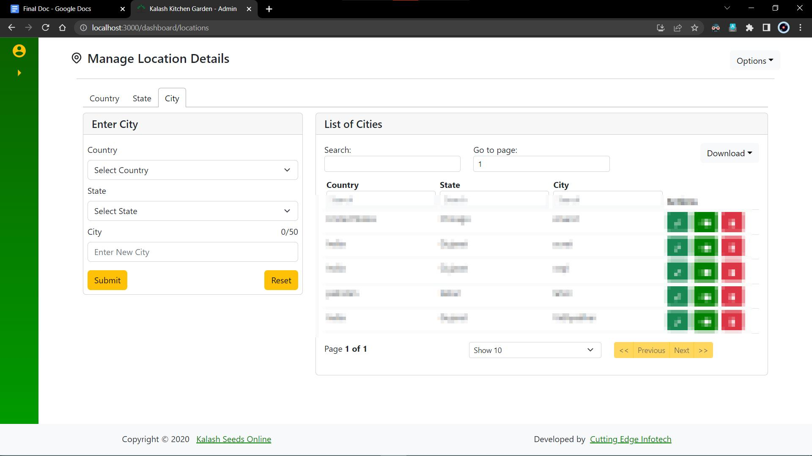

1. The following image consists of a form and a datatable which is created using the library react-table.

This page is intended to manage the location data from within the website.

The locations page is divided into 3 sections namely, Country, State and City.

The above image represents the City.

The library react-tabs is used to manage the views.

The form has all the necessary fields required to add new cities and all the current cities are visible in the datatable next to it.

The action column includes the buttons for editing, deleting and enabling or disabling any cities.

Edit button loads the row data according to the id in the form and it can be edited and updated from there itself.

Delete button will give the user a prompt asking if the user wants to delete it and if they click “Yes”, a toast message will be displayed for the same.

The enable and disable button is represented by a switch icon which changes state based on the status of the city.

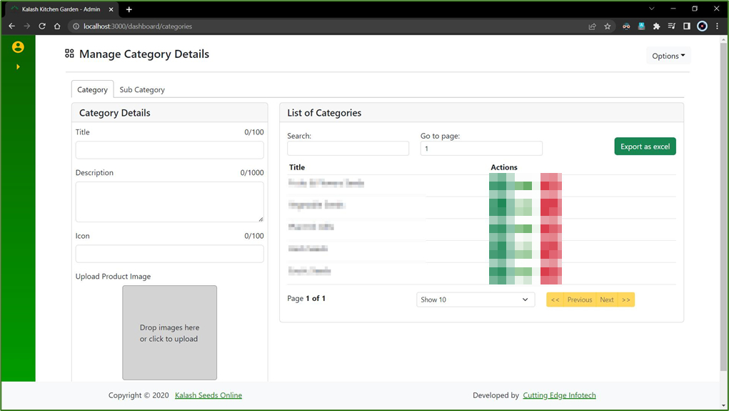

1. The following image consists of a form and a datatable which is created using the library react-table.

This page is intended to manage the categories and sub-categories of agro-products data from within the website.

The locations page is divided into 2 sections namely, Categories and Subcategories.

The above image represents the Categories.

The library react-tabs is used to manage the views.

The form has all the necessary fields required to add new Categories with image references and all the current categories are visible in the datatable next to it.

The action column includes the buttons for editing, deleting and enabling or disabling any categories.

Edit button loads the row data according to the id in the form and it can be edited and updated from there itself.

Delete button will give the user a prompt asking if the user wants to delete it and if they click “Yes”, a toast message will be displayed for the same.

The enable and disable button is represented by a switch icon which changes state based on the status of the category.

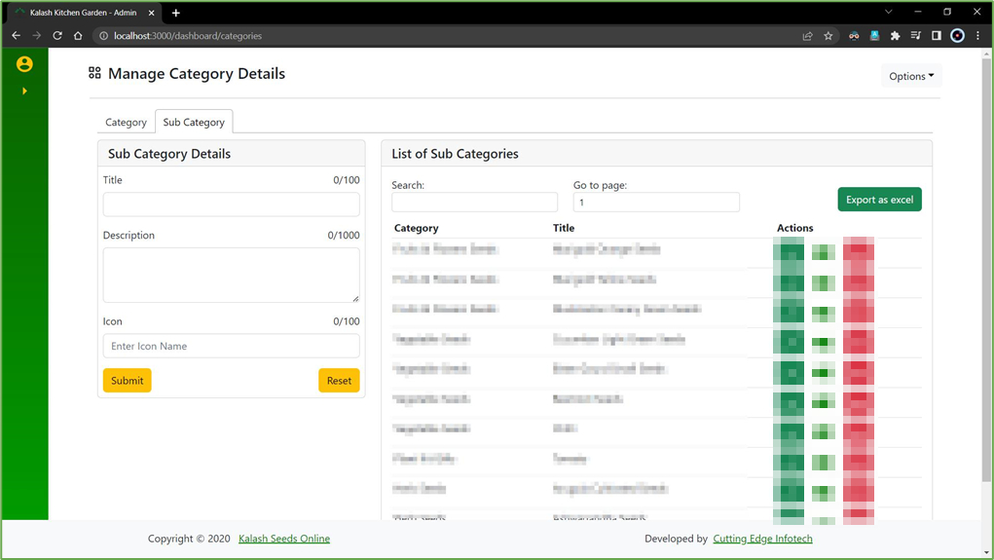

1. The following image consists of a form and a datatable which is created using the library react-table.

This page is intended to manage the categories and sub-categories of agro-products data from within the website.

The locations page is divided into 2 sections namely, Categories and Subcategories.

The above image represents the Sub-Categories.

The library react-tabs is used to manage the views.

The form has all the necessary fields required to add new Sub-Categories and all the current categories are visible in the datatable next to it.

The action column includes the buttons for editing, deleting and enabling or disabling any sub-categories.

Edit button loads the row data according to the id in the form and it can be edited and updated from there itself.

Delete button will give the user a prompt asking if the user wants to delete it and if they click “Yes”, a toast message will be displayed for the same.

The enable and disable button is represented by a switch icon which changes state based on the status of the sub-category.

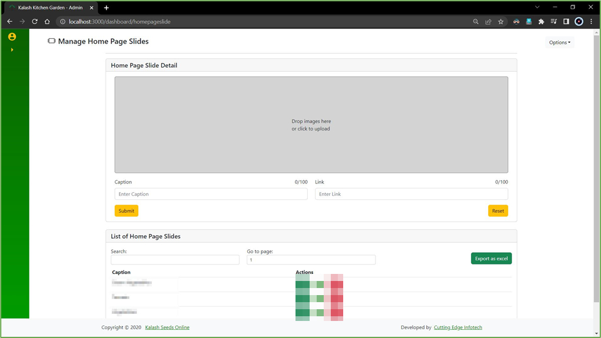

1. The following image consists of a form and a datatable which is created using the library react-table.

This page is intended to manage the data of the slides visible on the homepage of the website.

The form has all the necessary fields required to add new Slides with image references and all the current slides are visible in the datatable below it.

The action column includes the buttons for editing, deleting and enabling or disabling any categories.

Edit button loads the row data according to the id in the form and it can be edited and updated from there itself.

Delete button will give the user a prompt asking if the user wants to delete it and if they click “Yes”, a toast message will be displayed for the same.

The enable and disable button is represented by a switch icon which changes state based on the status of the category.

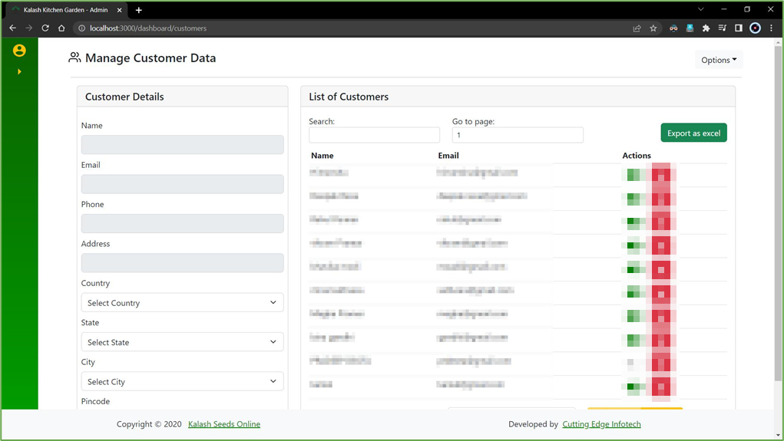

1. The following image consists of a form and a datatable which is created using the library react-table.

This page is intended to manage the customer data from within the website.

The form has all the necessary fields required to edit the existing data and all the current customers are visible in the datatable next to it.

The action column includes the buttons for editing, deleting and enabling or disabling any customers.

Edit button loads the row data according to the id in the form and it can be edited and updated from there itself.

Delete button will give the user a prompt asking if the user wants to delete it and if they click “Yes”, a toast message will be displayed for the same.

The enable and disable button is represented by a switch icon which changes state based on the status of the customer.

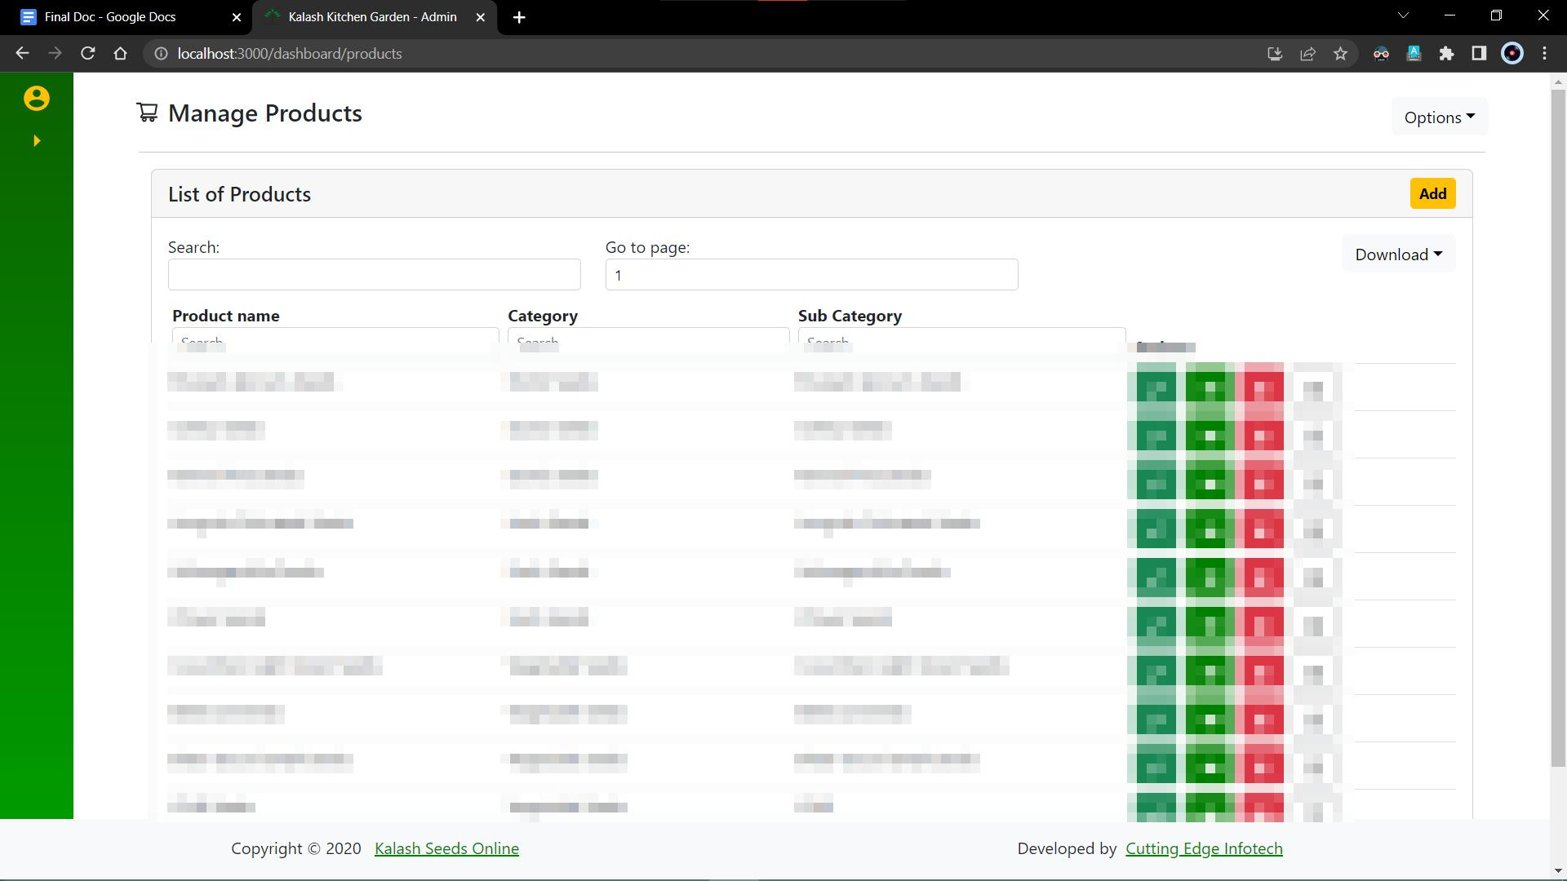

1. The following image consists of a datatable and two other views which are hidden by default.

This page is intended to manage the products data from within the website.

The datatable consists of all the products available with all the necessary details for the same.

There is an add button on top of the table which redirects the user to a form for adding a new product or editing an existing one.

The action column includes the buttons for editing, deleting and enabling or disabling as well as to check other variations of the product.

Edit button loads the row data according to the id in the form and it can be edited and updated from there itself.

Delete button will give the user a prompt asking if the user wants to delete it and if they click “Yes”, a toast message will be displayed for the same.

The enable and disable button is represented by a switch icon which changes state based on the status of the category.

The last button is for managing the variations of the product.

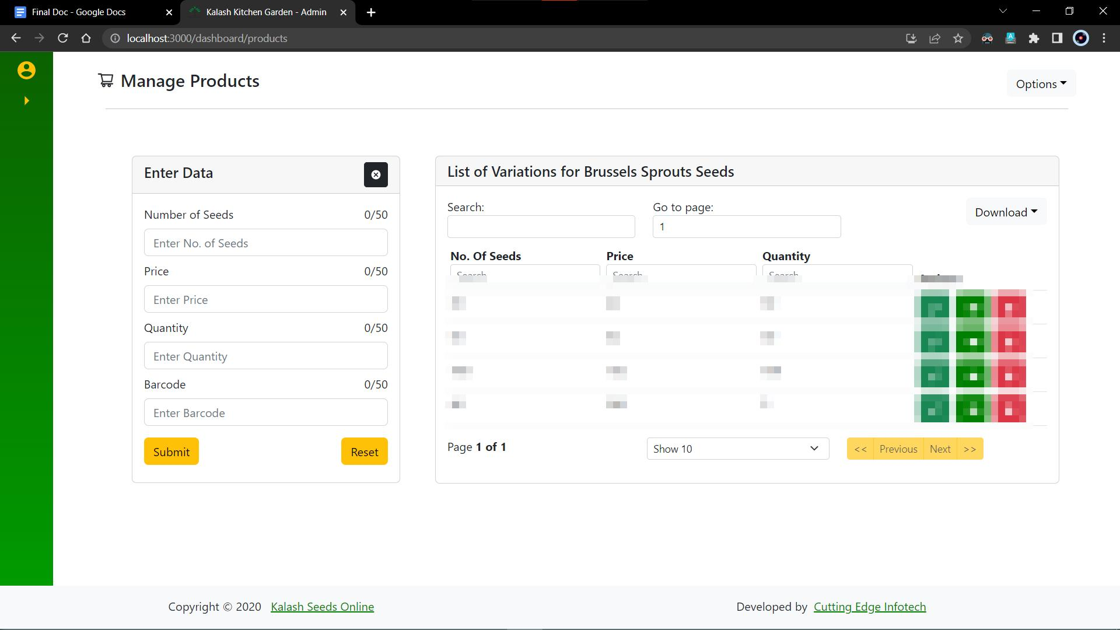

1. The following image consists of a form and a datatable which is created using the library react-table.

This page is intended to manage the variations of the products data from within the website.

The form has all the necessary fields required to add new Categories with image references and all the current categories are visible in the datatable next to it.

The action column includes the buttons for editing, deleting, and enabling or disabling any variations.

Edit button loads the row data according to the id in the form and it can be edited and updated from there itself.

Delete button will give the user a prompt asking if the user wants to delete it and if they click “Yes”, a toast message will be displayed for the same.

The enable and disable button is represented by a switch icon which changes state based on the status of the variation.

The form has a close button which will take back the user to the Manage Products page.

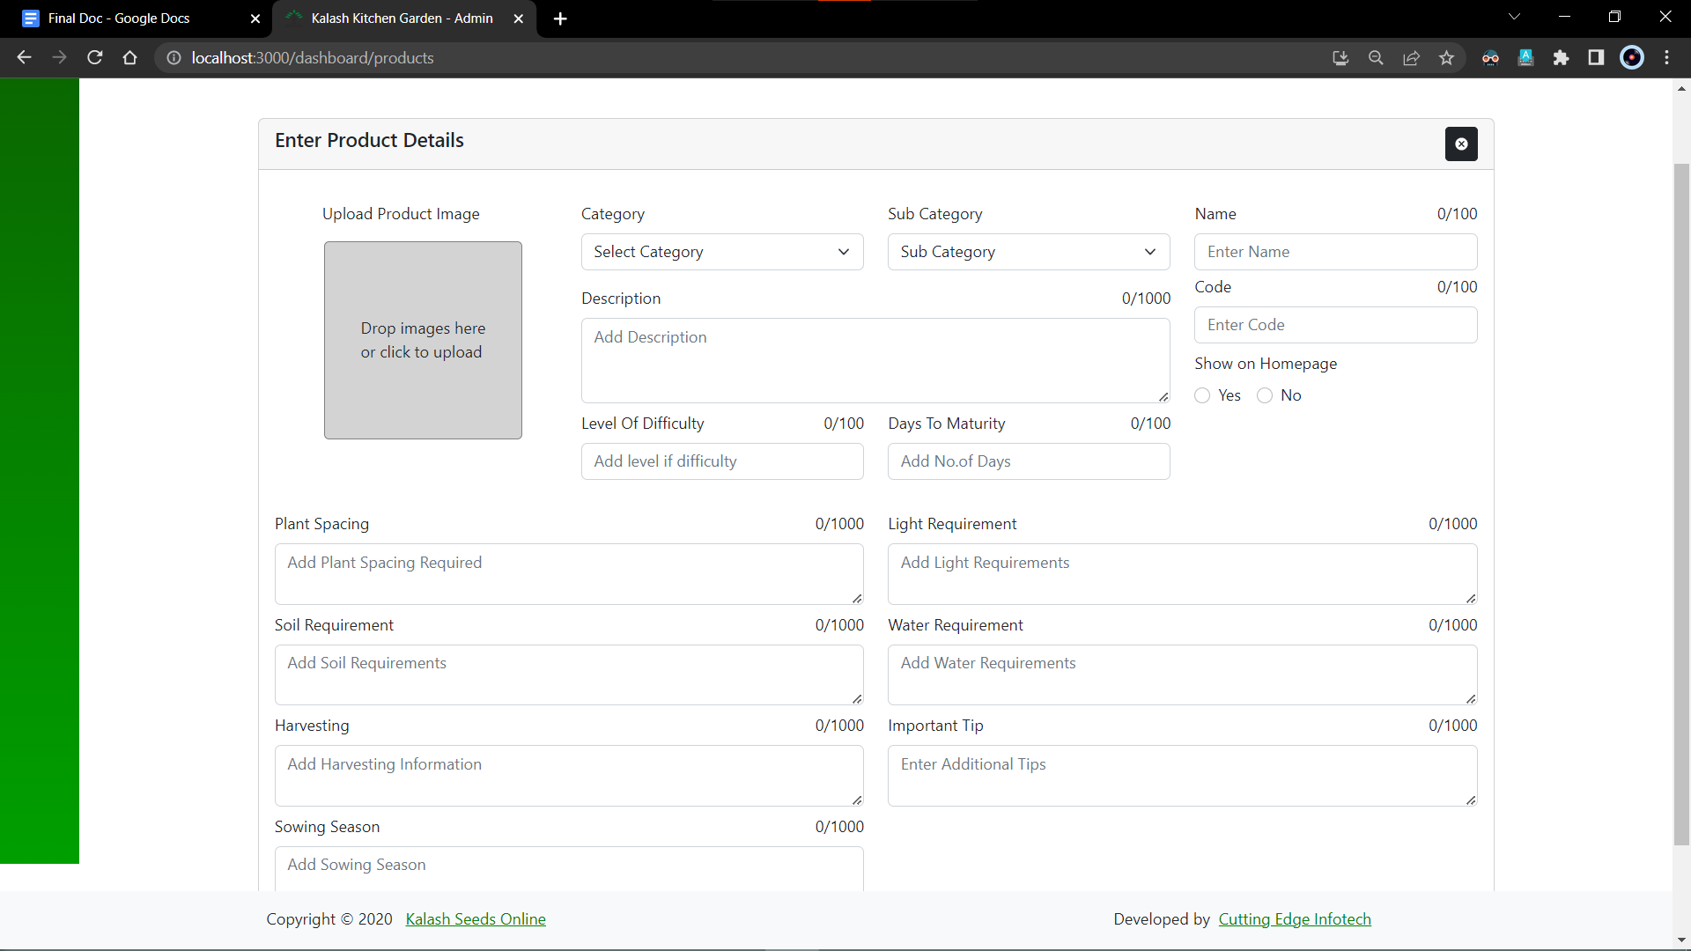

1. The above image consists of a form to edit or add new products.

The form has all the necessary fields required to add new Products with image references.

The form has a close button which will take back the user to the Manage Products page.

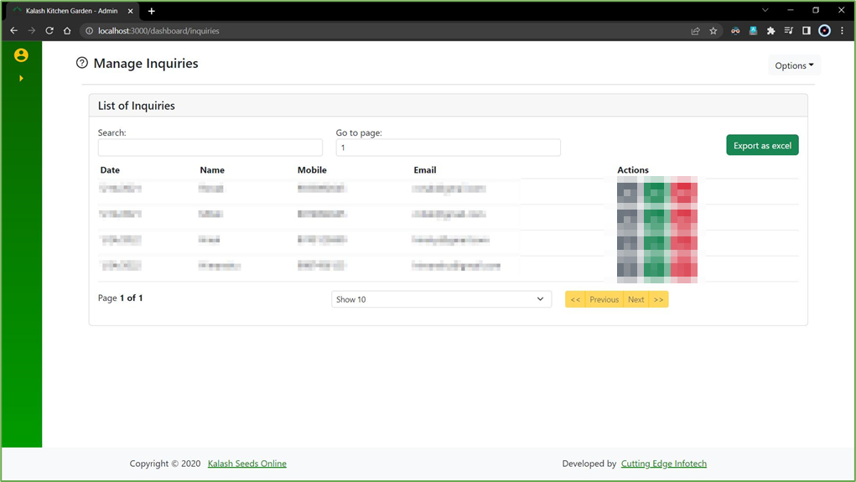

1. The following image consists of a datatable that is created using the library react-table.

This page is intended to manage the inquiries done by customers from within the website.

The action column includes the buttons for viewing details, marking the inquiry as read, and deleting any inquiries.

View details button takes the user to another view that has all the details of the inquiry that the customer has made.

The Mark as Read button represents the state of the query. If the query is resolved, it is marked as read.

Delete button will give the user a prompt asking if the user wants to delete it and if they click “Yes”, a toast message will be displayed for the same.

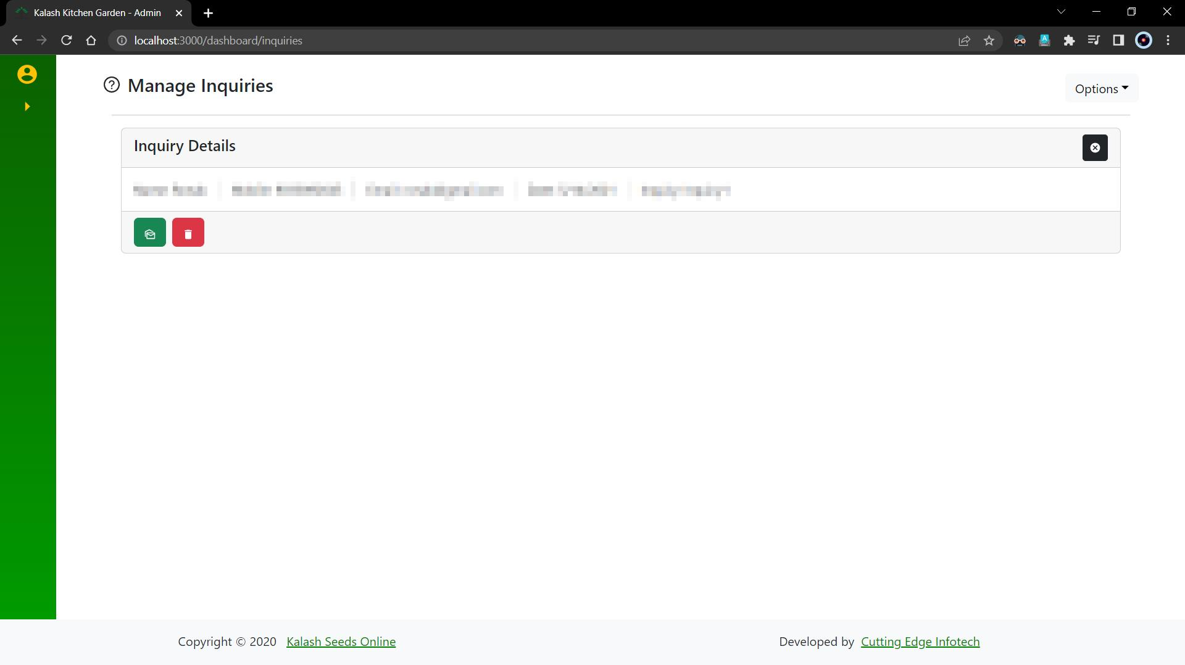

1. This is the details page of the inquiry.

The tab has a close button that will take back the user to the Manage Products page.

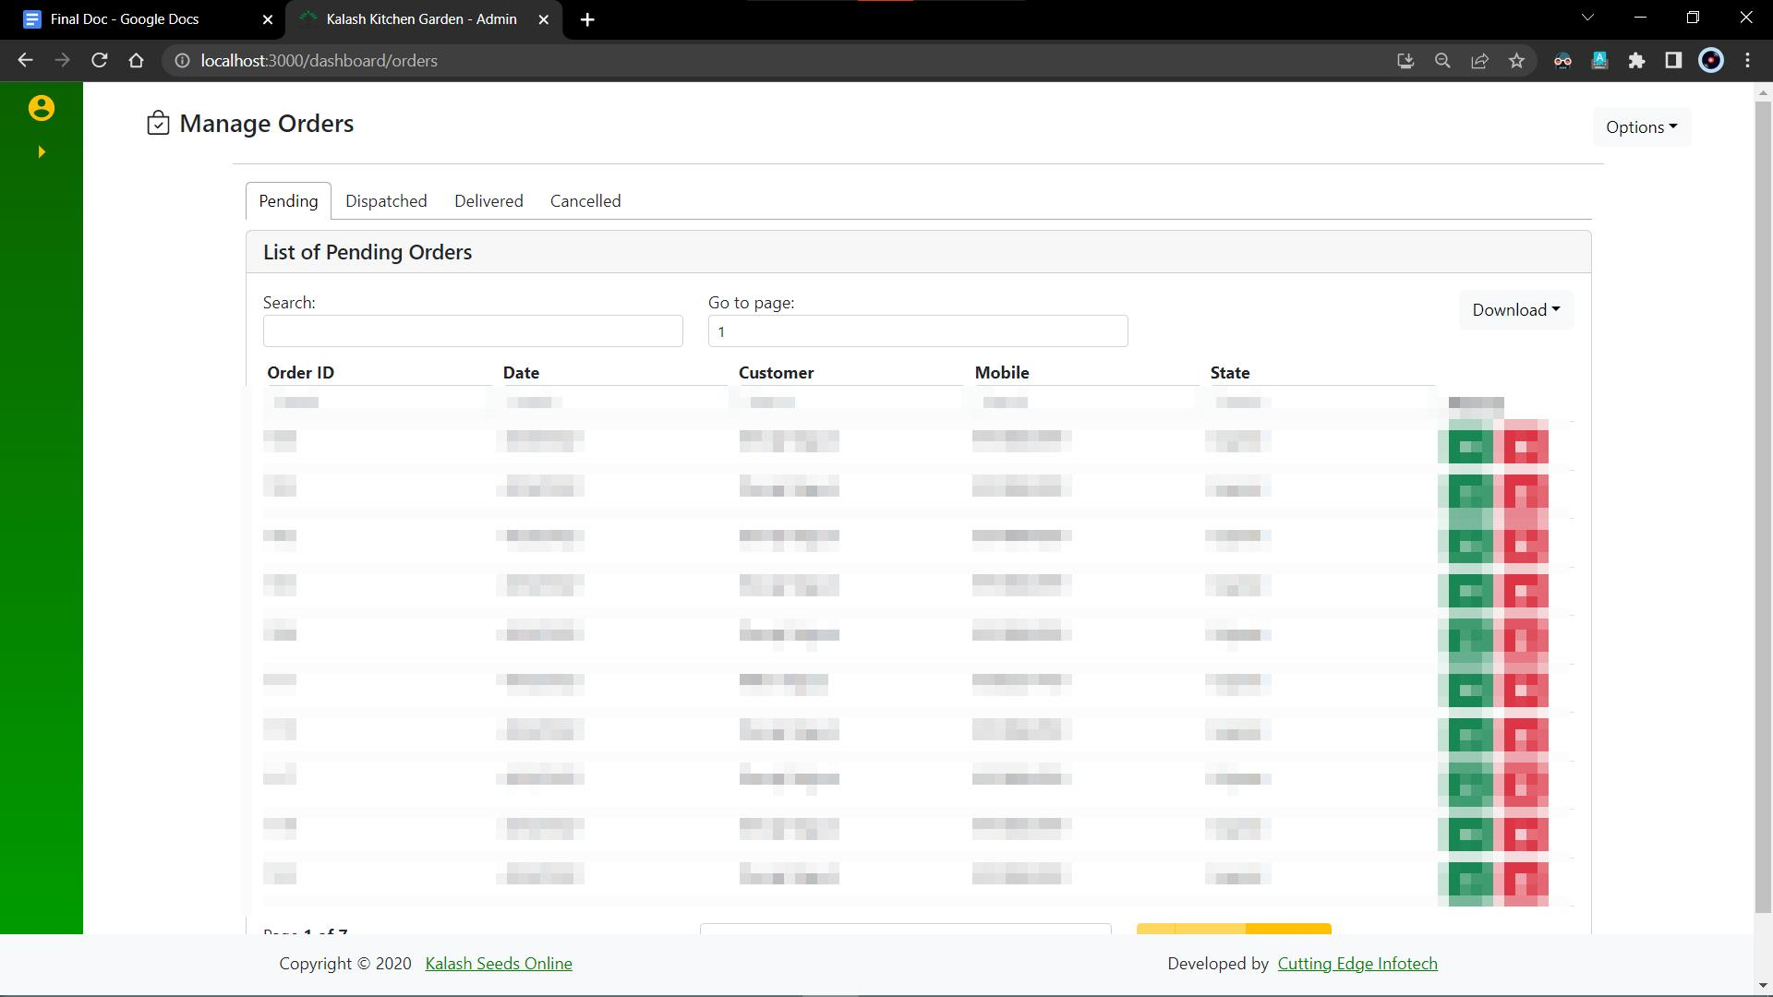

1. The following image consists of a datatable which is created using the library react-table.

This page is intended to manage the orders data from within the website.

The locations page is divided into 4 sections namely, Pending Orders, Dispatched Orders, Delivered Orders, and Canceled Orders.

The above image represents the Pending orders.

The library react-tabs are used to manage the views.

The action column includes the buttons for viewing details and deleting any orders.

View details button takes the user to another view which has all the details of the orders that the customer has placed.

Delete button will give the user a prompt asking if the user wants to delete it and if they click “Yes”, a toast message will be displayed for the same.

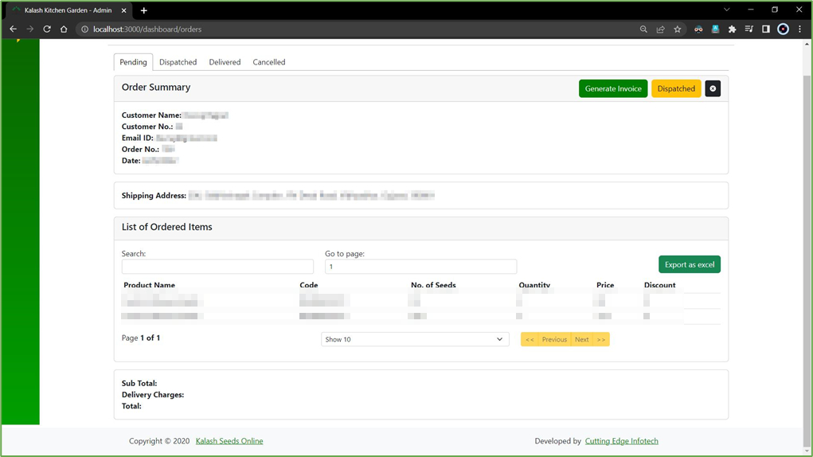

1. The following image consists of several cards showing the data of the customer and the orders he/she has placed.

The first card shows the order summary of the current order.

It has three buttons,

first to generate the invoice,

second to mark the order as dispatched,

and the last one to close the details view and go back to the datatable.

The second card shows the Shipping address

The third card consists of a table which includes the previous orders by the same customer.

And the final card shows the charges of the product ordered.

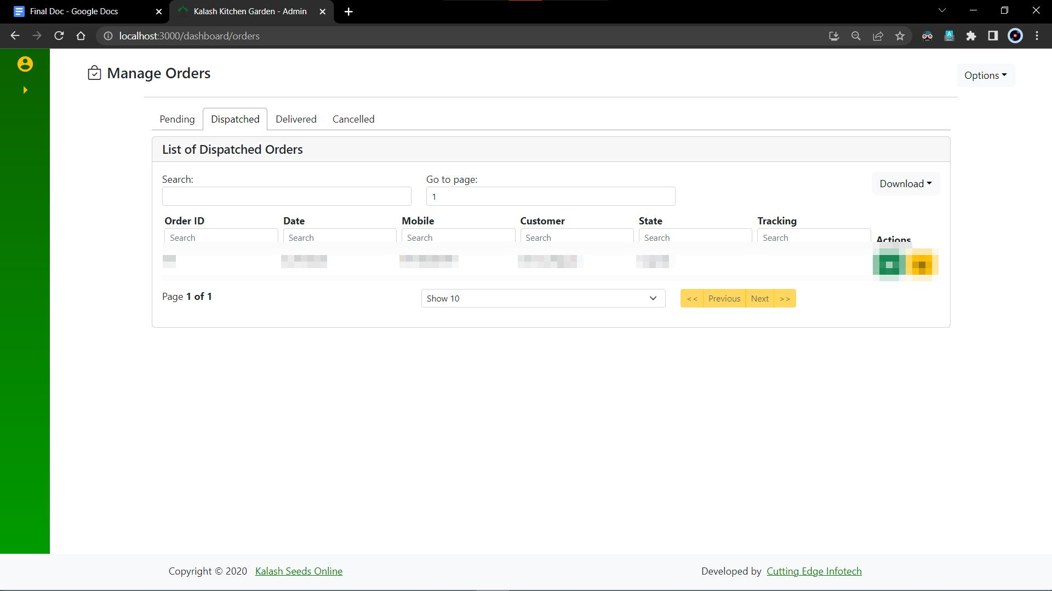

1. The following image consists of a data table that is created using the library react-table.

This page is intended to manage the order data from within the website.

The locations page is divided into 4 sections namely, Pending Orders, Dispatched Orders, Delivered Orders, and Canceled Orders.

The above image represents the Dispatched orders.

The library react-tabs is used to manage the views.

The action column includes the buttons for viewing details and marking as read any orders.

The view details button takes the user to another view that has all the details of the orders that the customer has placed.

The Mark as Read button represents the state of the order. If the order is resolved, it is marked as read.

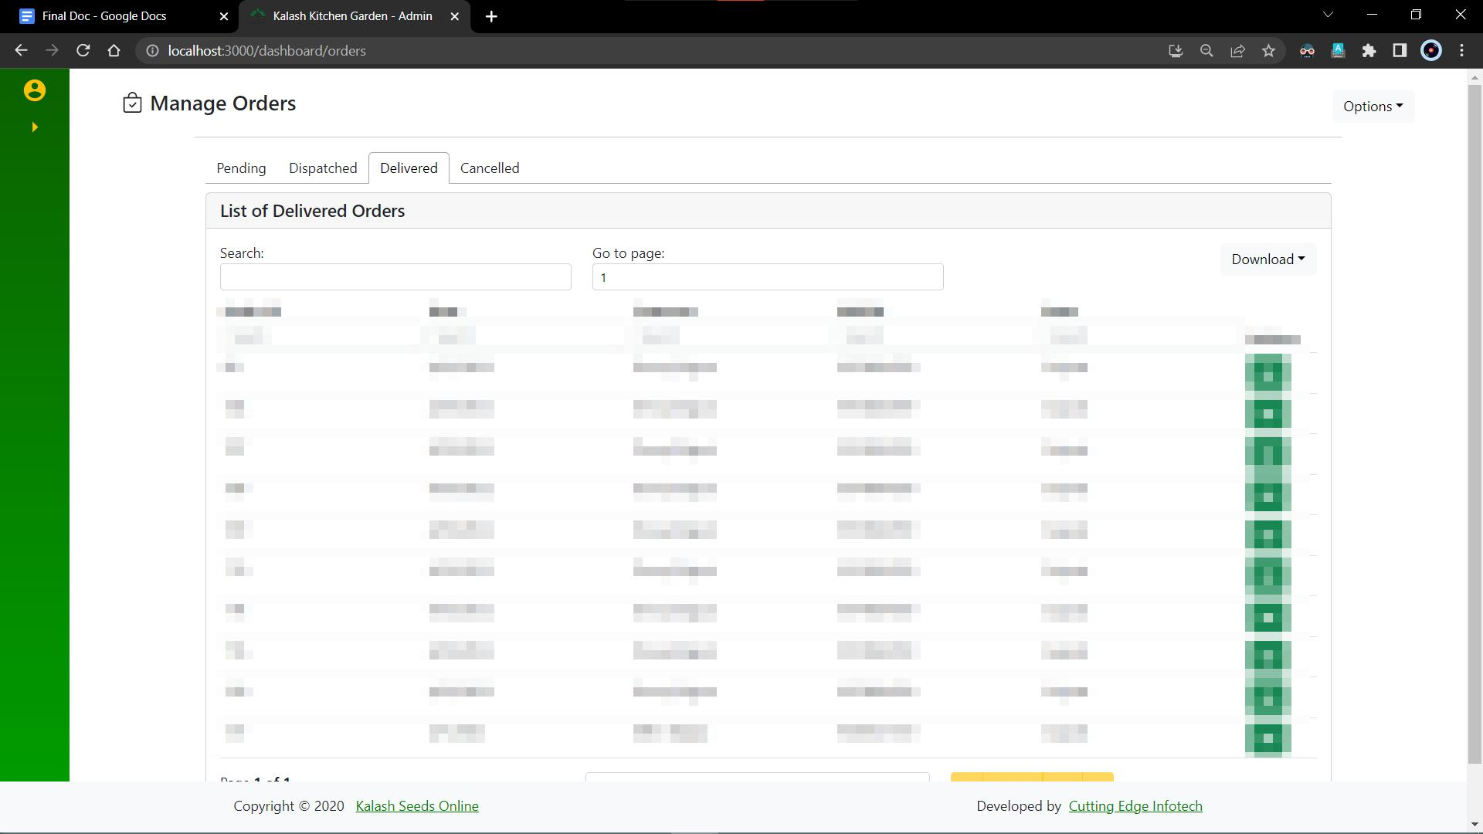

1. The following image consists of a data table that is created using the library react-table.

This page is intended to manage the order data from within the website.

The locations page is divided into 4 sections namely, Pending Orders, Dispatched Orders, Delivered Orders, and Canceled Orders.

The above image represents the Delivered orders.

The library react-tabs is used to manage the views.

The action column includes buttons for viewing the details of any orders.

The view details button takes the user to another view that has all the details of the orders that the customer has placed.

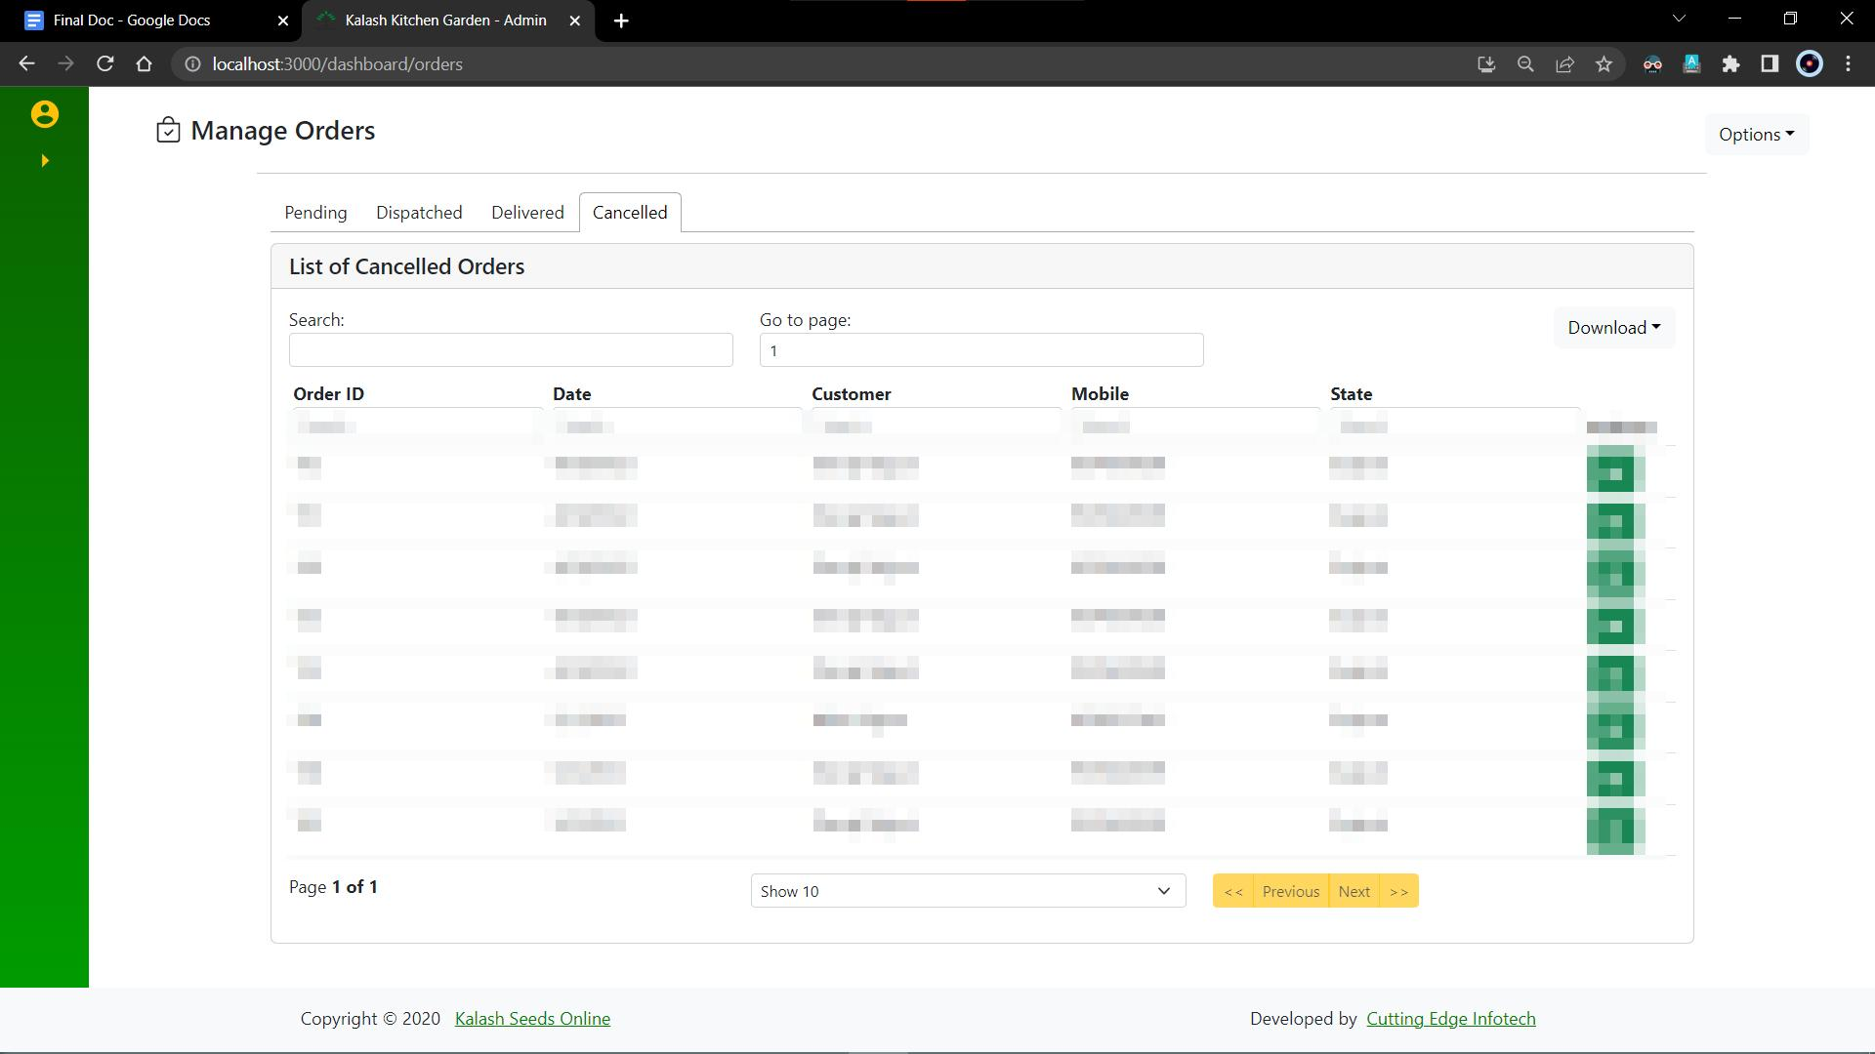

1. The following image consists of a datatable which is created using the library react-table.

This page is intended to manage the orders data from within the website.

The locations page is divided into 4 sections namely, Pending Orders, Dispatched Orders, Delivered Orders, and Canceled Orders.

The above image represents the Pending orders.

The library react-tabs are used to manage the views.

The action column includes the buttons for viewing details and deleting any orders.

View details button takes the user to another view which has all the details of the orders that the customer has placed.

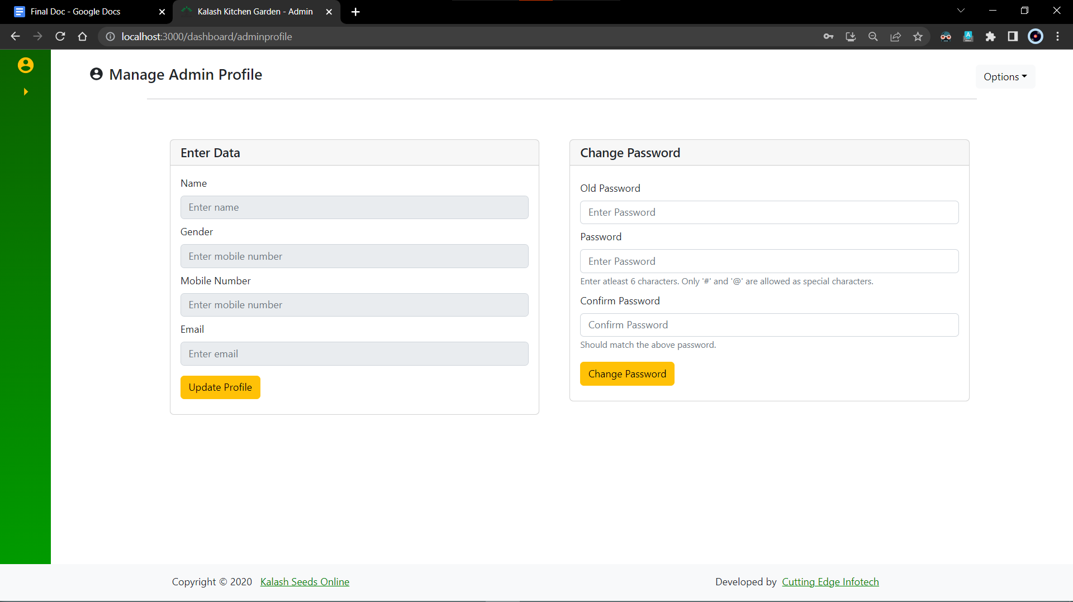

1. The following image consists of two forms.

The first form is for editing or updating the current data of the admin.

The second form is for changing the password of the admin.

This page is intended to manage the admin’s profile from within the website.

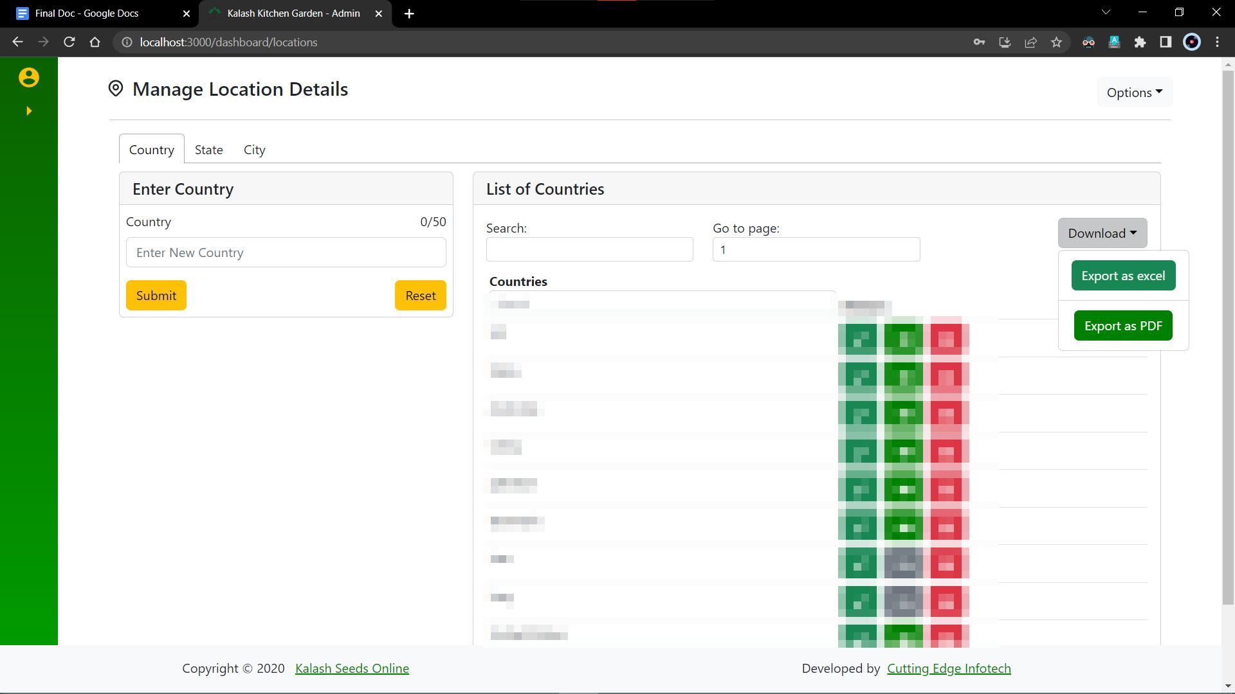

1. The above table is a drop-down option which has two menus.

First one is to download the table info as an excel file which is downloaded directly.

Second one is to save the table information as a pdf.

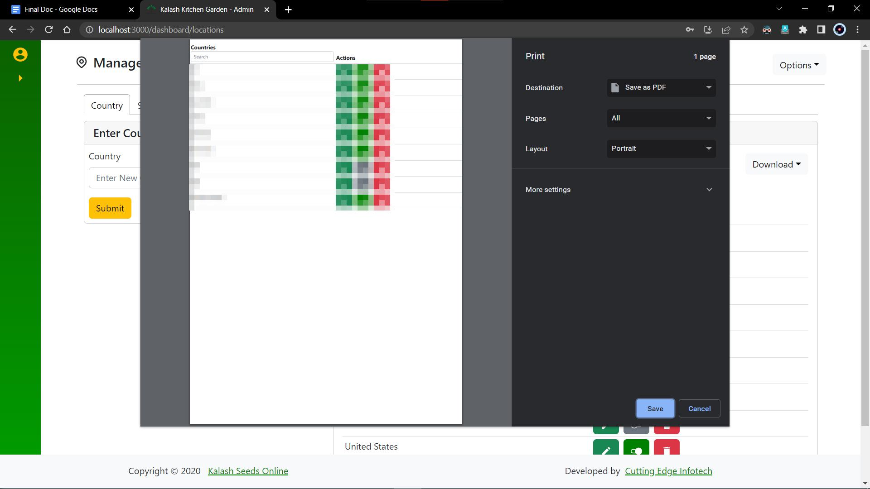

1. Here when clicked on the download as pdf option, the user gets prompted with the format preferred by the user to download the document.

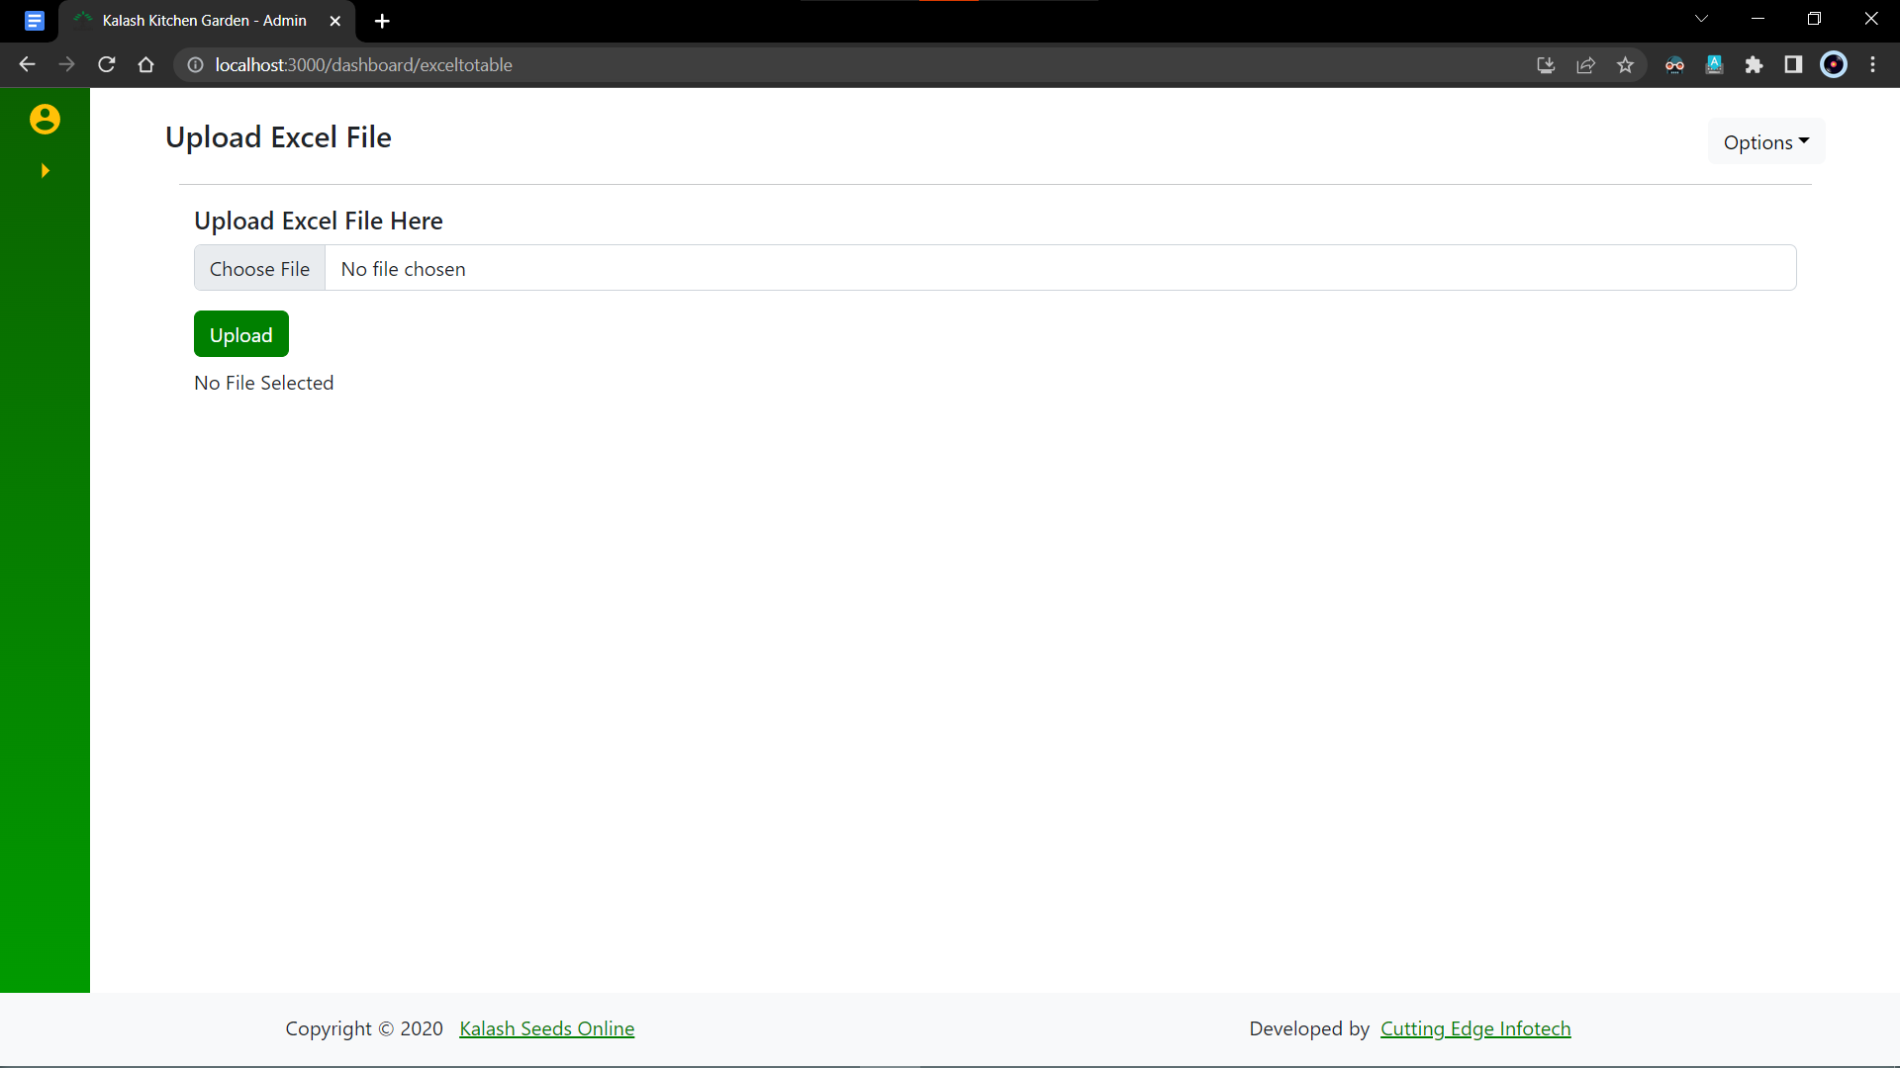

1. This page has a functionality to add an excel file directly which gets converted to JSON format which can be used to send it to the server directly.

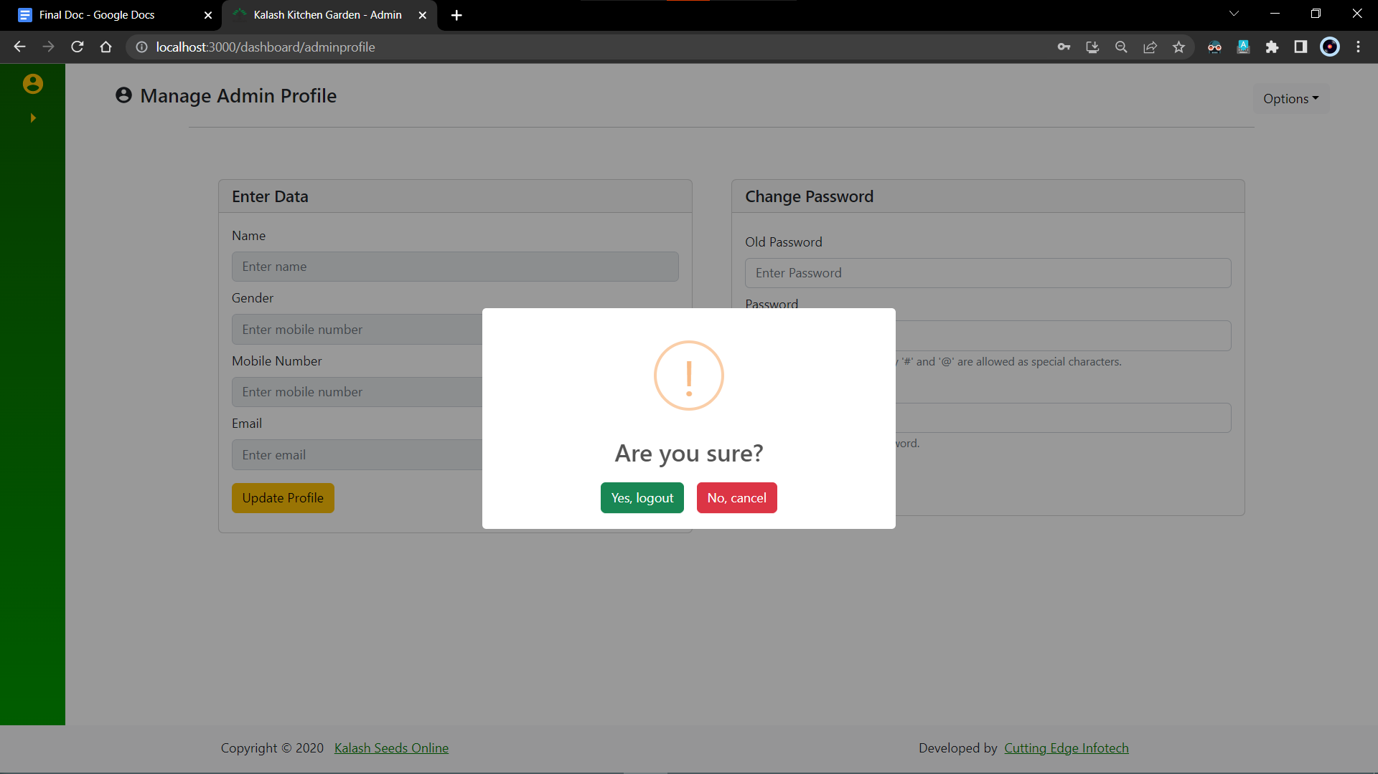

1. Finally, the “Options” dropdown has two options of taking the user to the admin profile which was mentioned above and another option to log out.

When the user chooses to logout, an alert is given to the user asking for confirmation if to logout or not.

If pressed “Yes”, the user is redirected to the login page, and the session is destroyed.

If pressed “No”, another prompt appears which says “Logout operation Canceled”

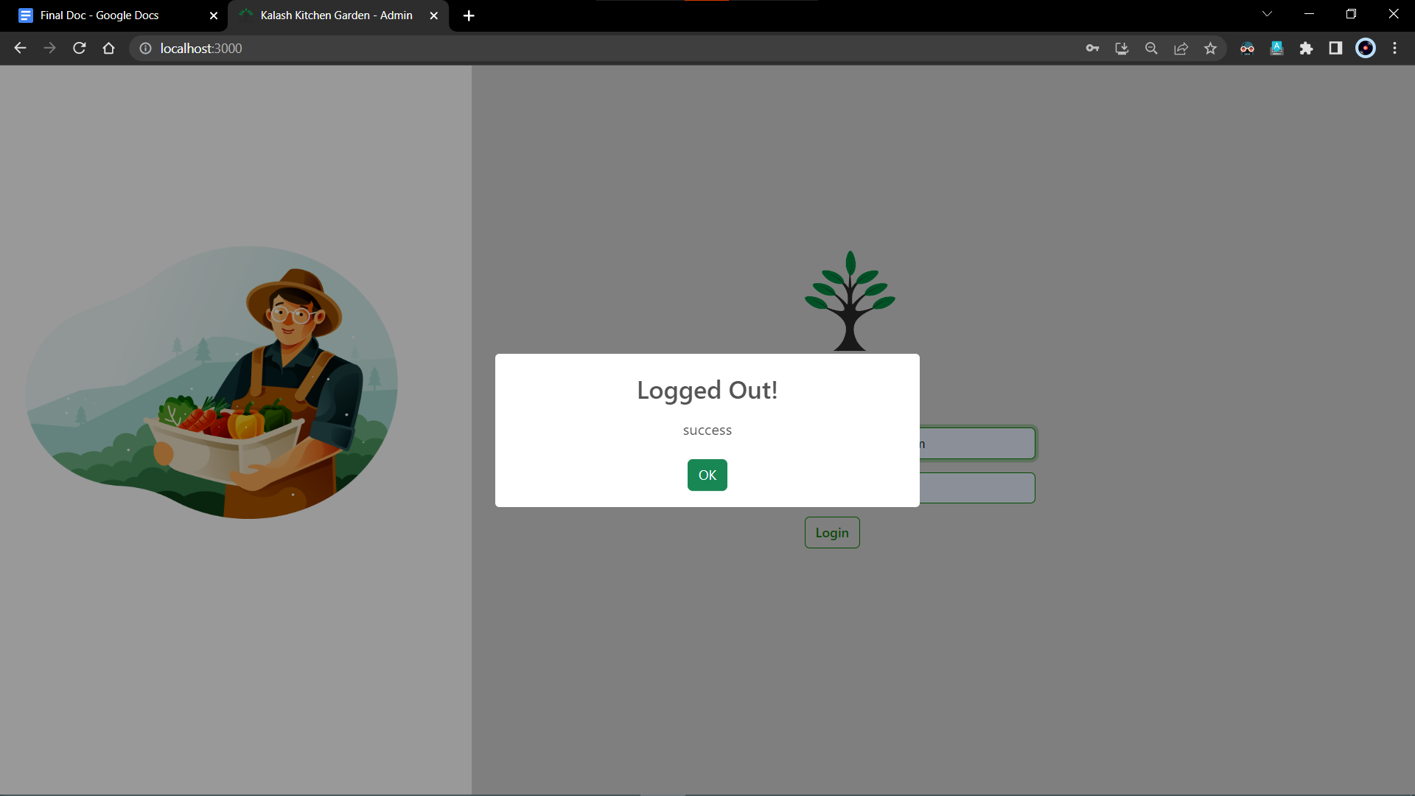

1. After Logging out, this page appears with a “Logged out” prompt.
   * 1. Assignment: 4 **[Backend Training]** (MS SQL Server and ASP .NET Framework)

**Project 1**

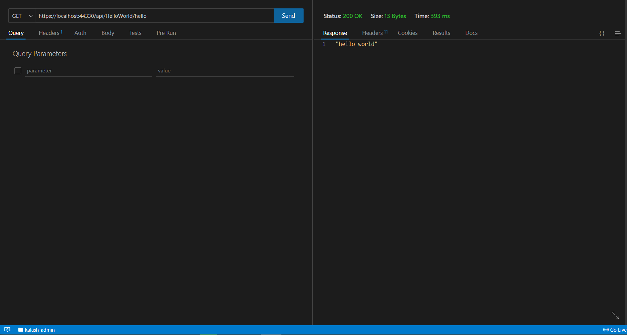

1. The first task was to create an API in ASP .NET Framework that would return a string of “hello world” when a request was made on the API link

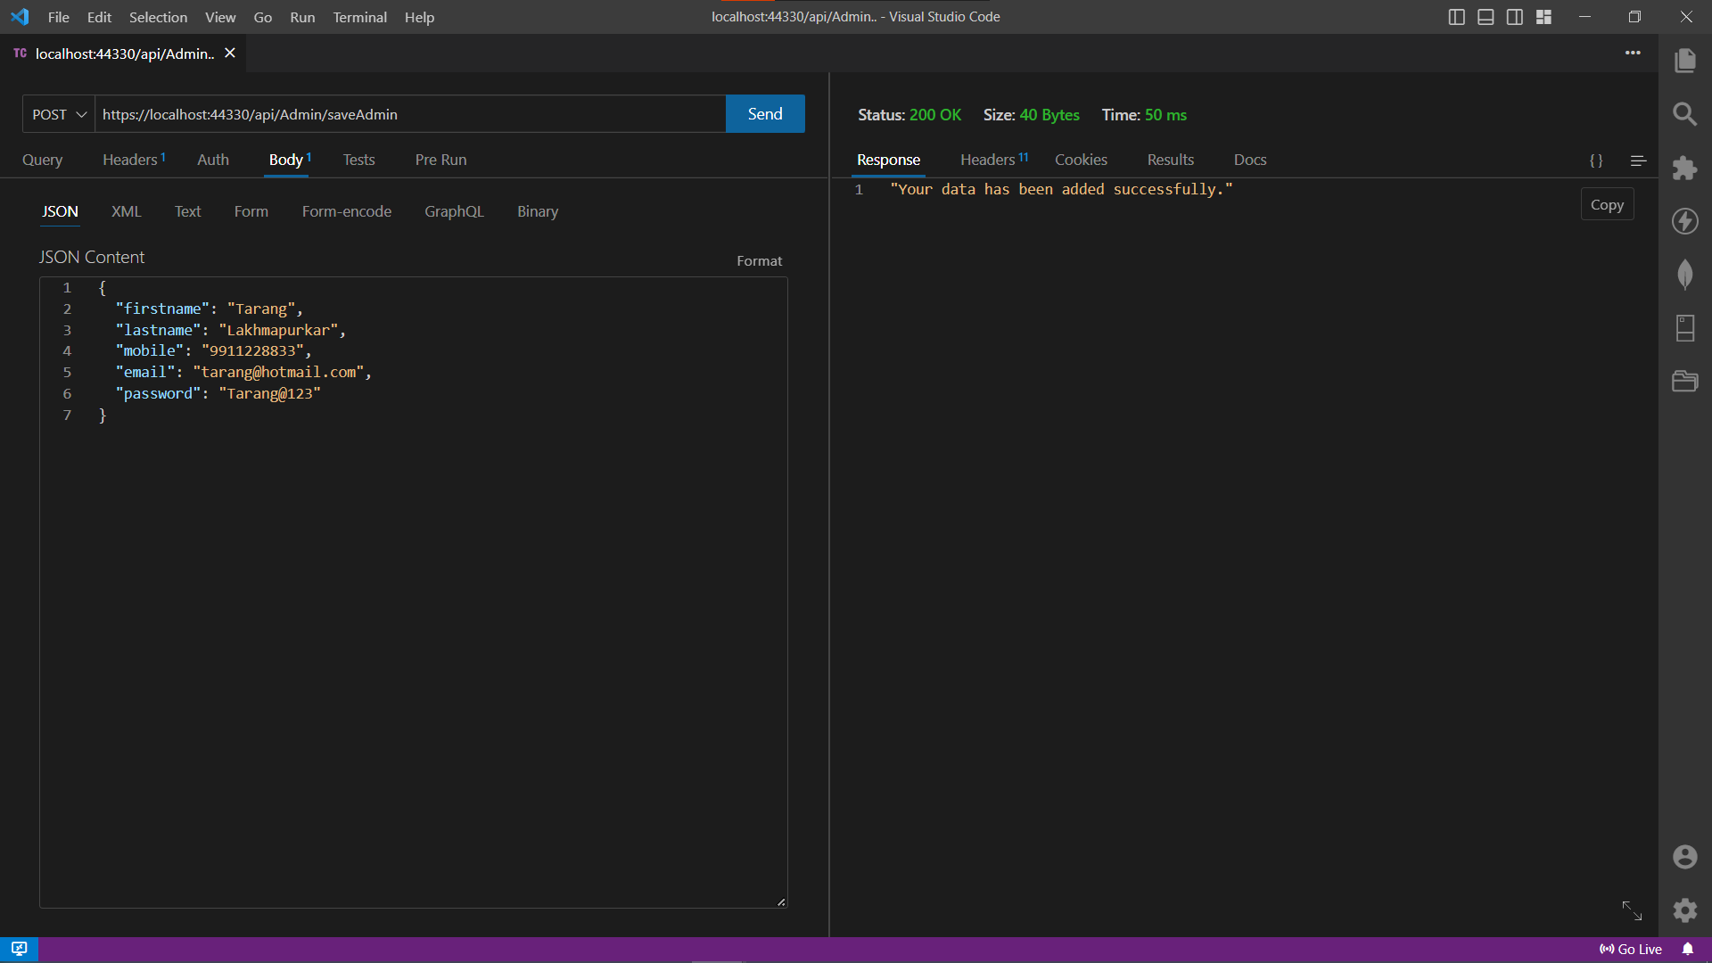

1. Then I was given training on how the company approaches backend development. How the database is connected with the Web-API project in Visual Studio.

So, the first API and query made were saving a new entry to a user's table.

Once the record is inserted, the user gets a response according to the success of the API request.

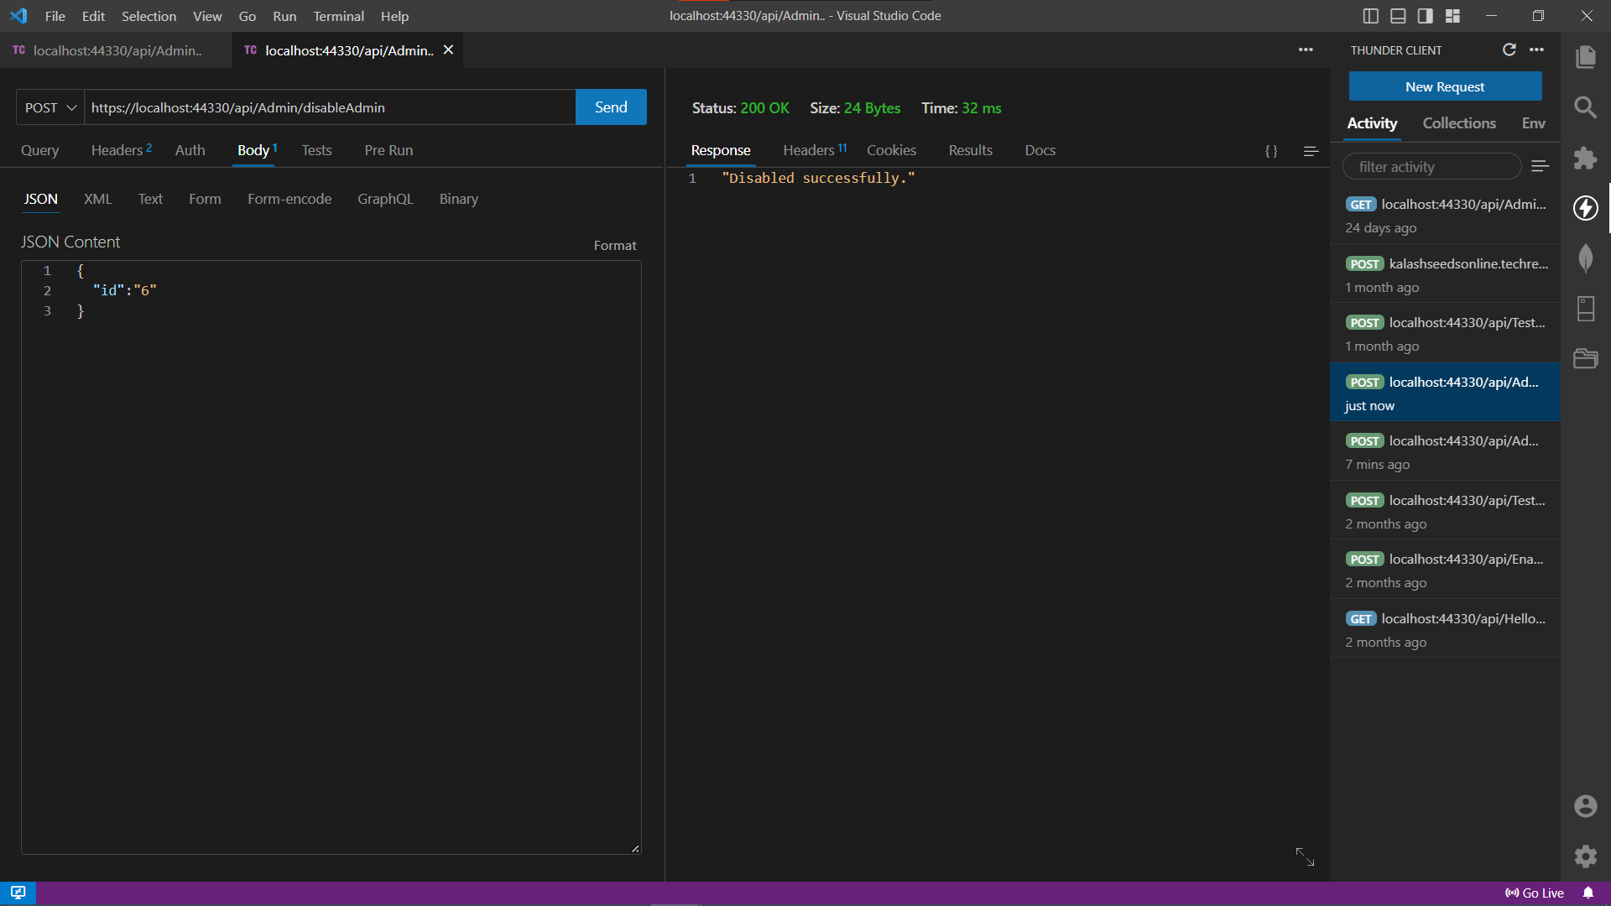

1. The next task was to disable a specific user.

The API works on a post request that requires an ID to be passed in the body parameter which in turn is passed the SQL method to implement the query.

In response the user gets a JSON object with the response code and the message from the server.

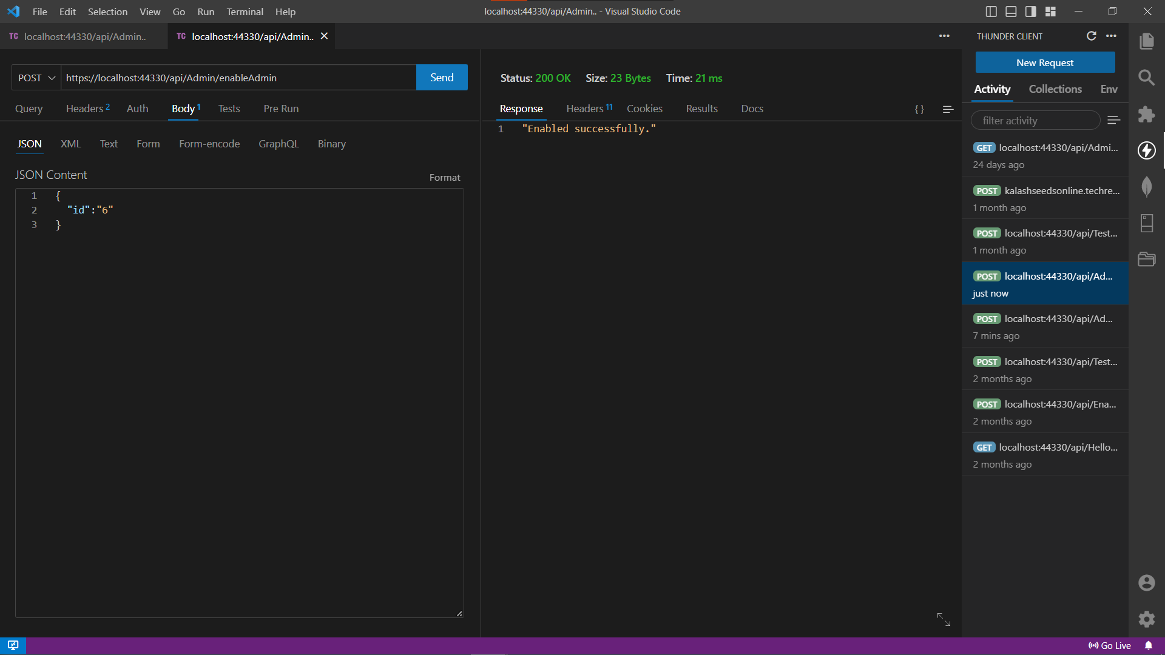

1. The next task was to enable a specific user.

The API works on a post request that requires an ID to be passed in the body parameter which in turn is passed the SQL method to implement the query.

In response the user gets a JSON object with the response code and the message from the server.

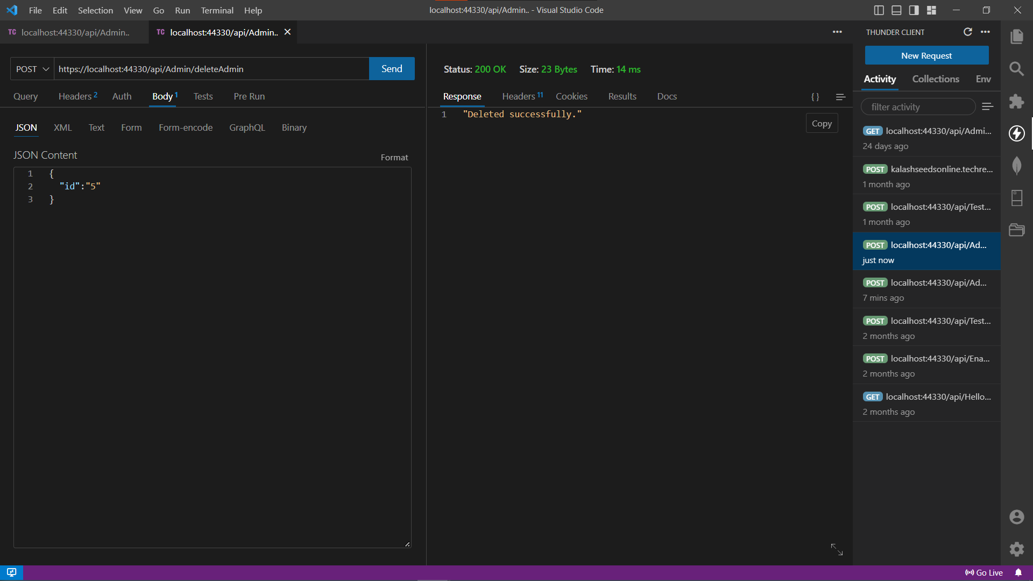

1. The final task was to delete a specific user.

The API works on a post request that requires an ID to be passed in the body parameter which in turn is passed the SQL method to implement the query.

In response the user gets a JSON object with the response code and the message from the server.

**Project 2**

**For Users**

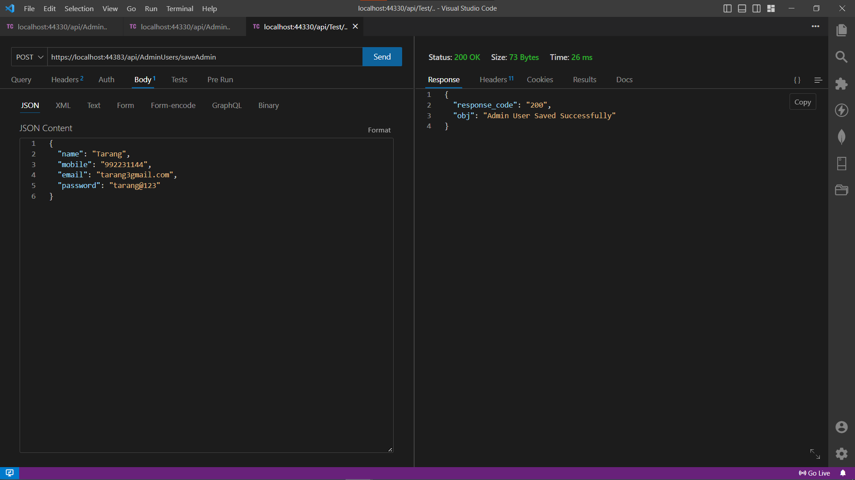

1. The new database was made in order to introduce me to work in stored procedures. Then create APIs to execute the SP.

So the first API and query made were saving a new entry to a user's table.

Once the record is inserted, the user gets a response according to the success of the API request.

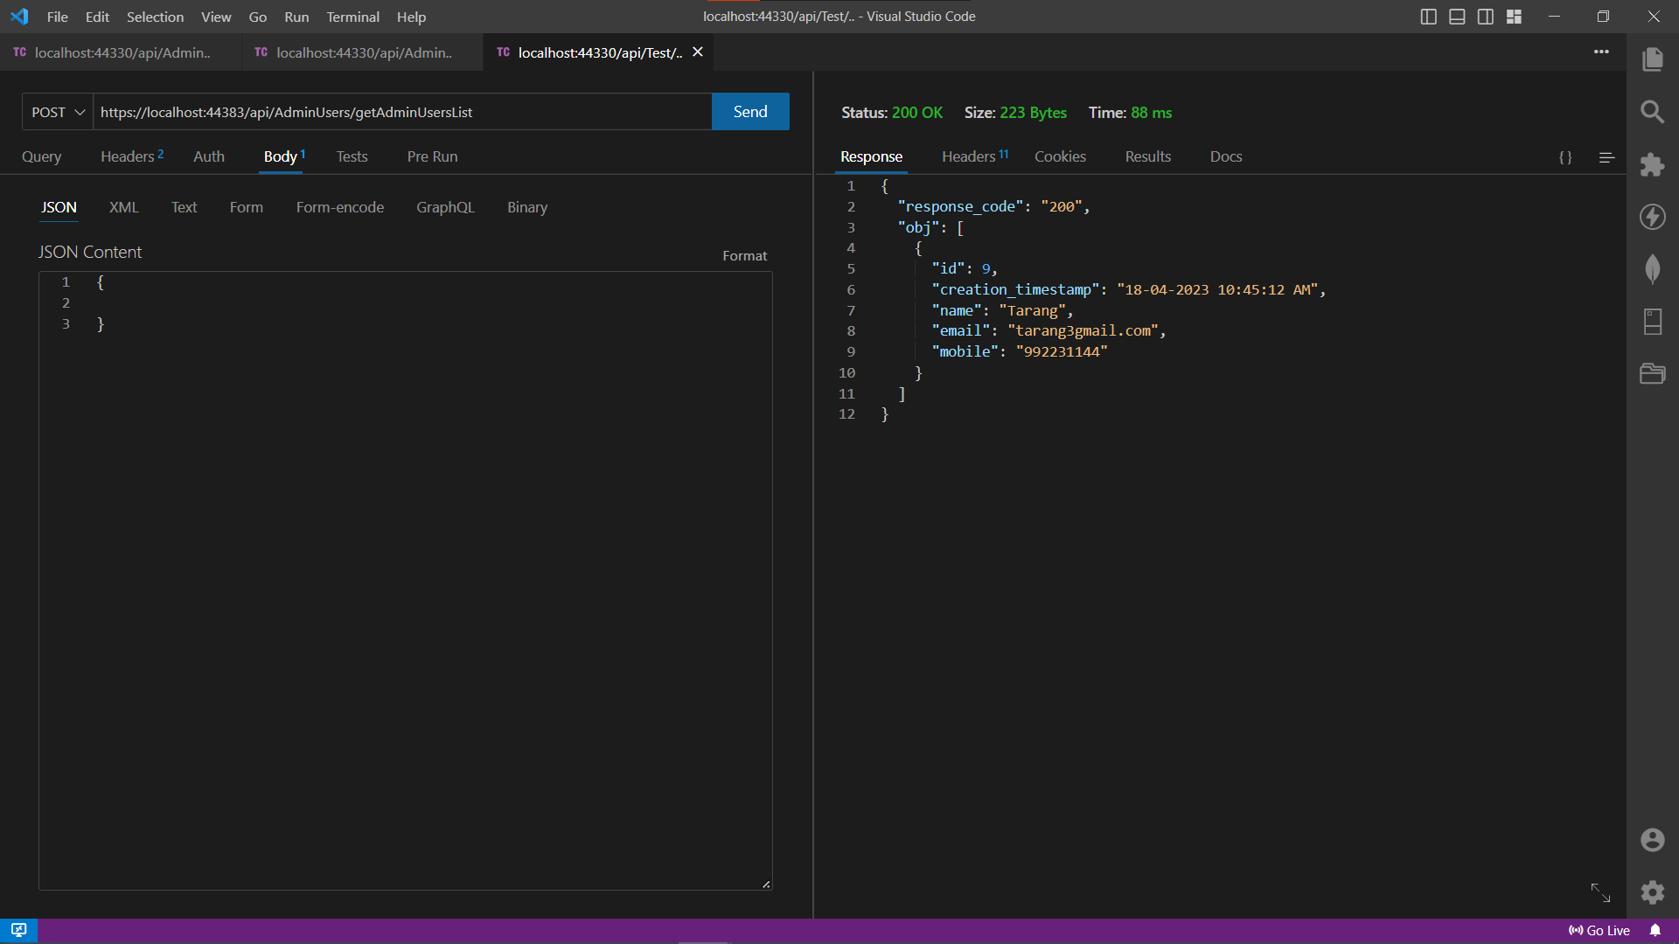

1. The above image is an implementation of the GET API and how it executes the get users list Stored Procedure.

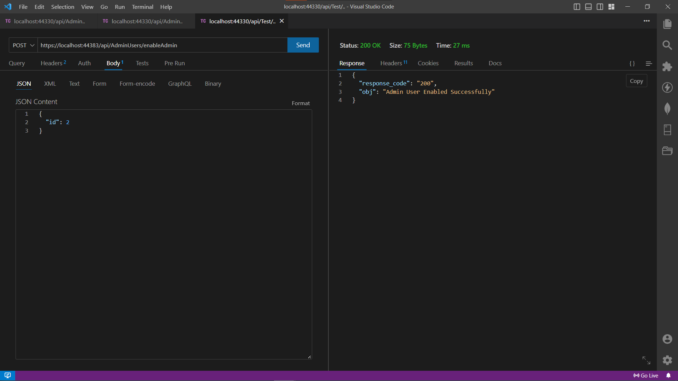

1. The next task was to enable a specific user by sending the “id” in the body of the request, which in turn filters all the users by enabled field in the Get All API.

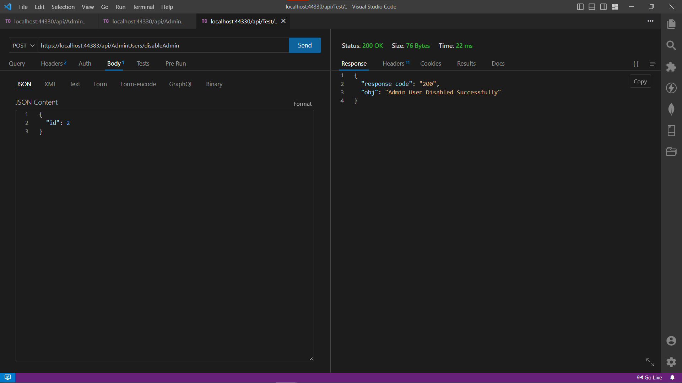

1. The next task was to disable a specific user by sending the “id” in the body of the request, which in turn filters all the users by the disabled field in the Get All API.

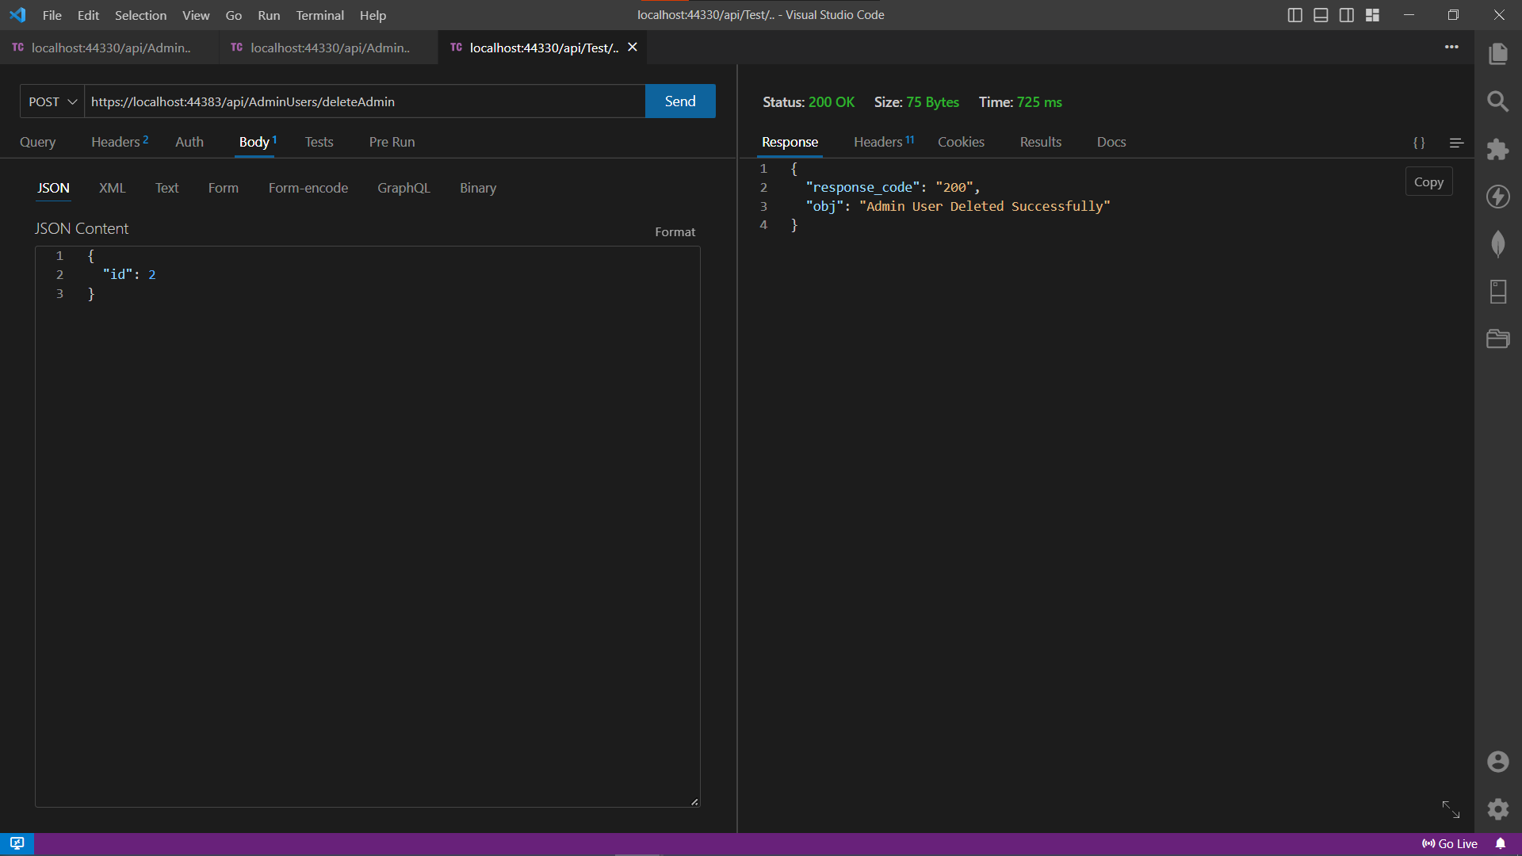

1. The final task was to delete a specific user.

The API works on a post request that requires an ID to be passed in the body parameter which in turn is passed the SQL method to implement the query.

In response the user gets a JSON object with the response code and the message from the server.

**For Country**

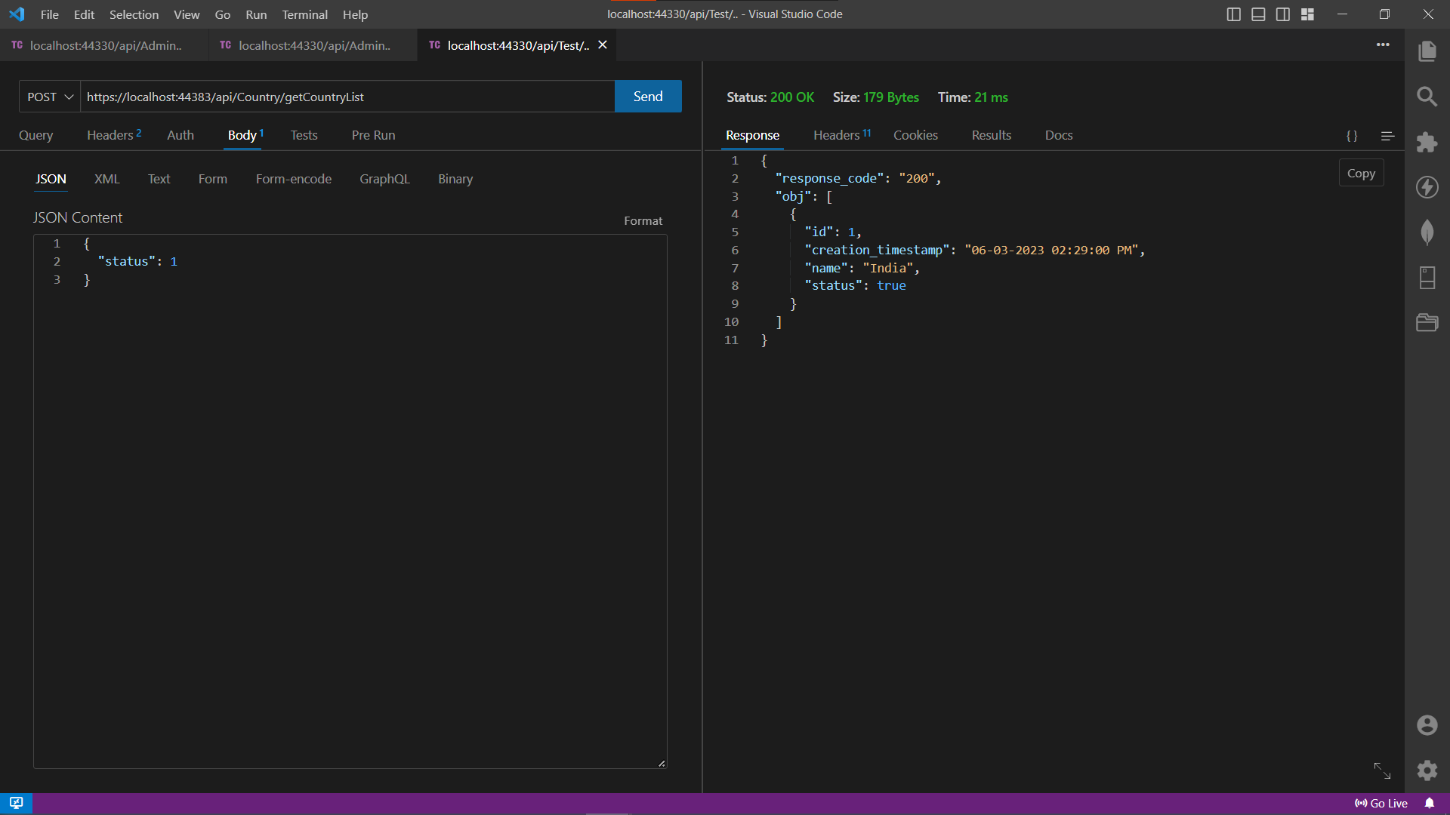

1. Now for showing dependency in tables, I was given to create a country table, a state table, and a city and handle the relationships using Foreign Keys.

So, this shows the get country list API.

The API works on a post request that requires the status parameter to be passed in the body parameter which in turn is passed the SQL method to implement the query.

In response the user gets a JSON object with the response code and all the data from the respective table as an array of objects.

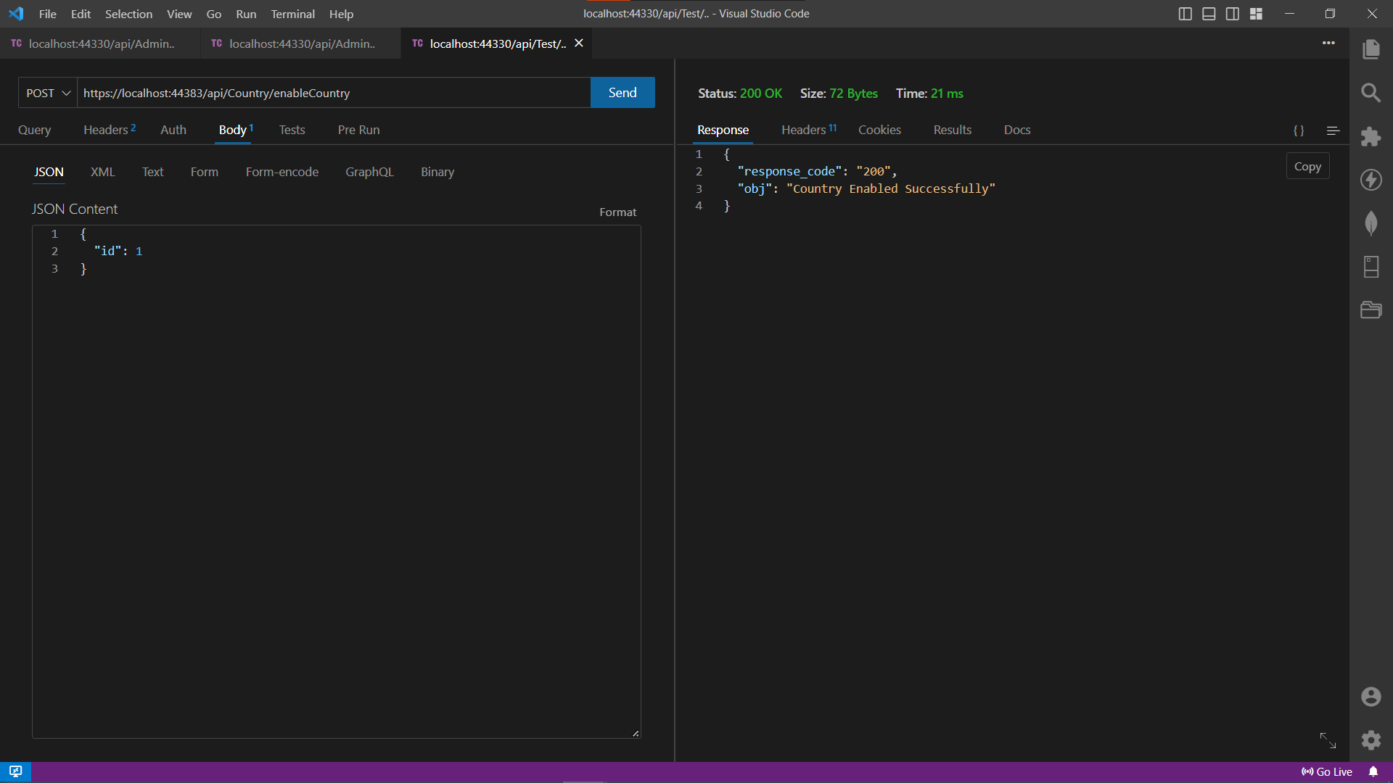

1. Next API is to disable a country depending on the client's requirement.

The API works on a post request that requires an ID to be passed in the body parameter which in turn is passed the SQL method to implement the query.

In response the user gets a JSON object with the response code and the message from the server.

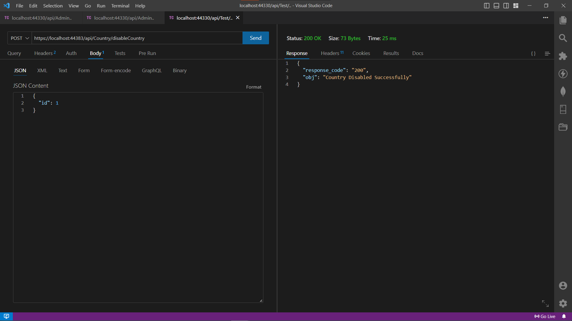

1. This API is to enable a country and allow it to show in the get API request.

The API works on a post request that requires an ID to be passed in the body parameter which in turn is passed the SQL method to implement the query.

In response the user gets a JSON object with the response code and the message from the server.

**For State**

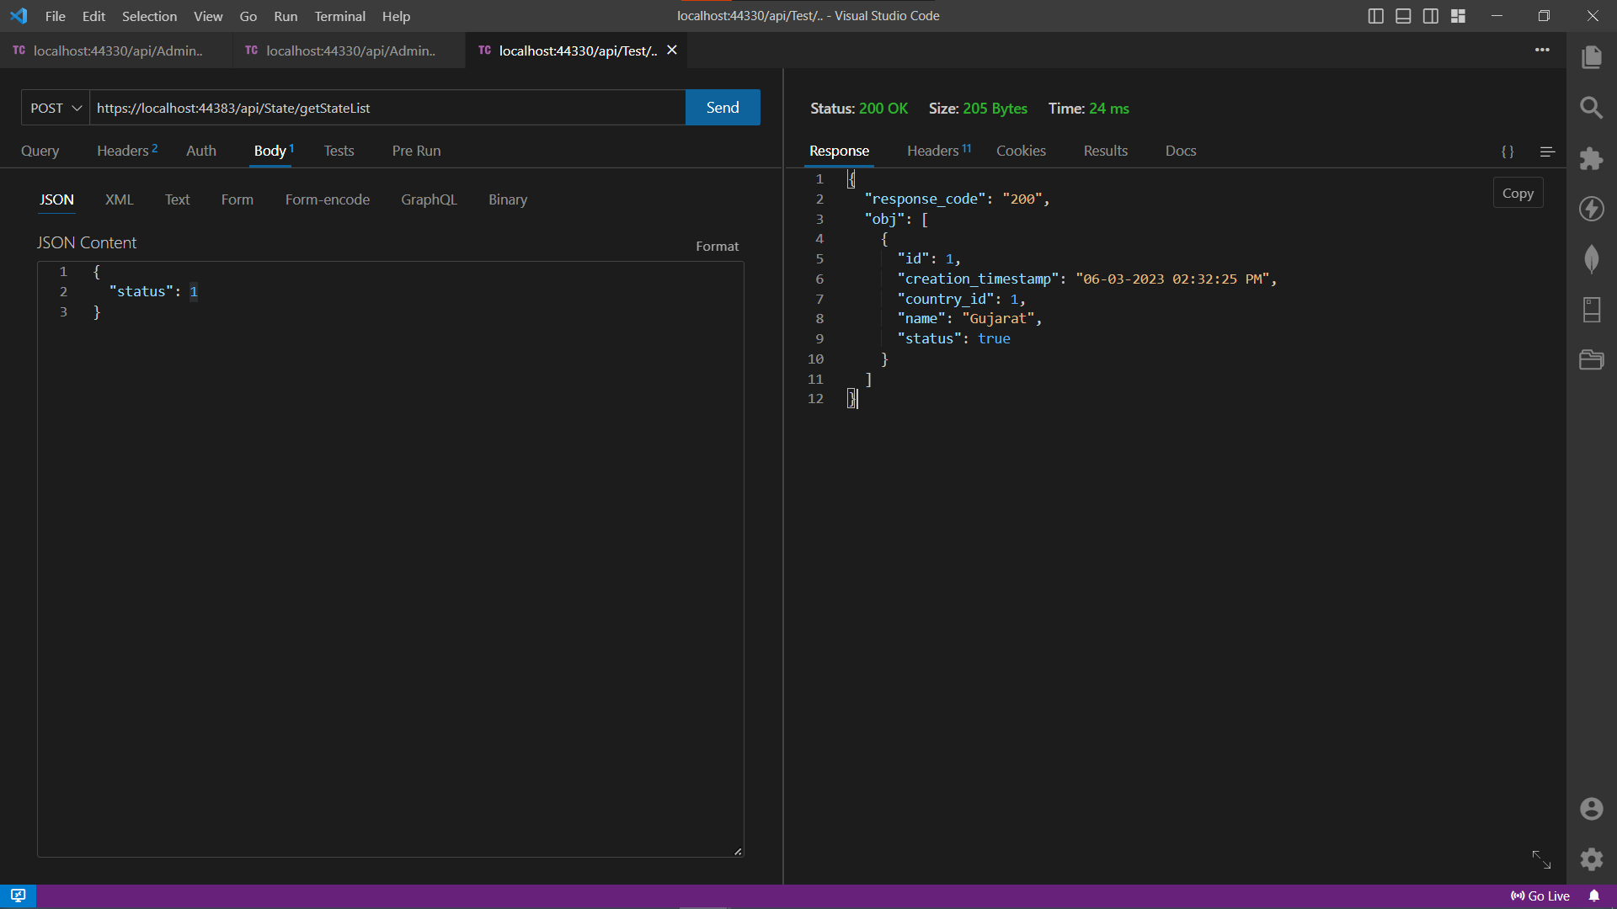

1. Now for showing dependency in tables, I was given to create a country table, a state table, and a city and handle the relationships using Foreign Keys.

So, this shows the get state list API.

The API works on a post request that requires an ID to be passed in the body parameter which in turn is passed the SQL method to implement the query.

In response the user gets a JSON object with the response code and the table data in the form of an array of objects.

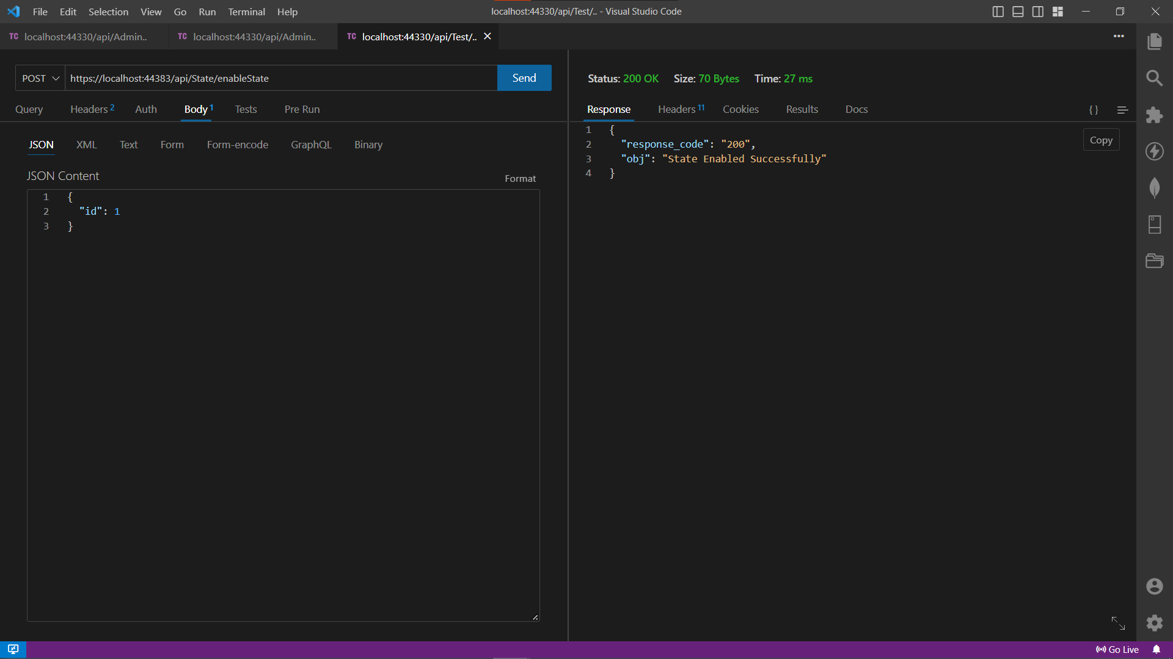

1. Next API is to disable a state depending on the client's requirement.

The API works on a post request that requires an ID to be passed in the body parameter which in turn is passed the SQL method to implement the query.

In response the user gets a JSON object with the response code and the message from the server.

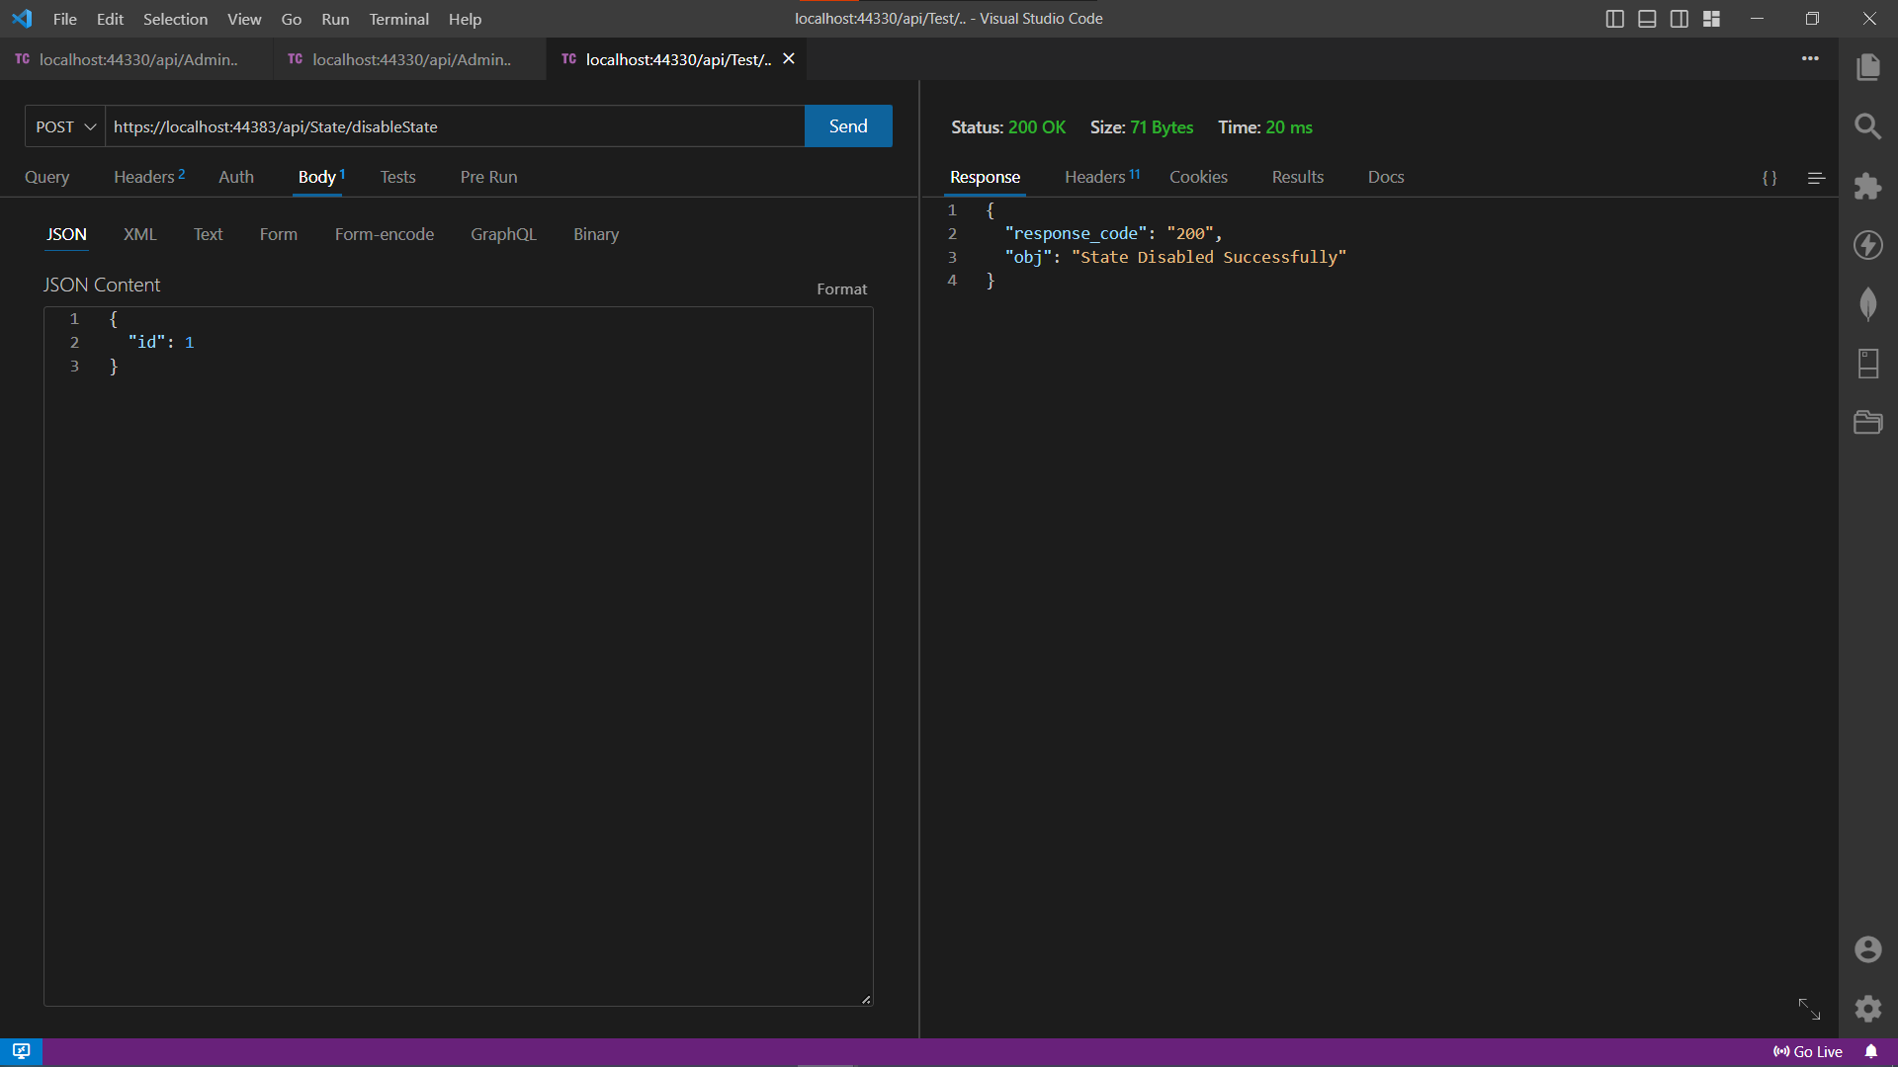

1. This API is to enable a state and allow it to show in the get API request

The API works on a post request that requires an ID to be passed in the body parameter which in turn is passed the SQL method to implement the query.

In response the user gets a JSON object with the response code and the message from the server.

**For City**

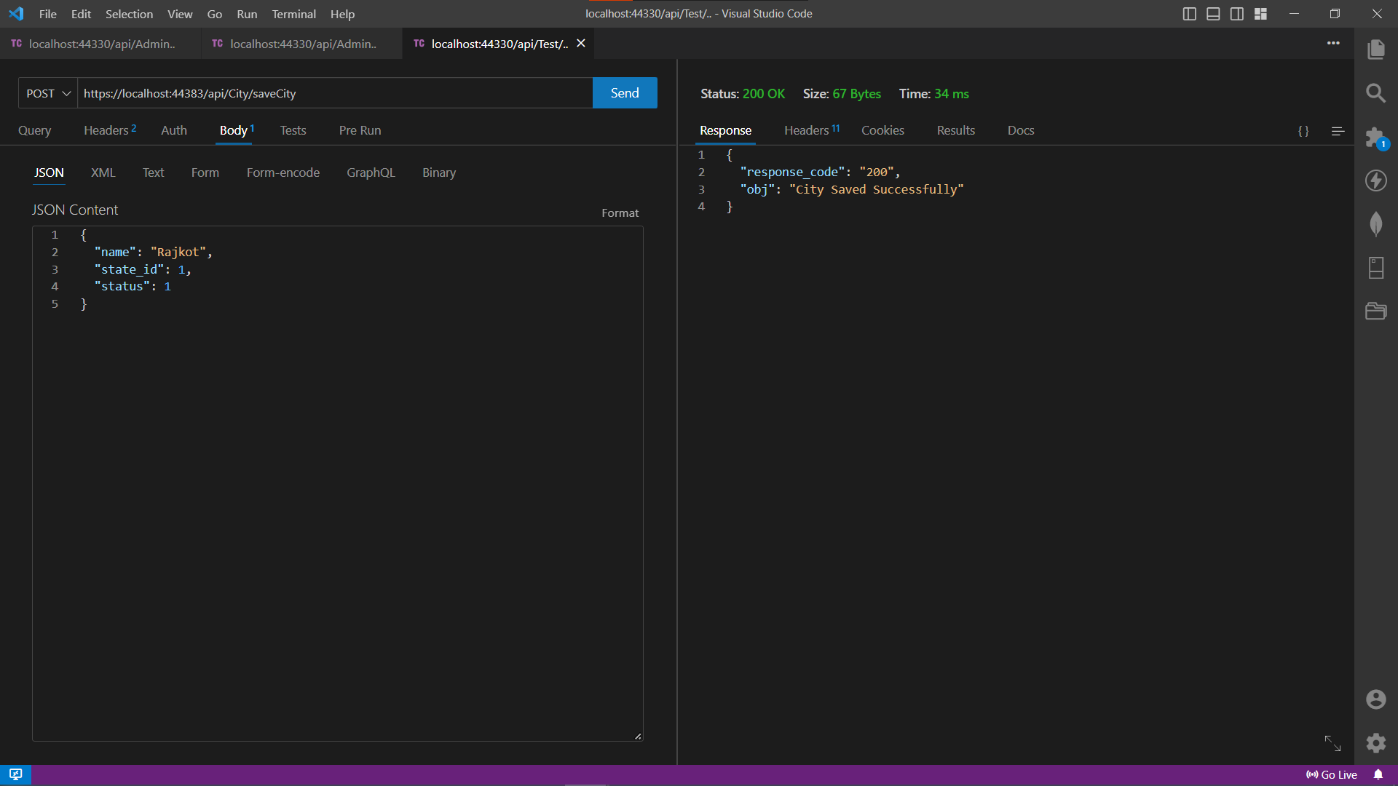

1. Now for showing dependency in tables, I was given to create a country table, a state table, and a city and handle the relationships using Foreign Keys.

So, this shows the save City API.

The API works on a post request that requires the name, the id of the state, and the status of the city to be passed in the body parameter which in turn is passed the SQL method to implement the query.

In response the user gets a JSON object with the response code and the message from the server.

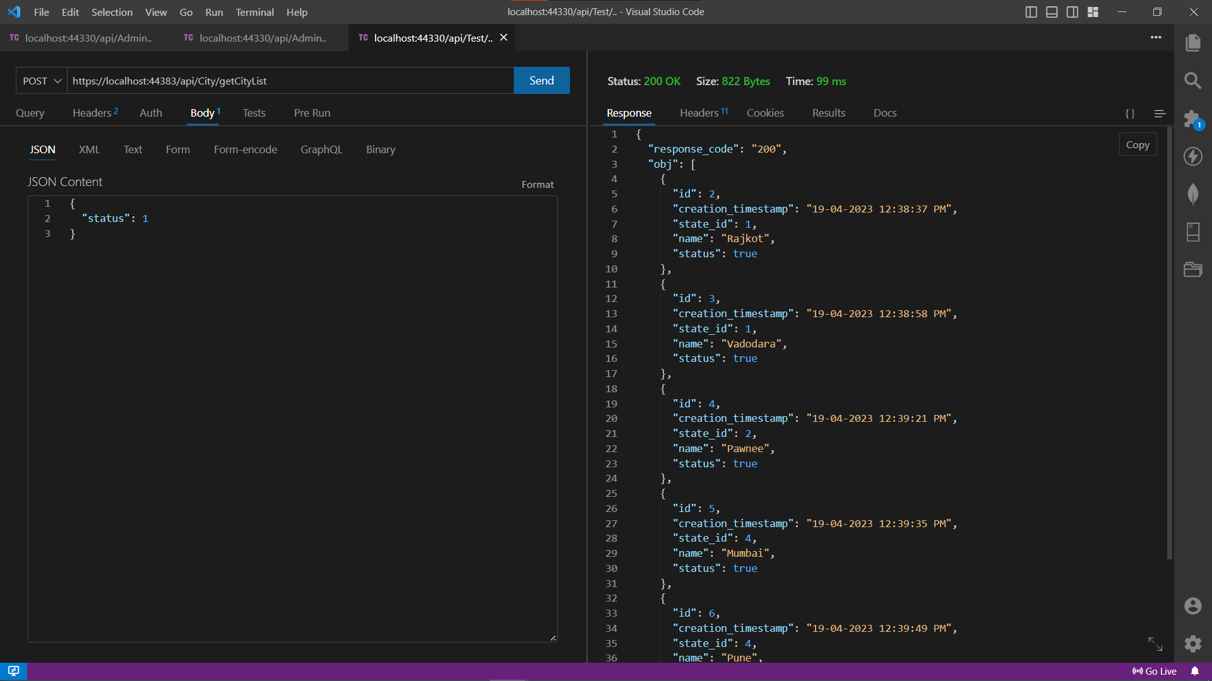

1. This is for getting all the Cities data.

The API works on a post request that requires the status parameter to be passed in the body parameter which in turn is passed the SQL method to implement the query.

In response the user gets a JSON object with the response code and all the data from the respective table as an array of objects.

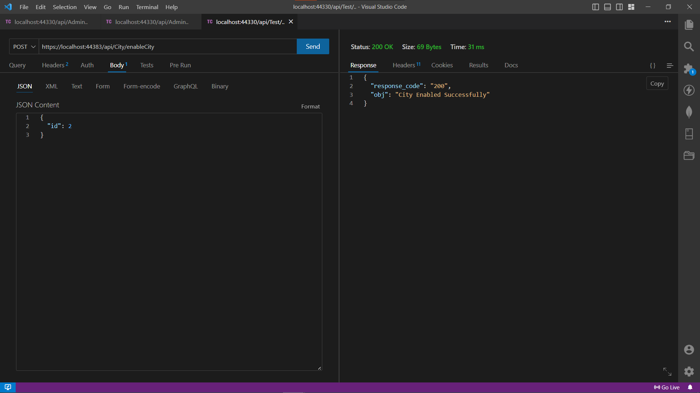

1. This API is to enable a city and allow it to show in the get API request.

The API works on a post request that requires an ID to be passed in the body parameter which in turn is passed the SQL method to implement the query.

In response the user gets a JSON object with the response code and the message from the server.

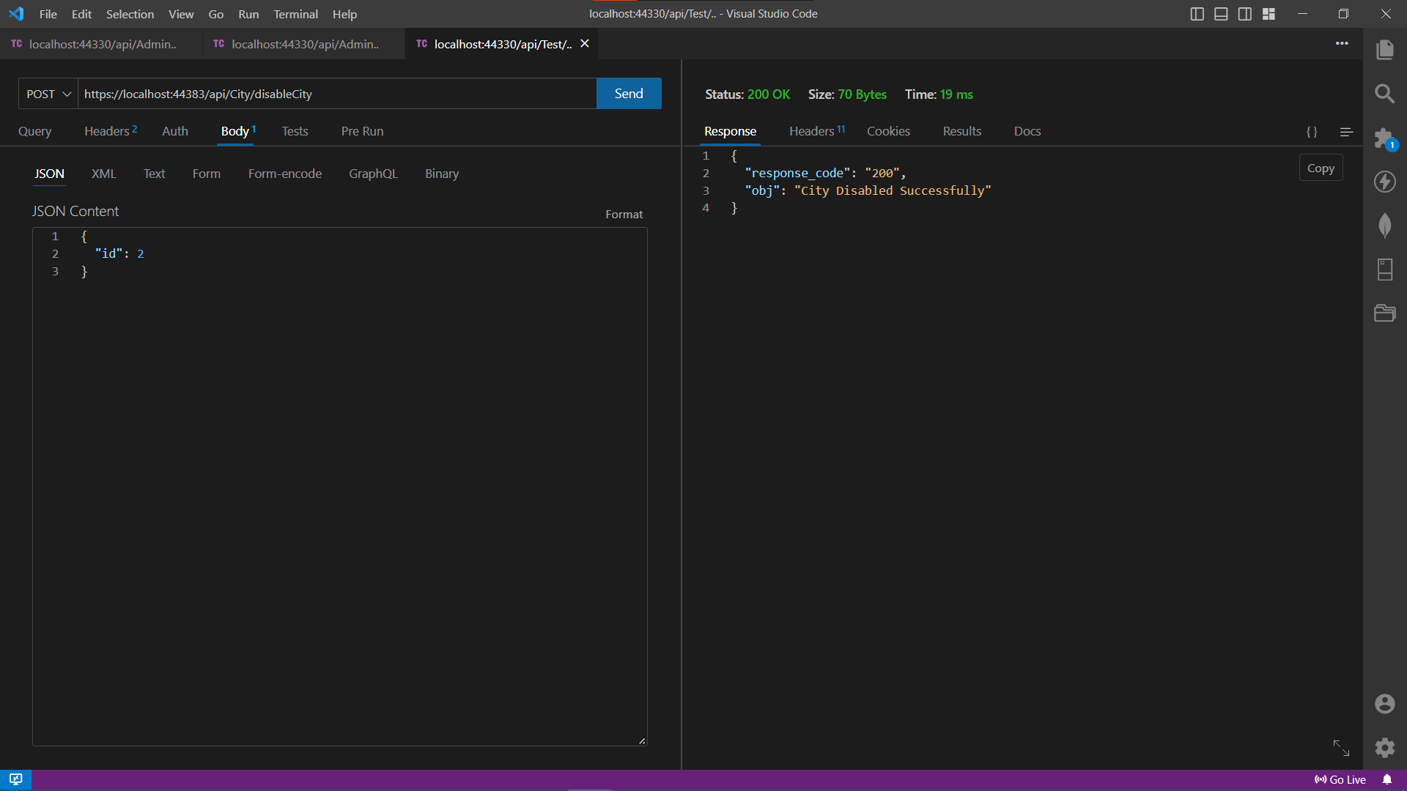

1. This API is to delete a city and allow it to show in the get API request.

The API works on a post request that requires an ID to be passed in the body parameter which in turn is passed the SQL method to implement the query.

In response the user gets a JSON object with the response code and the message from the server.

* + 1. Assignment: 5 **[Current going work]** (Car Reselling website)

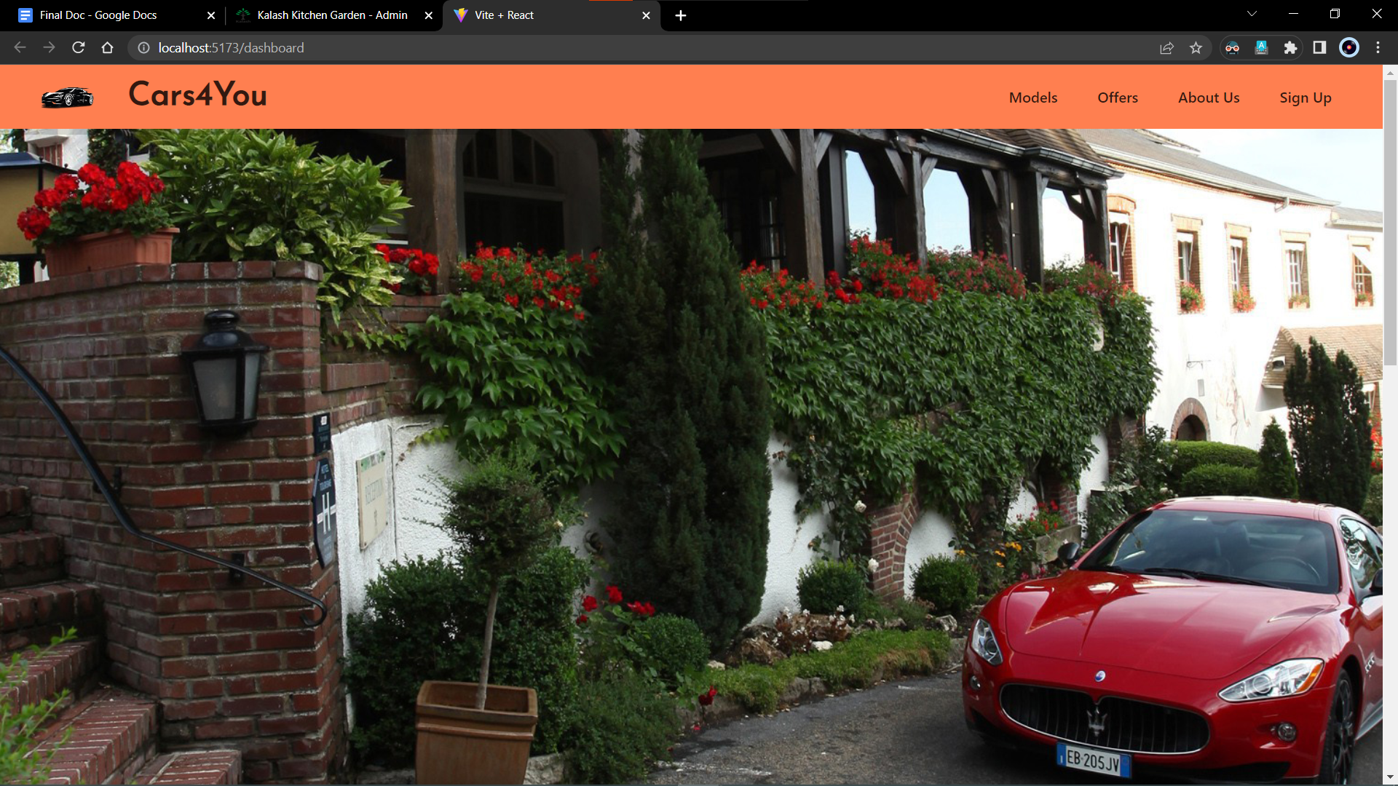

1. This was the most recent task assigned to me and which is currently I am working on.

After the admin panel, I was asked to design a client-side website using ReactJS and any other UI library which I preferred. So, I chose Chakra-UI.

This website currently has one page which is the homepage and another one which will have information about available cars with their interactive 3D models.

This homepage consists of the header and an image carousel of cars.

The image carousel slides images by default every 4 seconds.

The library used for the carousel is react-awesome-slider.

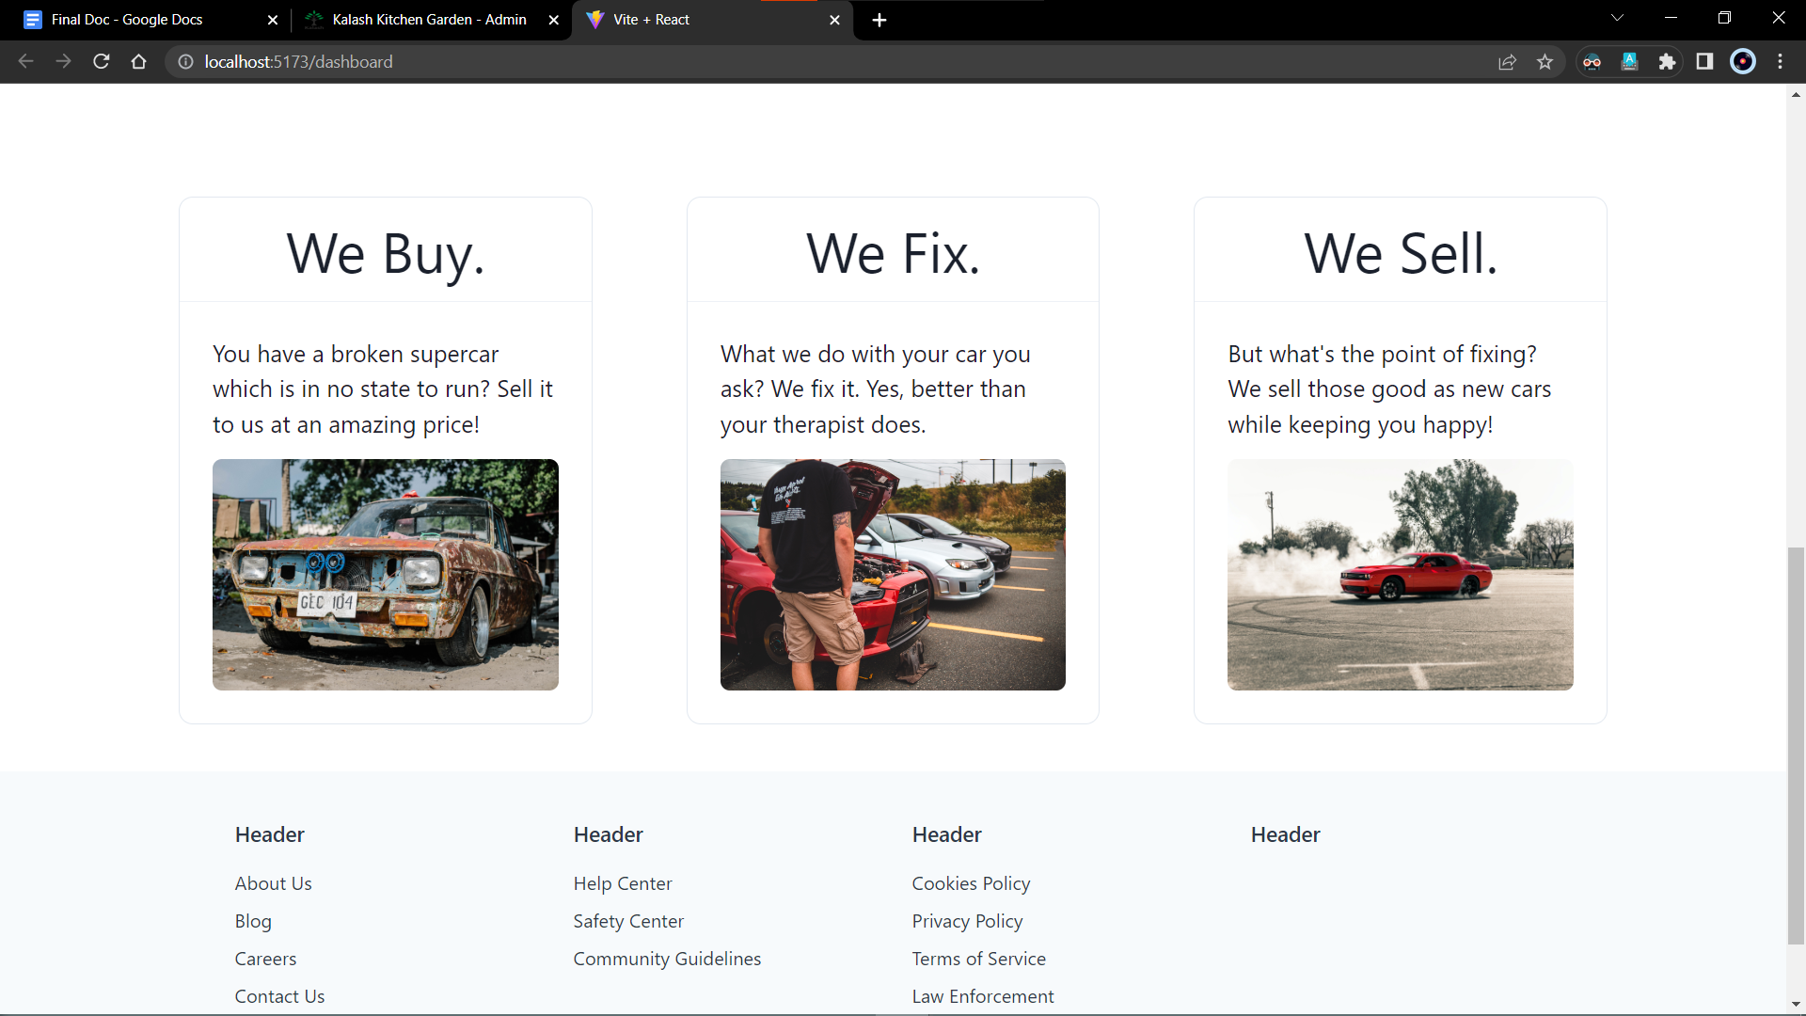

1. The bottom part of the website consists of some cards and a footer.

The cards denote the business idea of this website and give an overview to the user of how their cars will be remodeled.

The cards consist of a head, a body and an image source for the reference of the description given.

Then the page ends with a footer with the necessary links and socials.

The footer only represents a mock view of how the actual footer would look like.

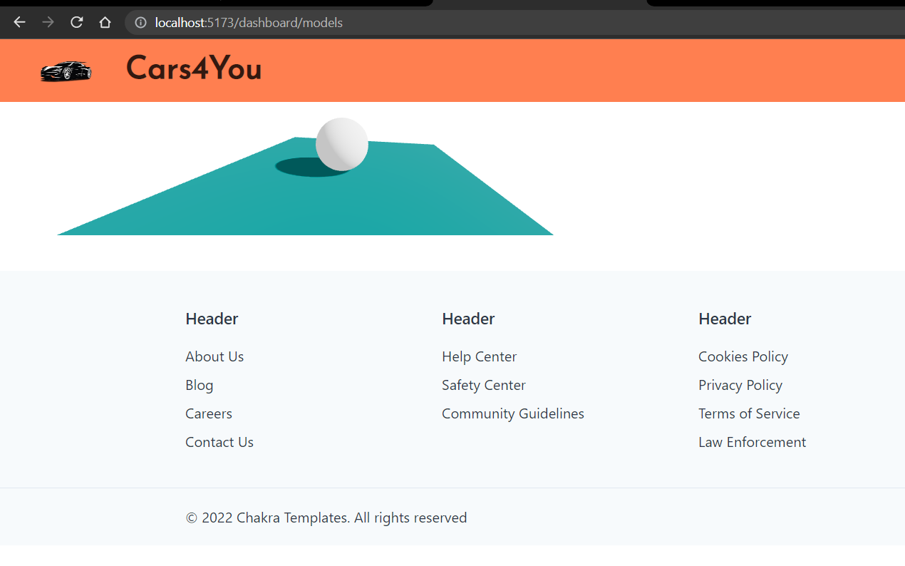

1. This is the models page.

As the page is still being developed, what you can see here is a simple 3D render of a sphere on a place that can be controlled by a mouse.

This part is implemented using two js libraries namely,

Three.js and react-three-fiber.

These libraries support only .gltf or .glb format to render on a webpage.

Here the models of cars will appear.

# Corporate Culture

### Working atmosphere in the organization

It is very exciting for me to work at Novus Ark. After spending the last few months interning at the office, I have come to develop a better understanding of the office’s culture. The individuals in this office all have a passion for software development and testing work and helping in development. Because the company is dealing in customized software solutions, every approach to a project varies differently and the developers focus on always giving the most optimal solution to the client.

### Remarks On the Culture Within the Organization

Individuals at this office, while all being very friendly, maintain very professional mannerisms. The senior developer under whom I was assigned, explained to me many of their software products and clients and the intricacies involved. They must ensure they are following software development and testing methodology. Employees need to stay up to date to ensure that they are following system requirements and each small update is reviewed by other developers, the manager, and by the client themselves.

It is very laid back in the office and there is no dress code. Fashion is a form of expression they are more concerned with work getting done not apparel.

### Insight gains about the corporate culture that I will take into consideration when searching for full-time employment

Here is a list of a few points that I will take into consideration for searching for my full-time job …

* very professional mannerisms.
* Friendly environment
* Supportive colleagues
* Flexible timing

# Career Reflection

The past three have been out of this world. I’ve learned so much -- as a student, as an intern, and just in general, as a person. I have developed new skills and abilities, exercised old ones, and more importantly, I had fun while doing it. While learning so much about myself and others, I developed aspirations about my future, and over the past semester, I have made plans to achieve and complete my aspirations and dreams.

An internship is meant to help you learn more about corporate life outside academia, as well as in your desired future area of work. More than that, it allows you to form a network and pick up actual work experience – which can be translated into a competitive edge later when you join the ranks of job seekers upon graduation.

### Internship related to the field of study

As a student of the information technology field, I’m very much interested in full-stack web development, and a major portion of the industry is working in the same field itself. In fact, from my childhood, I always wondered how these many websites with different interfaces and features are made which are so easily accessible to the everyday consumer.

There’s a big difference between what you learn sitting in a classroom and using that knowledge in the real world. The web development internship is a great way to show that you’ve taken in what you were taught and that you can apply it in a work environment. This not only adds to your confidence but your resume too. And when you go for an interview, you’ll have no problems saying “Yes, I can do that.” And unlike those without experience, you’ll be able to back it up with examples!

### *List out the technologies learned during the internship*

|  |  |
| --- | --- |
| ReactJS | Chakra UI |
| C# | React-Bootstrap |
| ASP .NET Framework | Postman |
| MS SQL Server | VS Code |
| Visual Studio | Web Browser (Chrome) |

# Conclusion

In a nutshell, this internship has been an excellent and rewarding experience. I can conclude that there has been a lot I’ve learned from my work at Novus Ark. Needless to say, the technical aspects of the work I’ve done are not flawless and could be improved provided enough time.

As someone with no prior experience with ReactJS or ASP. NET. I believe my time spent in research and discovering it was well worth it and contributed to finding an acceptable solution to build a fully functional web service.

Two main things that I’ve learned are the importance of our time-management skills and self-motivation.

Time management comes in crucial when you are given a live project to work on and have to achieve all the requirements in a given period.

Self-motivation plays an important role when any developer is faced with an error that is out of their understanding yet they decide to work on it and resolve it as soon as possible to deliver a refined product.

Finally, to end conclusion, I enjoyed the duration I spent in this internship and hope I could even grow more with better opportunities and responsibilities in this Information Technology industry.

# REFERENCES

* [***https://react-bootstrap.netlify.app/***](https://react-bootstrap.netlify.app/)
* [***https://react.dev/***](https://react.dev/)
* [***https://chakra-ui.com/***](https://chakra-ui.com/)
* [***https://react-icons.github.io/react-icons/search***](https://react-icons.github.io/react-icons/search)
* [***https://reactrouter.com/en/main***](https://reactrouter.com/en/main)
* [***https://axios-http.com/docs/intro***](https://axios-http.com/docs/intro)
* [***https://react-table-v7.tanstack.com/***](https://react-table-v7.tanstack.com/)
* [***https://github.com/reactjs/react-tabs***](https://github.com/reactjs/react-tabs)
* [***https://github.com/rcaferati/react-awesome-slider***](https://github.com/rcaferati/react-awesome-slider)
* ***https://vitejs.dev/guide/***